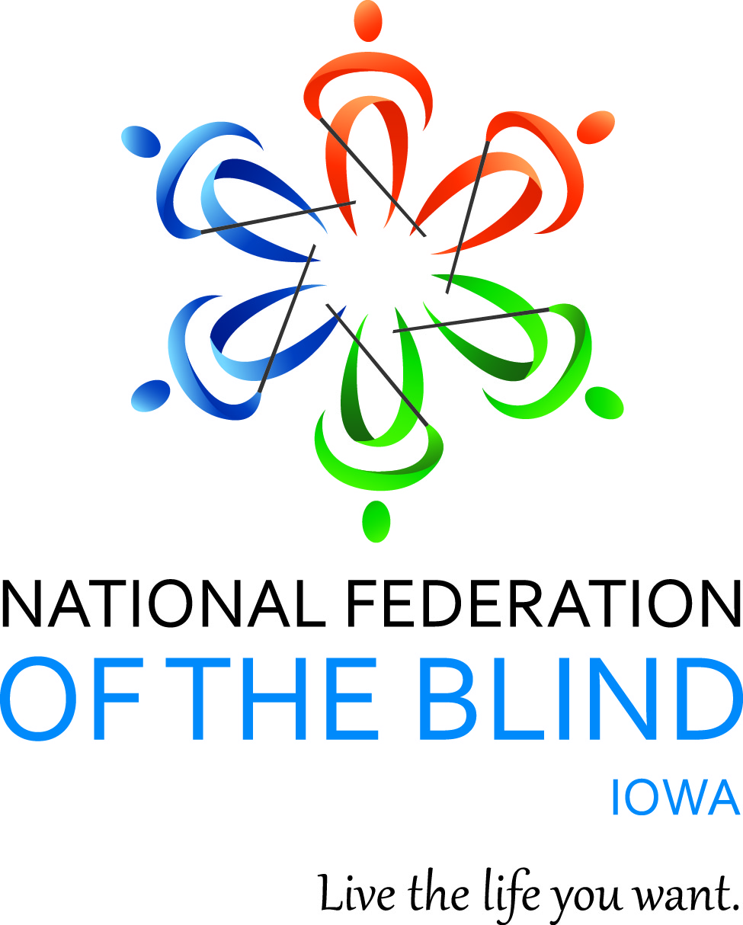

NATIONAL FEDERATION OF THE BLIND OF IOWA
2017 STATE CONVENTION
September 29–October 1, 2017

Holiday Inn Hotel & Suites, Des Moines Northwest
4800 Merle Hay Road, Urbandale, IA 50322

Jerad S. Nylin, President
E-Mail: jerad.nfbi@gmail.com
Cell: (319)535-3723
Website: www.nfbi.org
WELCOME

The members of the planning committee welcome you to the 2017 National Federation of the Blind of Iowa state convention!

Jerad S. Nylin, President, National Federation of the Blind of Iowa
Cindy Ray, President, Des Moines Chapter, Affiliate Board member
Katy Olsen, Chair, Student Committee
Michael Barber, President, Iowa Diabetes Action Network, Affiliate Board Member
Sam Claassen, President, Cedar Rapids Chapter
Donna Prime, Affiliate Board member

Committee Chairs
Bob Ray, Nominating
Cindy Ray, Resolutions
Helen Stevens, Registration
Katy Olsen, Entertainment
Karen Clayton, Auditing
April Enderton, Door Prizes

If you have questions or need assistance with the hotel during the convention, contact Mike Barber, Convention Coordinator: 515-771-8348.

Stay connected with the National Federation of the Blind of Iowa!
Like us on Facebook
Follow us on Twitter @NFB_Iowa
Sign up for the Tall-Corn mailing list to get our latest information
Read the Federation focus—our official eNewsletter

NFB PLEDGE

“I pledge to participate actively in the efforts of the National Federation of the Blind to achieve equality, opportunity, and security for the blind; to support the policies and programs of the federation; and to abide by its constitution.”

AGENDA

Friday, September 29, 2017

8:30-11:30 a.m. Meals From the Heartland Janae Burgmeier
Community Service Project -
Start your convention experience off right! Join the Des Moines Chapter to have fun and help those in need by participating in this community service project. We need at least 10 members to participate; all are welcome. Project time listed includes transportation time to and from the event. contact Janae janae.burgmeier@gmail.com to sign up or for more information.

1:00-3:00 p.m. Iowa Diabetes Action Michael Barber, President
Network Annual Meeting
Nebraska Room
Registration begins at 12:00 and costs $5.

3:00-5:00 p.m. At Large Chapter Meeting April Enderton, President --Wisconsin Room
Registration begins at 2:30 and costs $5.

3:00-5:00 p.m. Student Committee Meeting Katy Olsen, Chair
--Indiana Room
Registration begins at 2:30 and costs $5.
Attention Iowa Students!!! Please join us for a great opportunity to network with other blind students around the state. We will discuss our plans for the upcoming year and details about the start of our Iowa Association of Blind Students division. See you there!

3:00-7:00 p.m. Convention Registration, Between Salons B and C, lobby

4:00-9:00 p.m. Exhibit Hall, Salon D

5:15-6:45 p.m. BBQ Reception --Salon B
Potato Salad, Vegetable Crudités with Dip, Buffalo wings with Bleu Cheese and Celery, Barbequed Pork Slider Sandwiches, Loaded Potato Skins with cheddar, bacon, sour cream and chives. $20 if not pre-registered by September 20.

7:00-8:00 p.m. Resolutions Committee Cindy Ray, Chair
Meeting--Wisconsin Room
Open to all. Hear the resolutions before they come to the convention floor for a vote.

8:00-12:00 p.m. Hospitality--Salon B Student Committee
Students host hospitality night. Cash Bar available (Please drink responsibly).

Saturday, September 30, 2017

7:00-8:00 a.m. Convention Registration, Between Salons B and C, lobby

7:00-8:45 a.m. Exhibit Hall, Salon D

7:00-8:00 a.m. President’s Breakfast, Salon B

8:00-8:45 a.m. Affiliate Board Meeting, Salon B
Open to all

GENERAL SESSION, Salon C
9:00 a.m. Call to Order
9:05 a.m. Opening Ceremonies
Invocation: Cindy Ray, President, Des Moines Chapter
Pledge of Allegiance, National Anthem: Terri Wilcox, Des Moines
National Federation of the Blind Pledge
Welcome to the Hotel
Welcome to Urbandale: John Forbes, legislator—District 70, Owner, Medicap Pharmacy, Urbandale
9:20 a.m. Moving a Braille Bill Through the Iowa Legislature: A resolution on the revamped 1993 Braille Bill
9:45 a.m. National Report Kevan Worley, National Representative, President--Worley Enterprises, Colorado Springs, Colorado
10:15 a.m. O6: The ultimate life remote with Voiceover Support demonstration: Nick wilcox, Des Moines
10:20 a.m. Developing Accessible Technologies to Enhance Quality of Life: Kyle Rector, PhD, Assistant Professor, Computer Science, University of Iowa
10:35 A.m. Why I Am a Federationist
10:45 a.m. National Association of Blind Students Report Bryan Duarte, Board member National association of blind Students,

11:00 a.m. Presentation from Vanda Pharmaceuticals Jay Blind, Account Manager, Vanda Pharmaceuticals
11:15 a.m. Department Report, Emily Wharton--Director Iowa Department for the Blind, Des Moines
12:00 p.m. Adjourn

12:15-1:45 p.m. Networking Lunch, Salon B, Karly Prinds, Host
Do you know the people that make up the membership of the National Federation of the Blind of Iowa? Come to this informal lunch, to meet new people, and get to know the affiliate with group questions.

12:15-1:45 p.m. Exhibit Hall, Salon D

2:00 p.m. General Session Resumes, Salon C
2:05 p.m. Presidential Report: “A Year of Learning, Reflecting and New Opportunities in the National Federation of the blind of Iowa,” Jerad S. Nylin, President
2:30 p.m. “Newfound Confidence in Myself,” Katy Olsen, Recent graduate, Louisiana Center for the Blind
2:45 p.m. “Skydiving to Raise Expectations for Blind Students,” Danny Grimes, North Liberty
3:00 p.m. Why I Am a Federationist
3:15 p.m. “Finding My Way to the National Federation of the Blind: Help with The Massage &Bodywork Licensing Examination (MBLEx),” Kristen Steele, Underwood
3:30 p.m. Parental Rights Bill and Resolution
3:55 p.m. Newsline Demonstration and Funding, Mike Barber, NEWSLINE coordinator
4:10 p.m. Partnering with the Delta Gammas to Raise Expectations, Sarah Gornik, President, Tau Chapter, Delta Gamma Sorrority, Iowa City
4:25 p.m. Building the Federation: It Starts with Us
5:00 p.m. Adjourn

6:00-7:00 p.m. Pre-Banquet Reception and Cash Bar, Prefunction lobby B and C

7:00 p.m. Annual Banquet, Salon B
Master of Ceremonies: Scott Van Gorp – NFBI Secretary
Invocation: Cindy Ray – President, Des Moines Chapter
Banquet Address: Kevan Worley – National Representative
PAC Plan
Awards
Auction and Raffles

Sunday, October 1, 2017

8:15 a.m. Morning Devotions, Salon B, Katy Olsen, Leader
Start your morning off right with inspiring discussion and a positive message. Members of all denominations are welcome.

Business Session, Salon C
9:00 a.m. Call to Order
9:05 a.m. Business Meeting
2016 Meeting Minutes – Scott Van Gorp, Secretary
Treasurer’s Report – David Hammel, Treasurer
Auditing Committee Report – Karen Clayton, Chair
Resolutions Committee Report – Cindy Ray, Chair
10:30 a.m. Chapter and Division Reports
10:45 a.m. Elections – Bob Ray, Nominating Committee Chair
Election of Delegate and Alternate to the 2018 National Convention
Old Business
New Business
11:30 a.m. Final Remarks – Jerad S. Nylin, President and Kevan Worley, National Representative
12:00 p.m. Adjourn

2016-2017 OFFICERS AND BOARD MEMBERS

Jerad S. Nylin, President, Cedar Rapids, jerad.nfbi@gmail.com
Karen Clayton, First Vice President, Sioux City, Karen@simpco.org
Darrel Kirby , Second Vice President, Iowa City, dkirby@mchsi.com
Scott Van Gorp, Secretary, Des Moines, Scott.nfbi@gmail.com
David Hammel, Treasurer, Urbandale, dhammelia@aol.com
Cindy Ray, Board Member, Urbandale, cindyray@gmail.com
Tai Tomasi, Board Member, Des Moines, tai.tomasi8@gmail.com
Donna Prime, Board Member, Iowa City, dprime27@gmail.com
Michael Barber, Board Member, Des Moines, m.barber817@gmail.com

CONVENTION SPONSORS

Thank you to this year’s convention sponsors!

Vanda Pharmaceuticals: Vanda is a global biopharmaceutical company focused on the development and commercialization of innovative therapies to address high unmet medical needs and improve the lives of patients. Its first innovative therapy is Hetlioz (tasimelteon) for the treatment of Non-24-Hour Sleep Wake Disorder.

Kyle Rector, PhD: Kyle Rector will present her research in designing, developing, and evaluating accessible technologies that enhance quality of life. She will discuss her previous work relating to yoga and art exploration, and talk about her current research at the University of Iowa. To participate in her research project go to: https://uiowa.qualtrics.com/jfe/form/SV_0cCoVOmd2rkz5fn
to learn more, visit http://kyle-rector.com or email her at kyle-rector@uiowa.edu.

The National Federation of the Blind of Iowa knows that blindness is not the characteristic that defines you or your future. Every day we raise the expectations of blind people, because low expectations create obstacles between blind people and our dreams. You can live the life you want; blindness is not what holds you back.

