National Federation of the Blind of Iowa:

Parents' of Blind Children Seminar

10:00-12:00 PM TOOLS TO BOOST YOUR CHILD'S IEP: IEP WORKSHOP —Come learn about appropriate assessments, eligibility guidelines and building the IEP that best fits the needs of your child.

12:30 PM CHECK-IN

1:00 PM WELCOMING REMARKS—Jerad Nylin, President of the National Federation of the Blind of Iowa and Ryan Brems, Father of Jaxon, blind high school senior

1:10 PM PARENT INTRODUCTIONS

1:20 PM RAISING YOUR CHILD WITH HIGH EXPECTATIONS—Presentation by Kimberly Banks, 2nd Vice President of the National Organization of Parents of Blind Children

1:40 PM IOWA ASSOCIATION OF BLIND STUDENTS PANEL—Hear from some of our blind college students about their experiences in and out of the classroom

2:10 PM THE POWER OF INDEPENDENCE—Cane travel instructor, Zach Ellingson, NOMC will lead a hands on session on the importance of proper cane travel skills.

2:40 PM PHYSICAL ACTIVITY FOR BLIND YOUTH—Courage League Sports, a local adaptive sports facility will educate us on how to encourage an active lifestyle for our children.

3:00 PM BREAK

3:15 PM HELPFUL TECHNIQUES FOR ACTIVITIES OF DAILY LIVING—Karly Prinds, Home Management instructor at the Iowa Department for the Blind will share some tips and tricks to promote independent living skills for home, school, and your child's future

3:30 PM WHAT THE IOWA LIBRARY SERVICES HAS TO OFFER—The Iowa Library for the Blind will give a brief overview of the programs and materials that they have to offer our young readers

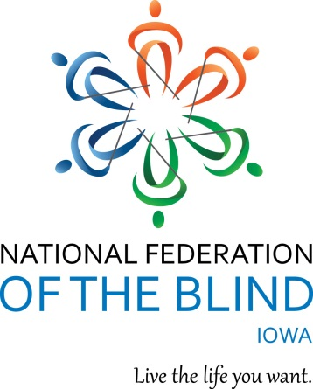3:45 PM ADVOCATING FOR YOUR CHILD'S EDUCATION—Tai Tomasi, attorney with Disability Rights Iowa will be facilitating a session about advocating on behalf of your child to ensure their needs are being met in the classroom.

4:45 PM NEXT STEPS/CLOSING REMARKS

5:00 PM ADJOURN