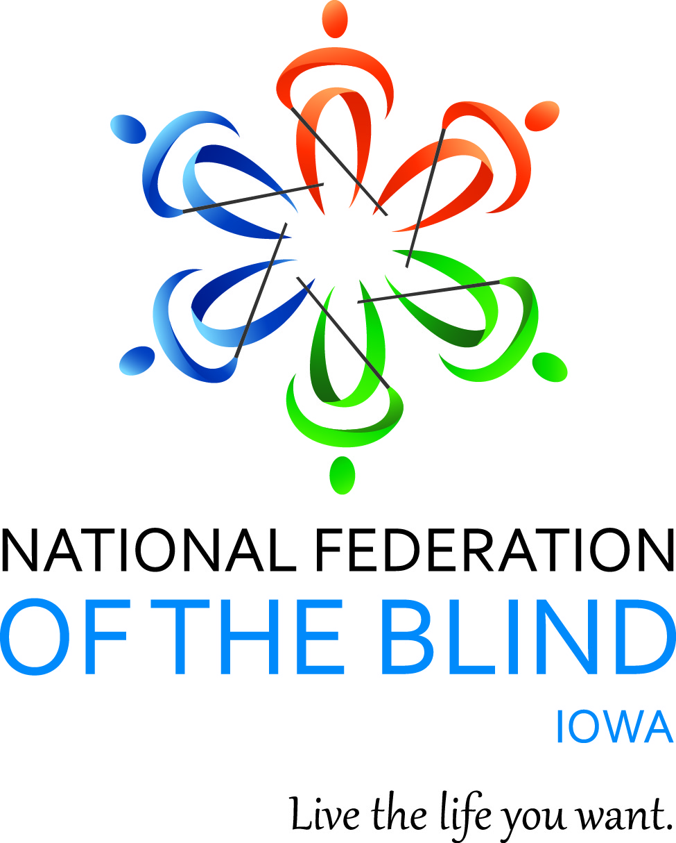

NATIONAL FEDERATION OF THE BLIND OF IOWA
2018 STATE CONVENTION
October 5–October 7, 2018

Holiday Inn Hotel & Suites, Des Moines Northwest
4800 Merle Hay Road, Urbandale, IA 50322

Jerad S. Nylin, President
E-Mail: jerad.nfbi@gmail.com
Cell: (319)535-3723
Website: www.nfbi.org

WELCOME

The members of the planning committee welcome you to the 2018 National Federation of the Blind of Iowa state convention!

Jerad S. Nylin, President, National Federation of the Blind of Iowa
Cindy Ray, President, Des Moines Chapter; Affiliate Board Member
Katy Olsen, President, Iowa Association of Blind Students; Affiliate Board Member
Thomas Topping, Cedar Rapids Iowa
Sam Claassen, Cedar Rapids Iowa

Committee Chairs
Bob Ray, Nominating
Tai Tomasi, Resolutions
Helen Stevens, Registration
Karen Clayton, Auditing
Mike Harvey, Door Prizes
Katy Olsen, Outreach

2017-2018 OFFICERS AND BOARD MEMBERS

Jerad S. Nylin, President, Iowa City, jerad.nfbi@gmail.com
Karen Clayton, First Vice President, Sioux City, kjeanette1978@gmail.com
Darrel Kirby, Second Vice President, Iowa City, kirbydarrel@gmail.com
Scott Van Gorp, Secretary, Des Moines, scott.nfbi@gmail.com
David Hammel, Treasurer, Urbandale, dhammelia@aol.com
Cindy Ray, Board Member, Urbandale, cindyray@gmail.com
Katy Olsen, Board Member, Iowa City, president.iabs@gmail.com
Christie Steele, Board Member, Burlington, steele.christiane@gmail.com
Michael Barber, Board Member, Des Moines, m.barber817@gmail.com

If you have questions or need assistance with the hotel during the convention, contact Co-Convention Coordinators Sam Claassen (Cell: 319-899-8707) or Thomas Topping (Cell: 319-450-5468)

Stay connected with the National Federation of the Blind of Iowa!
Use the hashtag: #NFBIA18
Like us on Facebook: National Federation of the Blind of Iowa
Follow us on Twitter: @NFB_Iowa
Sign up for the Tall-Corn mailing list to get our latest information
AGENDA

Friday, October 5, 2018

10:00 a.m.-Noon Tools to Boost Your Child’s IEP Kimberly Banks
Salon D
Come learn about appropriate assessments, eligibility guidelines and building the IEP that best fits the needs of your child.

10:00 a.m.-Noon Child Care Provided. All kids 13 and under are welcome.
Salon B
While you are in meetings, your kids will have the opportunity to create arts and crafts, play games, and meet other blind and sighted children from the state.

12:30-2:30 p.m. Iowa Diabetes Action Network Mike Barber, President
Salon C
The Iowa Diabetes Action Network will hold its annual meeting with registration beginning at noon outside Salon C. Our main speaker will be Dr. Robert Dahlberg, a Des Moines dentist, who will talk about dental hygiene and your health. We will also hold our election of officers and board members. Registration/Dues is $5

12:30-2:00p.m. Child Care Provided: All kids 13 and under are welcome.
Salon B until 2:00p.m., then Bennigan's West until 5:00p.m

1:00-5:00 p.m. Parents Networking Seminar Ryan Brems, facilitator
Salon D
This exciting event will be jam packed with informational programming and will give parents the opportunity to share experiences and connect with other families as well as professionals in the blindness field.
See separate agenda for more details on this event

3:00-5:00 p.m. At Large Chapter Meeting April Enderton, President Salon C
Kristen Steele will be our guest speaker. She will talk about her work as a blind, licensed massage therapist. Michael Barber will talk about the Library Consumer Advisory Committee. We will also hold our annual chapter election and have a little convention trivia. Registration begins at 2:45. Registration/dues is $5.

3:00-5:00 p.m. Iowa Association of Blind Students, Katy Olsen, President
Salon B
See separate agenda for details on the student meeting
Registration begins at 2:30 and dues are $5.

3:00-6:45 p.m. Convention Registration Pick Up Helen Stevens, Chair
Lobby between Salons B and C

5:15-6:45 p.m. Welcome Reception
Salon B
Come reconnect with friends you have not seen for a year, and make new friends at this event. Hors d'oeuvres will be served to those who have registered for the event and are wearing the wrist band for the event.

7:00-8:00 p.m. Resolutions Committee Meeting Tai Tomasi, Chair
Salon C
Open to all. Hear the resolutions before they come to the convention floor for a vote.

8:00 p.m.-Midnight Hospitality
Salon B Des Moines Chapter host hospitality night. Cash Bar available

Saturday, October 6, 2018

7:00-8:00 a.m. Convention Registration
Lobby between Salons B and C

7:00-8:00 a.m. Fundraising Breakfast
Salon B
8:00-8:45 a.m. Affiliate Board Meeting Jerad S. Nylin, President
Salon B
Open to all

8:45-Noon Child Care Provided. All kids 13 and under are welcome.
1:45-5:00 p.m. Salon D

GENERAL SESSION
Salon C
9:00 a.m. Call to Order: Jerad S. Nylin, President, National Federation of the Blind of Iowa
9:05 a.m. Opening Ceremonies
Invocation: Cindy Ray, President, Des Moines Chapter
National Anthem: Beth Rouse
Pledge of Allegiance
National Federation of the Blind Pledge
Welcome to Urbandale: Mayor Bob Andeweg
9:20 a.m. Finding Pride and Identity, Along with a Little Cash for School
Beth Rouse, 2018 National Scholarship finalist, Student at Central College
9:35 a.m. National Report: The Federation on the Move
Scott LaBarre, National representative; President, National Federation of the Blind of Colorado
10:05 a.m. Advocacy for Equal Education of Blind Students
Tai Tomasi, J.D., M.P.A., staff attorney, Disability Rights Iowa
10:20 a.m. Report on the Former Iowa Braille and Sight Saving School location and Iowa Educational Services for the Blind and Visually Impaired
Justin Ruegg, Director of Human Resources, IESBVI
10:50 a.m. Iowa Department for the Blind: Director’s Report
Emily Wharton, Director, Iowa Department for the Blind,
11:15 a.m. Do you know what the Iowa Library for the blind has to offer?
Sarah Willeford, Library Director, Iowa Library for the Blind and Physically Handicapped
11:50 a.m. Fuel the Fire for Higher Expectations
Kimberly Banks, 2nd Vice President, National Organization of Parents of Blind Children
Noon Recess

12:15-1:45 p.m. Networking Lunch
Salon B
Come reconnect with your friends, meet new friends, and be a part of a relaxing lunch with your federation family

12:15-1:30 p.m. Student/Parent Luncheon:
Salon C
All parents and students are welcome to join in on the engaging conversations!

2:00 p.m. General Session
Salon C
2:05 p.m. Presidential Report: Growing the Federation We Want in New Ways, Jerad S. Nylin, President, National Federation of the Blind of Iowa
2:30 p.m. NABS Report: Paving the Path for Our Future Leaders
Kathryn Webster, President, National Association of Blind Students
2:45 p.m. It Takes a Village: Bridging the Gap between Education and Rehabilitation Training
Michelle Gip, Youth Services Coordinator, BLIND, Inc., Minneapolis, Minnesota
3:10 p.m. Legal Advocacy and Priorities: Overview and Interactive Discussion
Tai Tomasi, J.D., M.P.A. staff attorney, Disability Rights Iowa
3:45 p.m. Developing Accessible Technologies to Enhance Quality of Life,
Kyle Rector, Ph.D., Assistant Professor, Computer Science, University of Iowa
4:00 p.m. Healthy Living
Sandi Ryan, Vice President, Iowa Diabetes Action Network
4:15 p.m. Our Website, Our Brand, and Our Social Network Presence
Scott Van Gorp, Secretary, National Federation of the Blind of Iowa
4:30 p.m. Access Technology Affordability Act: a Champion for the Blind of Iowa in the Halls of Congress
The Honorable David Young, 3rd district Iowa, United States Congressman
5:00 p.m. Recess
5:00-6:45 p.m. Pre-Banquet Reception and Cash Bar
Lobby between Salons B and C

7:00p.m. Annual Banquet
Salon B
Master of Ceremonies: Darrel Kirby – 2nd vice President, National Federation of the Blind of Iowa; President, Old Capital Chapter
Invocation: Cindy Ray – President, Des Moines Chapter
Banquet Address: Scott LaBarre, – National Representative
PAC Plan Scott LaBarre, – National Representative
Auction and Raffles

Following Banquet until Midnight.
Students host hospitality
Salon B
After the banquet, stop by for a night of games, music, and fun with our thriving student division!

Sunday, October 7, 2017
8:15 a.m. Morning Devotions Katy Olsen
Salon B
Start your morning off right with inspiring discussion and a positive message. Members of all denominations are welcome.

8:45-Noon Child Care Provided. All kids 13 and under are welcome.
Bennigan’s West

BUSINESS SESSION
Salon C
9:00 a.m. Call to Order
9:05 a.m. Business Meeting
2017 Meeting Minutes – Scott Van Gorp, Secretary
Treasurer’s Report – David Hammel, Treasurer
Auditing Committee Report – Karen Clayton, Chair
Resolutions Committee Report – Tai Tomasi, Chair
10:30 a.m. Chapter, Division, and Committee Reports
10:45 a.m. Elections – Bob Ray, Nominating Committee Chair
Election of Delegate and Alternate to the 2019 National Convention
Old Business
New Business
Fundraising
11:30 a.m. Final Remarks – Jerad S. Nylin, President and Scott LaBarre, National Representative
Noon Adjourn

MISSION OF THE NATIONAL FEDERATION OF THE BLIND OF IOWA

The National Federation of the Blind of Iowa knows that blindness is not the characteristic that defines you or your future. Every day we raise the expectations of blind people, because low expectations create obstacles between blind people and our dreams. You can live the life you want; blindness is not what holds you back.

THE NATIONAL FEDERATION OF THE BLIND PLEDGE

I pledge to participate actively in the efforts of The National Federation of the Blind to achieve equality, opportunity, and security for the blind; to support the policies and programs of the federation; and to abide by its constitution.

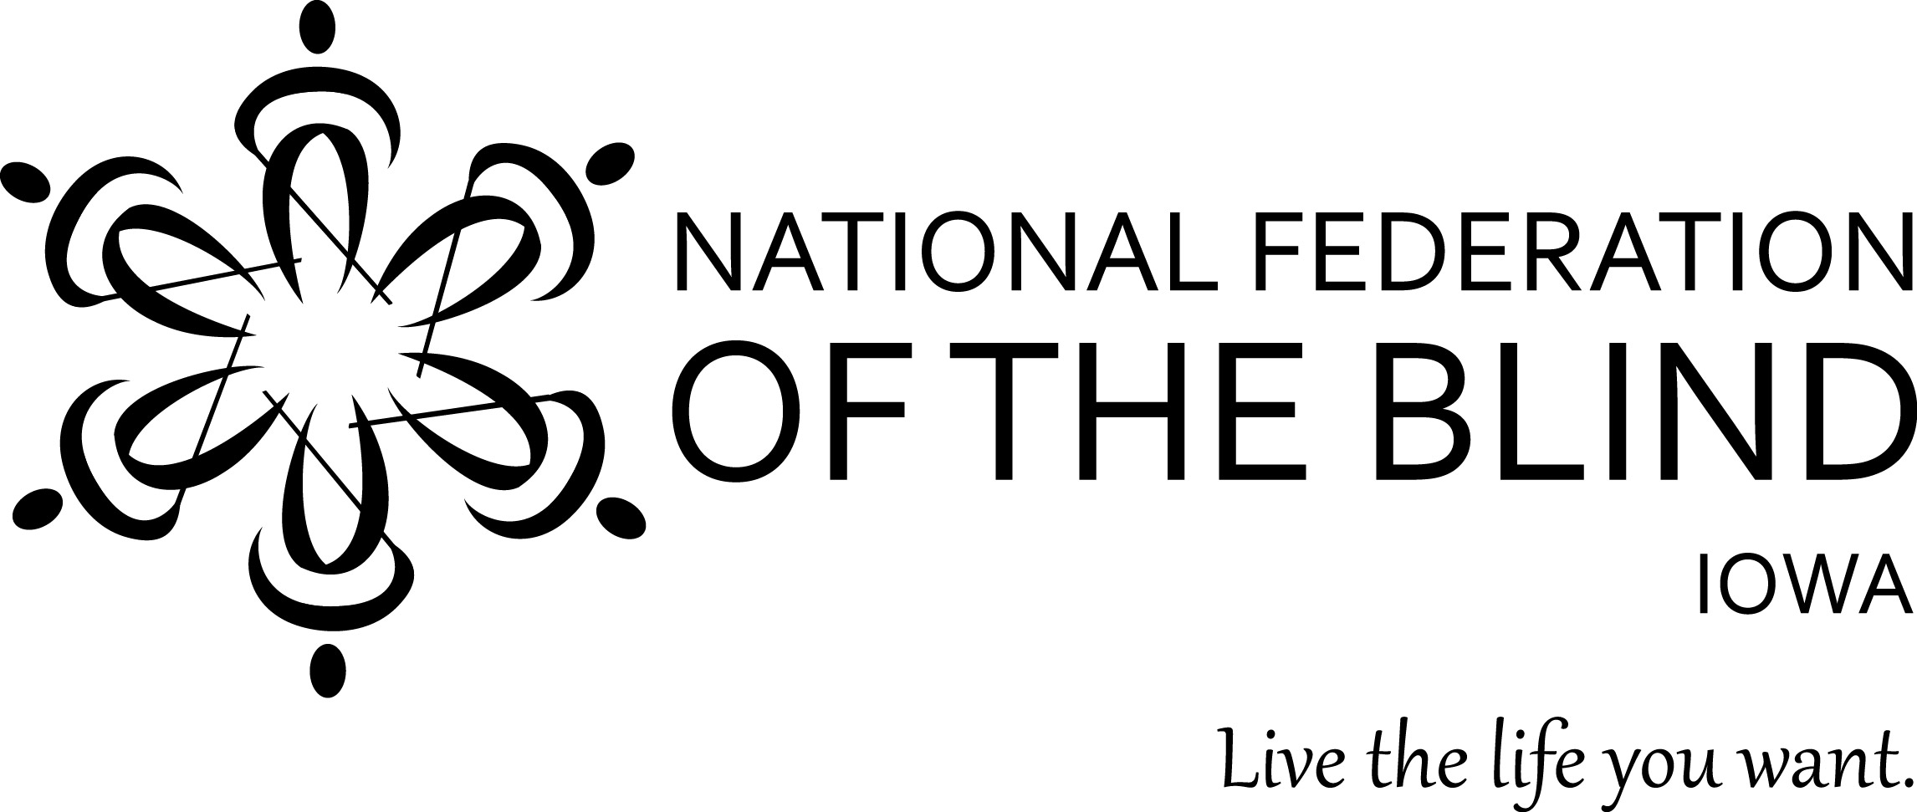

Free Aira Site Access at National Federation of the Blind State Conventions

The National Federation of the Blind has partnered with Aira to provide free Aira Site Access to NFB members during our 2018 state convention. Aira subscribers who are National Federation of the Blind members can use the service at our convention for free without having minutes deducted from their plans. In addition, those interested in Aira have the unique opportunity to try out the service for free while at our convention. This convention-wide, free site access is available only at NFB state conventions, giving NFB members an exclusive opportunity to test-drive Aira in a convention setting.

To download the Aira app go here: www.aira.io/app you will see a banner at the top of the app that says, “Tap to use Aira as a Guest for Free.” Aira allows blind individuals to connect via live video to a trained agent through a mobile app or wearable glasses to get real-time visual information or assistance. Learn more about Aira and special pricing available for NFB members at go.aira.io/NFB.

How it Works - Before you head to convention or as soon as you get there, download the free Aira app from the App Store, and create a guest account if you are not already an Aira subscriber. Also, make sure your phone’s GPS feature is enabled. When you enter the convention Site Access Location, your phone will receive a notification letting you know that the space you are in is part of the Aira Network. When you connect with an agent, he or she will also confirm that you are now covered by the network, and no minutes will be deducted from your account.

When you leave or enter convention areas that are covered by the Site Access network, you will be informed by the Aira agent.

To learn more about Aira and the special plan available exclusively to NFB members, visit go.aira.io/NFB.

