Iowa Association of Blind Students
Building A Future of Student Successes
October 5, 2018

3:00 PM Welcoming Remarks – Katy Olsen | President, Iowa Association of Blind Students

3:05 PM Ice Breaker: Guess who? – Kathryn Webster | President, National Association of Blind Students

3:15 PM Students Are Essential – Jerad Nylin | President, National Federation of the Blind of Iowa

3:20 PM Investment Matters Most – Scott LaBarre | National Representative; President, National Federation of the Blind of Colorado

3:30 PM Philosophy Debate – Katy Olsen | President, Iowa Association of Blind Students and Kathryn Webster | President, National Association of Blind Students

4:00 PM The Power of Independence: Structured Discovery Training - Michell Gip | Youth Services Coordinator, BLIND Incorporated

4:10 PM Advocacy is at the Forefront of Progress - Tai Tomasi | Attorney, Disability Rights Iowa

4:20 PM Library Services Drive Success in the Classroom – Lois Crozier and Sarah Willeford | Iowa Library for the Blind

4:30 PM Presidential Report – Katy Olsen | President, Iowa Association of Blind Students

4:35 PM Treasurer’s Report – Elizabeth Rouse | Secretary, Iowa Association of Blind Students

4:40 PM Leadership Matters: You Matter More! – Kathryn Webster | President, National Association of Blind Students
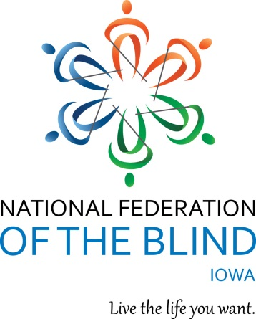
4:50 PM Elections

5:00 PM Adjourn

