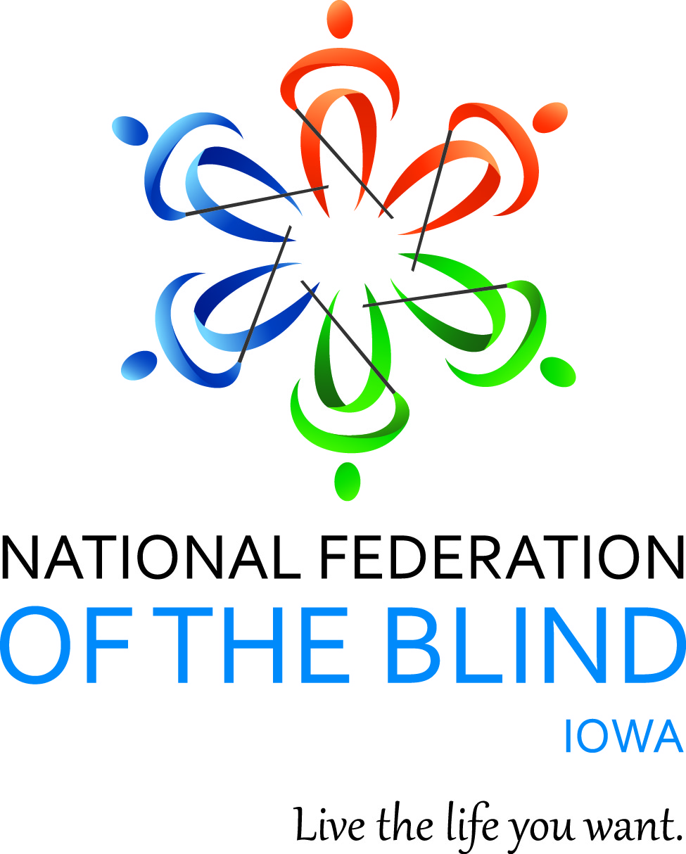

NATIONAL FEDERATION OF THE BLIND OF IOWA
2019 STATE CONVENTION
October 25–October 27, 2019

Holiday Inn Hotel & Suites, Des Moines Northwest
4800 Merle Hay Road, Urbandale, IA 50322

Scott Van Gorp, President
E-Mail: svangorp@nfbi.org
Cell: (515)720-5282
Website: www.nfbi.org
If you have questions or need assistance with the hotel during the convention, contact Convention Coordinator Cindy Ray (Cell: 515-208-2351)

WELCOME

The members of the planning committee welcome you to the 2018 National Federation of the Blind of Iowa state convention!

Scott Van Gorp, President, National Federation of the Blind of Iowa

Cindy Ray, Convention Coordinator, Des Moines Chapter; Secretary, National
Federation of the Blind of Iowa

Joe Goode, Des Moines Chapter; National Federation of the Blind of Iowa

Sharonda Goode, des Moines Chapter; National Federation of the Blind of Iowa

Helen Stevens, Des Moines Chapter; National federation of the Blind of Iowa

Committee Chairs
Bob Ray, Nominating
Michael Barber, Resolutions
Helen Stevens, Registration
Karen Clayton, Auditing
Chelsea Page, Door Prizes
Katy Olsen, Outreach

2018-2019 OFFICERS AND BOARD MEMBERS

Scott Van Gorp, President, Des Moines, svangorp@nfbi.org
Vacant, First Vice President,
Katy Olsen, Second Vice President, Des Moines, president.iabs@gmail.com
Cindy Ray, Secretary, Des Moines, cindyray@gmail.com
David Hammel, Treasurer, Urbandale, dhammelia@aol.com
Tai Tomasi, Board Member, Birmingham, AL tai.tomasi8@gmail.com
Sam Claassen, Board Member, Cedar Rapids, blindsoul93@gmail.com
Karen Clayton, Board Member, Sioux City, kjeanette1978@gmail.com
Michael Barber, Board Member, Des Moines, m.barber817@gmail.com

Stay connected with the National Federation of the Blind of Iowa!
Use the hashtag: #NFBIA19
Like us on Facebook: National Federation of the Blind of Iowa
Follow us on Twitter: @NFB_Iowa
Sign up for the Tall-Corn mailing list to get our latest information

AGENDA

Friday, October 25, 2019

10:00 a.m.-Noon Technology Showcase
Location: Wisconsin Room

Staff from the Iowa Department for the Blind and others will have various pieces of technology on display. You will also have the opportunity to get your technology questions answered and troubleshoot any problems.

1:00-3:00 p.m. Iowa Diabetes Action Network Mike Barber, President
Location: Wisconsin Room

The Iowa Diabetes Action Network will hold our annual meeting with registration beginning at 12:30 P.M. outside the Wisconsin room. Our main speakers will be Laurie and Hannah from the Iowa Diabetes Research Foundation. They will provide us with any updates in Diabetes research since the last time they visited. We will also have our annual business meeting.

3:00-5:00 p.m. At Large Chapter Meeting April Enderton, President Location: Wisconsin Room

We will hear from Dolores Reisinger about her activities with “Meet the Blind Month”. We will also hold our annual chapter elections and much more. Registration begins at 2:45. Registration/dues: $5

3:00-5:00 p.m. Iowa Association of Blind Students Katy Olsen, President
Location: Nebraska Room

See separate agenda for details on the student meeting
Registration begins at 2:30 / Dues: $5

3:00-6:45 p.m. Convention Registration Pick Up Helen Stevens, Chair
Location: Lobby between Salons B and C

5:15-6:45 p.m. Welcome Reception
Location: Salon B

Come reconnect with friends you have not seen for a year and make new friends at this event. Hors d'oeuvres will be served to those who have registered for the event and are wearing the appropriate wrist band for the event.

7:00-8:00 p.m. Resolutions Committee Meeting Michael Barber, Chair
Location: Wisconsin Room

Open to all. Hear the resolutions before they come to the
Convention floor for a vote.

8:00pm-Midnight: Hospitality
Location: Salon B
Iowa Association of Blind Students host hospitality night. Cash Bar
available . Come join in on the fun as the student division provides the
entertainment for our first night of the convention.

Saturday, October 26, 2019

7:00-8:00 a.m. Convention Registration
Location: Lobby between Salons B and C

7:00-8:00 a.m. President’s Buffet Breakfast
Location: Salon B
8:00-8:45 a.m. Affiliate Board Meeting Scott Van Gorp, President
Location: Salon B
Open to all

GENERAL SESSION (Salon C)

9:00 a.m. Call to Order: Scott Van Gorp, President, National Federation of the Blind of Iowa

9:05 a.m. Opening Ceremonies
Invocation: Cindy Ray, Secretary, NationalFederation of the Blind of Iowa
Pledge of Allegiance

National Anthem: Terri Wilcox, Secretary, Des Moines Chapter; David
Hammel, Treasurer, National Federation of the Blind of Iowa; Cindy Ray,
Secretary, National Federation of the Blind of Iowa

National Federation of the Blind Pledge

Welcome to Urbandale: State Senator Brad Zaun R Iowa Senate district 20, Urbandale, Iowa
9:20 A.M. Convention Arrangements: Cindy Ray, Convention Coordinator and Secretary, National Federation of the Blind of Iowa

9:25 a.m. National Report: What’s Happening in the Federation?
Julie Deden, National representative; Director, Colorado Center for the Blind

9:55 a.m. Report on Student Legislative Initiatives
Beth Rouse, Student at Central College and board member, National Association of Blind Students (NABS)
10:10 A.M. Self-Confidence Levels in Sequential Learning Versus Structured Discovery Cane Travel, Post Orientation and Mobility Instruction: A Comparison Study Dr. Merry-Noel Chamberlain
11:15 a.m. Report from Iowa Educational Services for the Blind and Visually Impaired (IESBVI)
Steve Gettel, Superintendent, IESBVI and Staff

12:00 P.M. Recess

12:15-1:45 p.m. Networking Lunch
Location: Salon B
Come reconnect with old friends, make new ones, and be a part of a relaxing lunch with your federation family

2:00 p.m. General Session
Location: Salon C

2:05 p.m. Presidential Report: The Promise of the Future: where we have been and where we are going, Scott Van Gorp, President, National Federation of the Blind of Iowa

2:35 p.m. Iowa Department for the Blind Director’s report: Emily Wharton, Director, Iowa Department for the Blind

3:15 p.m. An update from the I Can Connect program, what it is, and how it works. Laurie McBride, Iowa Representative for I Can Connect, Helen Keller National Center (HKNC)

3:45 p.m. Developing Accessible Technologies to Enhance Quality of Life,
Kyle Rector, Ph.D., Assistant Professor, Computer Science, University of Iowa

4:00 p.m. NABS Report: What has NABS been up to this year?
Dustin Cather, Treasurer, National Association of Blind Students

4:20 p.m. Legislative Updates: What have we been working on and how can you get involved?

Michael Barber, board member, National Federation of the Blind of Iowa

4:40 P.M. How the Federation Philosophy Affects my Life and Influences My Work: Chelsea Page, Teacher of the Blind and Visually Impaired, IESBVI

5:00 p.m. Recess

6:00-6:45 p.m. Pre-Banquet Reception and Cash Bar
Lobby between Salons B and C

7:00p.m. Annual Banquet
Location: Salon B

- Master of Ceremonies: Mike Harvey – President, Des Moines Chapter, National Federation of the Blind of Iowa
- Invocation: Cindy Ray – Secretary, National Federation of the Blind of Iowa
- Banquet Address: Julie Deden, – National Representative
- Membership Ceremony: Scott Van Gorp – President, National Federation of the Blind of Iowa

PAC Plan: Julie Deden, – National Representative
- Awards – Scott Van Gorp, President, National Federation of the Blind of Iowa
- Michael Barber – Board Member, National Federation of the Blind of Iowa
- Auction and Raffles: Scott Van Gorp, President, National Federation of the Blind of Iowa and Julie Deden, National Representative

Following Banquet until Midnight:
Convention Planning Committee host hospitality
Location: Salon B
After the banquet, stop by and continue the networking with old and new friends!

Sunday, October 27, 2019

8:00-8:45 a.m. Morning Devotions Joe and Sharonda Goode
Location: Salon B

Start your morning off right. Rise and shine with great music, faith, and Federation family! Everyone is welcome!

BUSINESS SESSION
Location: Salon C

9:00 a.m. Call to Order

9:05: Remarks – Julie Deden, National Representative

9:15 a.m. Business Meeting
- 2018 Meeting Minutes – Cindy Ray, Secretary
- Treasurer’s Report – David Hammel, Treasurer
- Auditing Committee Report – Karen Clayton, Chair
- Resolutions Committee Report – Michael Barber, Chair

10:30 a.m. Chapter, Division, and Committee Reports

10:45 a.m. Elections – Bob Ray, Nominating Committee Chair

Election of two 2-year board terms, one 1-year board term, and first Vice-President for a 1-year term. Election of Delegate and Alternate to the 2020 National Convention

- Old Business
- New Business
- Fundraising

11:30 a.m. Final Remarks –Scott Van Gorp, President

Noon Adjourn

Convention Notes:

We will have exhibits this year in Salon D throughout Friday and possibly Saturday. Patrick Fischer from Nanopac and Laurie McBride from the Helen Keller National Center will be there to answer questions and let you know what they have to offer. Thank you NanoPac and HKNC!

We will once again have free access to Aira at this year’s convention. The hotel will be an Aira access location. For more information on Aira, please visit www.aira.io.

For those who need it, there is a dog relief area at the hotel. As you exit the west entrance, turn north and go about 50 paces until you are along the fence. Bags and a waste receptacle are available.

MISSION OF THE NATIONAL FEDERATION OF THE BLIND OF IOWA

The National Federation of the Blind of Iowa knows that blindness is not the characteristic that defines you or your future. Every day we raise the expectations of blind people, because low expectations create obstacles between blind people and our dreams. You can live the life you want; blindness is not what holds you back.

THE NATIONAL FEDERATION OF THE BLIND PLEDGE

I pledge to participate actively in the efforts of The National Federation of the Blind to achieve equality, opportunity, and security for the blind; to support the policies and programs of the federation; and to abide by its constitution.

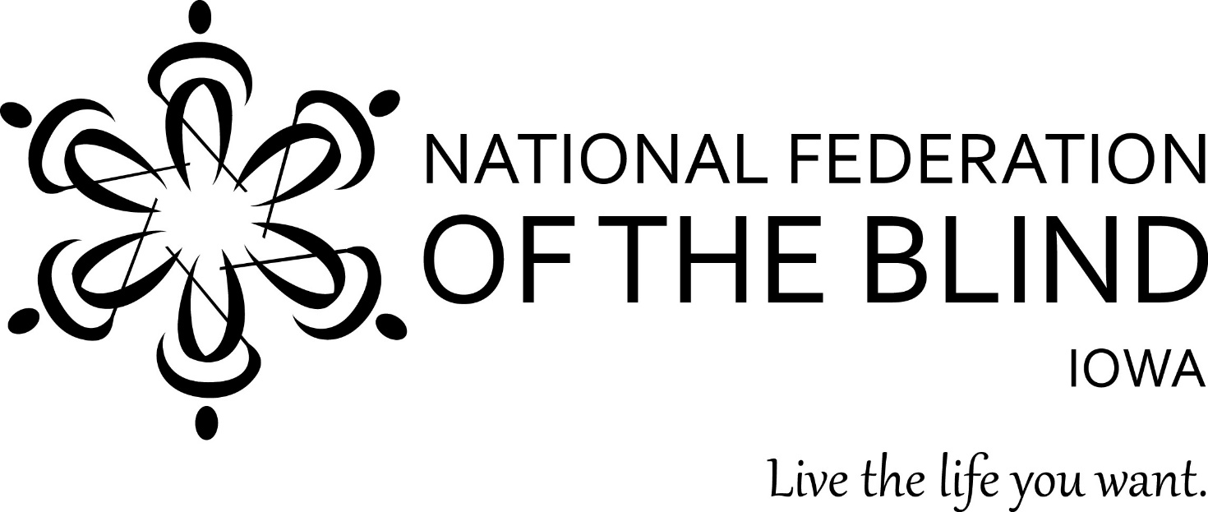 Free Aira Access at National Federation of the Blind State Conventions

The National Federation of the Blind has partnered with Aira to provide free Aira Access during our 2019 state convention. Aira subscribers can use the service at our convention for free without having minutes deducted from their plans. In addition, those interested in Aira have the unique opportunity to try out the service for free while at our convention. This convention-wide, free site access is available only at NFB state conventions, giving an exclusive opportunity to test-drive Aira in a convention setting.

To download the Aira app go here: www.aira.io/app you will see a banner at the top of the app that says, “Tap to use Aira as a Guest for Free.” Aira allows blind individuals to connect via live video to a trained agent through a mobile app or wearable glasses to get real-time visual information or assistance. Learn more about Aira at www.aira.io.

How it Works - Before you head to convention or as soon as you get there, download the free Aira app from the App Store, and create a guest account if you are not already an Aira subscriber. Also, make sure your phone’s GPS feature is enabled. When you enter the convention Aira Access Location, your phone will receive a notification letting you know that the space you are in is part of the Aira Network. When you connect with an agent, he or she will also confirm that you are now covered by the network, and no minutes will be deducted from your account.

When you leave or enter convention areas that are covered by the Aira Access network, you will be informed by the Aira agent. The first five minutes of every Aira call are now free, so even when you leave the convention, Aira can go with you!

