TIME TO GET IN THE HOLIDAY SPIRIT!
AT IOWA DEPARTMENT FOR THE BLIND
524 4TH ST., DES MOINES
Sing along with Antique Harmony and Off the Cuff as they
harmonize to your Holiday and Barbershop favorites
Friday, December 3, 2021
7-9:30 pm
Only $10 a ticket
Tickets available at the door or in advance
From any Friends Board Member

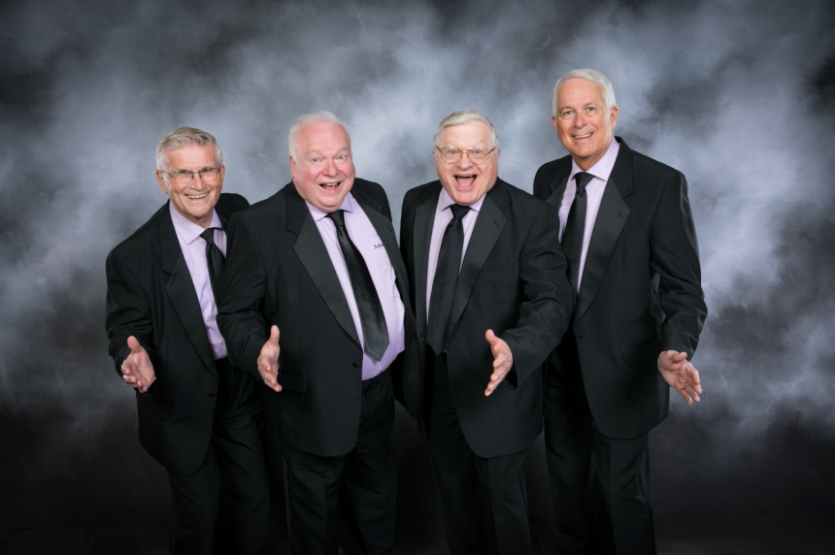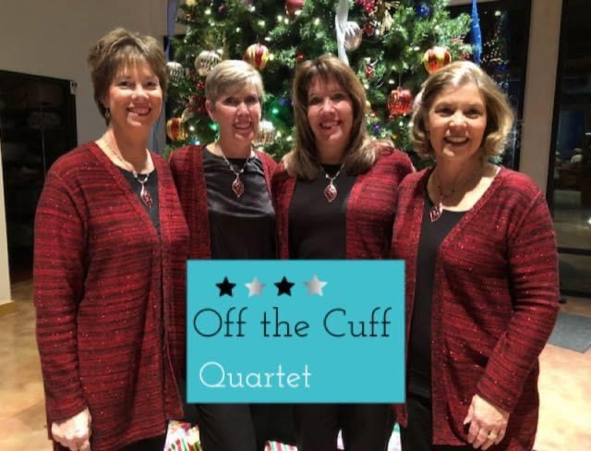
Antique Harmony

A benefit concert for the Friends of the Iowa Library
for the Blind and Physically Handicapped
PO Box 93046 Des Moines IA 50393-3046

