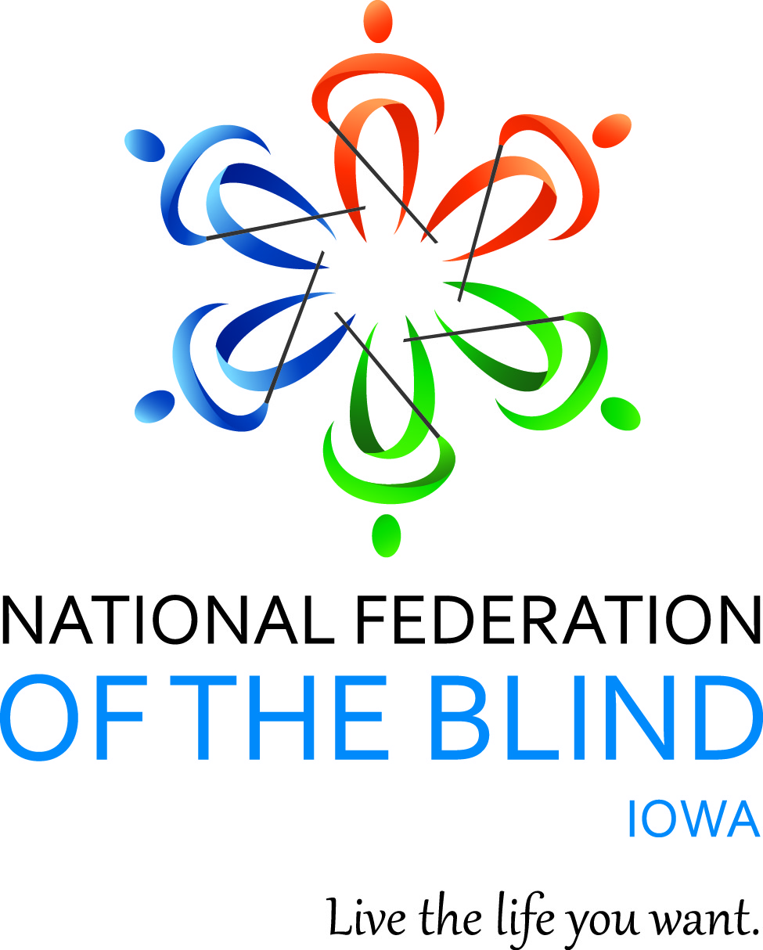

NATIONAL FEDERATION OF THE BLIND OF IOWA
2022 STATE CONVENTION
September 9–September 10, 2022

Holiday Inn and Suites Des Moines Northwest
4800 Merle Hay Road
Urbandale, IA 50322
Anywhere and Everywhere on Zoom

Scott Van Gorp, President
E-Mail: svangorp@nfbi.org
Cell: (515)720-5282
Website: www.nfbi.org

If you have questions or need assistance during the convention, contact Convention Coordinator Cindy Ray (Cell: 515-208-2351)

The members of the planning committee welcome you to the 2020 National Federation of the Blind of Iowa state convention!

Scott Van Gorp, President, NFBI

Cindy Ray, Convention Coordinator, First Vice-President; NFBI

Chelsea Van Gorp, Door Prize Coordinator and Fund raising chair, Des Moines Chapter; NFBI

Bob Ray, Des Moines Chapter, NFBI

Committee Chairs
Bob Ray, Nominating
Cindy Ray, Resolutions
Karen Clayton, Auditing
Chelsea Van Gorp, Door Prizes and Fund raising
Terri Wilcox and Cindy Ray, Outreach

The National Federation of the blind of Iowa is pleased to welcome Vanda Pharmaceuticals, Inc. as this year’s convention sponsor. Thank you Vanda for your support of the National Federation of the Blind of Iowa!

2021-2022 OFFICERS AND BOARD ,

Scott Van Gorp, President, Des Moines, svangorp@nfbi.org
Cindy Ray, First Vice-President, Urbandale, cindyray@gmail.com
Kim Brown, Second Vice President, Wapello, kimbeth@mchsi.com
Terri Wilcox, Secretary, Urbandale, trising1943@gmail.com
David Hammel, Treasurer, Urbandale, dhammelia@aol.com
Terry Poldberg, Board Member, tpoldberg@gmail.com
Sharonda Goode, Board Member, Phoenix AZ, s.goode1013@gmail.com
Tom Venesky, Board Member, Sioux City, tomvenesky2@gmail.com
Richard Webb, Board Member, Burlington
Use the hashtag: #NFBIA2022
Like us on Facebook: National Federation of the Blind of Iowa
Follow us on Twitter: @NFB_Iowa
Sign up for the Tall-Corn mailing list to get our latest information

AGENDA

Friday, September 9, 2022
9:00 A.M. – 9:00 P.M; Exhibits – Prefunction Foyer between Salons B and C
11:00 A.M. - 12:00 P.M. Guide Dog Users Meeting – We are meeting to continue discussing current guide dog issues and whether people are interested in forming a guide dog users group in Iowa to address guide dog related matters – Wisconsin Room

Join Zoom Meeting
https://zoom.us/j/7941099792?pwd=UHRXTEZLamFoNzA1djg1dEdpQVl3UT09
Meeting ID: 794 109 9792
Passcode: 6324692
One tap mobile
+13126266799,,7941099792# US (Chicago)

Dial by your location
+1 312 626 6799 US (Chicago)
Meeting ID: 794 109 9792

Meetings
1:00-3:00 p.m. At Large Chapter Meeting April Enderton, President – Wisconsin Room
Join Zoom Meeting
https://zoom.us/j/7941099792?pwd=UHRXTEZLamFoNzA1djg1dEdpQVl3UT09
Meeting ID: 794 109 9792
Passcode: 6324692
One tap mobile
+13126266799,,7941099792# US (Chicago)

Dial by your location
+1 312 626 6799 US (Chicago)
Meeting ID: 794 109 9792

3:30-4:30 p.m. Resolutions Committee Meeting Cindy Ray, Chair
Open to all. Hear the resolutions before they come to the convention floor for a vote. – Wisconsin Room

Join Zoom Meeting:
https://zoom.us/j/7941099792?pwd=UHRXTEZLamFoNzA1djg1dEdpQVl3UT09

Meeting ID: 794 109 9792
Passcode: 6324692
One tap mobile
+13126266799,,7941099792# US (Chicago)

Dial by your location
+1 312 626 6799 US (Chicago)
Meeting ID: 794 109 9792
3:00 P.M.- 6:45 P.M. In-person registration and online registration packet pickup -prefunction foyer outside of Salons B and C
5:00-6:45 P.M. Welcome reception and meal hosted by and compliments of the Des Moines Chapter, NFBI
Mix and mingle with old and new friends and enjoy delicious food as we celebrate coming back together again after 3 years apart. – Salon B
Friday General Session
All general sessions and the banquet and board meeting will be using the same Zoom information. – Salon C
Join Zoom Meeting
https://zoom.us/j/7941099792?pwd=UHRXTEZLamFoNzA1djg1dEdpQVl3UT09

Meeting ID: 794 109 9792
Passcode: 6324692
One tap mobile
+13126266799,,7941099792# US (Chicago)
Dial by your location
+1 312 626 6799 US (Chicago)
Meeting ID: 794 109 9792
7:00 P.m. Call to Order: Scott Van Gorp, President, National Federation of the Blind of Iowa

7:05 P.m. Opening Ceremonies
Invocation: Cindy Ray, First Vice-President, NFBI

Pledge of Allegiance

National Anthem:
Terri Wilcox, Secretary, NFBI
David Hammel, Treasurer, NFBI
Cindy Ray, First Vice-President, NFBI

National Federation of the Blind Pledge

Welcome (TBD)

7:20 P.M. Convention Arrangements: Cindy Ray, Convention Coordinator and First Vice-President, NFBI
7:30 P.M. Panel discussion on voting rights and efforts to achieve accessible voting for all in Iowa – Moderated by Bob Ray, Des Moines Chapter, NFBI
Panelists:
Emanuel Smith, Disability Rights Iowa
Don Wirth, Iowa Council of the United Blind (ICUB)
Matthew Gillespie, Assistant United States Attorney for the northern district of Iowa
8:30 P.M. Navigating the immigration system from a blind person’s perspective – Bitrus Gwamna, Vice-President, Southeast Iowa Chapter, NFBI
9:00 P.M. Adjourn
9:05 - 11:00 P.M. Hospitality – Convention planning committee
Join us for a great time for networking and to mix and Mingle in person. You never know what could happen! – Salon B
Cash bar available
Separate virtual hospitality experience available if desired.
Join Zoom Meeting
https://zoom.us/j/7941099792?pwd=UHRXTEZLamFoNzA1djg1dEdpQVl3UT09

Meeting ID: 794 109 9792
Passcode: 6324692
One tap mobile
+13126266799,,7941099792# US (Chicago)

Dial by your location
+1 312 626 6799 US (Chicago)
Meeting ID: 794 109 9792

Saturday, September 10, 2022

7:00-8:00 AM. Buffet breakfast – Salon B
7:00-9:00 A.M. Final Registration/packet pickup – Prefunction foyer outside Salons B and C
7:00 A.M-5:00 P.M. Exhibits – Prefunction Foyer between Salons B and C
8:00-8:45 a.m. Affiliate Board Meeting – Salon B
Scott Van Gorp, President, NFBI
Open to all

Join Zoom Meeting:
https://zoom.us/j/7941099792?pwd=UHRXTEZLamFoNzA1djg1dEdpQVl3UT09

Meeting ID: 794 109 9792 Passcode: 6324692
One tap mobile +13126266799,,7941099792# US (Chicago)
Dial by your location +1 312 626 6799 US (Chicago)

GENERAL SESSION – Salon C
9:00 A.M. Call to Order and invocation

9:05 A.M. Presidential Report – Scott Van Gorp, President, NFBI

9:30 A.M. Iowa Department for the Blind Report - Emily Wharton, Director, Iowa Department for the Blind

10:00 a.m. Report on what is happening in the movement - Anil Lewis, National Representative, Director of Blindness Initiatives, National Federation of the Blind

10:30 A.M. Legislative process – What have we accomplished this last year and how can we get more involved going forward? – A discussion led by Bob Ray, Des Moines Chapter, NFBI and Scott Van Gorp, President, NFBI

11:30 A.M. Reflections on New Orleans – Thoughts from some of us who attended the first National Convention in 3 years!

12:00 p.m. Adjourn
12:15-1:45 P.M. Lunch – Come and enjoy food and fellowship with the Federation Family and share stories from the past and dreams for the future – Salon B
Business Session – Salon C

2:00 P.M. Call to Order
2:05 P.M. Remembering the ones we’ve lost over this last year – Cindy Ray, First Vice-President, NFBI
2:10 P.M. Business Meeting
- 2021 Meeting Minutes –Terri Wilcox, Secretary,
- Treasurer’s Report – David Hammel, Treasurer
- Auditing Committee Report – Karen Clayton, Chair
- Resolutions Committee Report –Cindy Ray, Chair

3:00 P.M. Report from the Friends of the Library

3:10 P.M. Chapter, Division, and Committee Reports

3:30 P.m. Elections – Bob Ray, Nominating Committee Chair

Election of 5 officers and 2 board members for two-year terms. Election of Delegate and Alternate delegate to the 2023 National Convention

- Old Business
- New Business

4:30 P.m. Final Remarks –Anil Lewis, National Representative, and Scott Van Gorp, President, National Federation of the Blind of Iowa

5:00 P.M. Adjourn

6:00-6:45 P.M. Meet and Greet – prefunction area outside Salons B and C
Cash bar available
7::00 p.m. Annual Banquet – Salon B and C
- Master of Ceremonies: Cindy Ray – First Vice-President, National Federation of the Blind of Iowa
- Invocation: Sharonda Good–Board Member, National Federation of the Blind of Iowa
- Banquet Address: Anil Lewis, – National Representative

PAC Plan: Anil Lewis, – National Representative and Chelsea Van Gorp, Pac Chair for Iowa
Final remarks and adjournment – Scott Van Gorp, President, National Federation of the Blind of Iowa
Following Banquet:
Convention Planning Committee host hospitality
After the banquet it’s another evening for networking and to mix and mingle! Anything can happen, so come join us. – Salon B
Cash bar available
Virtual experience available
Join Zoom Meeting
https://us02web.zoom.us/j/145230447?pwd=T2FEaGN3Zk5sNVNPQ1QyTVpubjlpQT09
Meeting ID: 145 230 447
Passcode: 6324692
One tap mobile
+13462487799,,145230447# US (Houston)
+12532158782,,145230447# US (Tacoma)

Dial by your location
+1 312 626 6799 US (Chicago)
Meeting ID: 145 230 447
Sunday, September 11
7:30 A.M. Iowa Blind Amateur Radio Club breakfast - TBD
Convention Notes:
Thank you to our exhibitors for this years convention, Jennifer Lyman with Vanda Pharmaceuticals and Emily Ehlers with Disability Rights Iowa. Jennifer will be glad to talk with people regarding non-24 sleep wake disorder, and Emily will gladly talk with people about our dealings with Iowa DHS and making documents and correspondence with DHS accessible to blind people. Please stop by and thank them for their work and ask questions!

COVID-19 Statement:
The National Federation of the Blind of Iowa recognizes there are many different comfort levels regarding COVID-19. To protect the health and safety of all in-person convention participants, masks are highly encouraged at all convention meetings and events and in common areas as appropriate except while actively eating or drinking. Convention speakers do have the option to remove masks if they are comfortable doing so at the platform. If you experience symptoms, please take all necessary testing and mitigation measures as necessary. Masks will be available as needed. Together, we can all do our part to make this convention Federation safe.

For those who need it, there is a dog relief area at the hotel. As you exit the west entrance, turn north and go about 50 paces until you are along the fence. Bags and a waste receptacle are available.

MISSION OF THE NATIONAL FEDERATION OF THE BLIND OF IOWA

The National Federation of the Blind of Iowa knows that blindness is not the characteristic that defines you or your future. Every day we raise the expectations of blind people, because low expectations create obstacles between blind people and our dreams. You can live the life you want; blindness is not what holds you back.

THE NATIONAL FEDERATION OF THE BLIND PLEDGE

I pledge to participate actively in the efforts of The National Federation of the Blind to achieve equality, opportunity, and security for the blind; to support the policies and programs of the federation; and to abide by its constitution.

