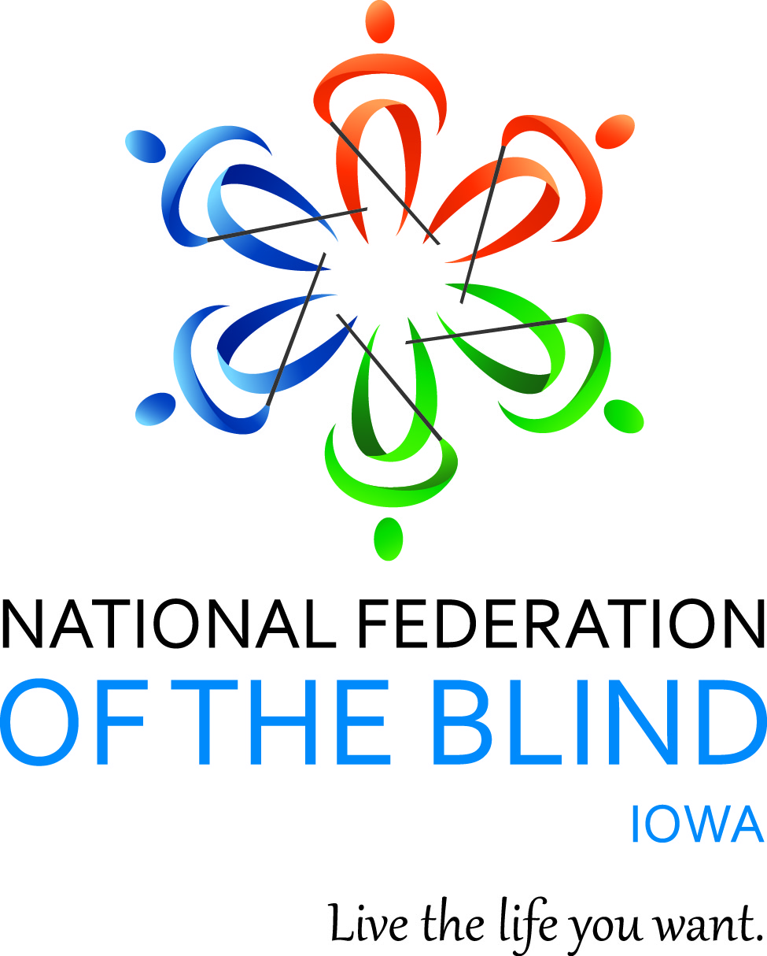

NATIONAL FEDERATION OF THE BLIND OF IOWA
2023 STATE CONVENTION
September 15–September 16, 2023

Holiday Inn and Suites Des Moines Northwest
4800 Merle Hay Road
Urbandale, IA 50322

Scott Van Gorp, President
E-Mail: svangorp@nfbi.org
Cell: (515)720-5282
Website: www.nfbi.org

If you have questions or need assistance during the convention, contact Convention Coordinator Cindy Ray, (Cell: 515-208-2351)

The members of the planning committee welcome you to the 2023 National Federation of the Blind of Iowa state convention!

Scott Van Gorp, President, NFBI
Cindy Ray, Convention Coordinator, First Vice-President; NFBI
Becky Young, Door Prize Coordinator and President, Des Moines Chapter; NFBI
Chelsea Van Gorp, Registration Chair and President, At Large Chapter, NFBI
Bob Ray, Des Moines Chapter, NFBI

Committee Chairs
Bob Ray, Nominating
Cindy Ray, Resolutions
Karen Clayton, Auditing
Mary McGee, Fund raising
Terri Wilcox and Cindy Ray, Outreach

The National Federation of the blind of Iowa is pleased to welcome Vanda Pharmaceuticals, Inc. as this year’s convention sponsor. Thank you Vanda for your support of the National Federation of the Blind of Iowa!

2022-2023 OFFICERS AND BOARD ,
Scott Van Gorp, President, Des Moines, svangorp@nfbi.org
Cindy Ray, First Vice-President, Urbandale, cindyray@gmail.com
Kim Brown, Second Vice President, Wapello, kimbeth@mchsi.com
Terri Wilcox, Secretary, Urbandale, trising1943@gmail.com
David Hammel, Treasurer, Urbandale, dhammelia@aol.com
Terry Poldberg, Board Member, Coralville, tpoldberg@gmail.com
Enrique Mejia, Board Member, Des Moines, emejia@nfbi.org
Tom Venesky, Board Member, Sioux City, tomvenesky2@gmail.com
Richard Webb, Board Member, Burlington, NF5B@mediacombb.net

Use the hashtag: #NFBIA2023
Like us on Facebook: National Federation of the Blind of Iowa
Follow us on Twitter: @NFB_Iowa
Sign up for the Tall-Corn mailing list to get our latest information

AGENDA

Friday, September 15, 2023
9:00 A.M. – 9:00 P.M; Exhibits – Prefunction Foyer between Salons B and C
11:00 A.M. - 12:00 P.M. Seniors Division Meeting – We are meeting to discuss whether we would like to form a seniors group/division in Iowa and what that might look like. Bob Ray, Des Moines Chapter and Glenn Crosby, President, National Seniors Division of the National Federation of the Blind - Bennigan's Meeting Room

Meetings
1:00-2:30 p.m. At Large Chapter Meeting Chelsea Van Gorp, President – Bennigan's Meeting Room
Join Zoom Meeting
https://zoom.us/j/7941099792?pwd=UHRXTEZLamFoNzA1djg1dEdpQVl3UT09
Meeting ID: 794 109 9792
Passcode: 6324692
One tap mobile
+13126266799,,7941099792# US (Chicago)

Dial by your location
+1 312 626 6799 US (Chicago)
Meeting ID: 794 109 9792
3:30-4:30 p.m. Resolutions Committee Meeting Cindy Ray, Chair
Open to all. Hear the resolutions before they come to the convention floor for a vote. – Bennigan's Meeting Room
3:00 P.M.- 6:45 P.M. In-person registration and online registration packet pickup -prefunction foyer outside of Salons B and C
5:00-6:45 P.M. Welcome reception and meal hosted by and compliments of the Des Moines Chapter, NFBI
Mix and mingle with old and new friends and enjoy delicious food as we celebrate being together over the last year. – Salon C

Friday General Session – Salon C
7:00 P.m. Call to Order: Scott Van Gorp, President, National Federation of the Blind of Iowa
7:05 P.m. Opening Ceremonies
Invocation: Josh Bingaman, Lead Pastor, First Church of the Open Bible, Des Moines
Pledge of Allegiance
National Anthem:
Terri Wilcox, Secretary, NFBI
David Hammel, Treasurer, NFBI
Cindy Ray, First Vice-President, NFBI
National Federation of the Blind Pledge
Welcome (TBD)
7:15 P.M. Convention Arrangements: Cindy Ray, Convention Coordinator and First Vice-President, NFBI
7:25 P.M. Panel discussion on grilling techniques from the blindness perspective. We’ll hear about ways to smoke and grill using modern grills and smartphones as well as traditional grilling done the low-tech way – Moderated by Bob Ray, Des Moines Chapter, NFBI
Panelists:
Cindy Ray, First Vice-President, NFBI
Tom Venesky, President, Siouxland Chapter, NFBI
Monica Venesky, Siouxland Chapter, NFBI
8:30 P.M. Navigating the immigration system from a blind person’s perspective – Bitrus Gwamna, Vice-President, Southeast Iowa Chapter, NFBI
9:00 P.M. Adjourn
9:05 - 11:00 P.M. Hospitality – Convention planning committee
Join us for a great time for networking and to mix and Mingle in person. You never know what could happen! There might even be games involved – Salon C
Refreshments will be available.

Saturday, September 16, 2023
7:00-8:00 AM. Plated breakfast – Salon C
7:00-9:00 A.M. Final Registration/packet pickup – Prefunction foyer outside Salons B and C
7:00 A.M-5:00 P.M. Exhibits – Prefunction Foyer between Salons B and C
8:00-8:45 a.m. Affiliate Board Meeting – Salon C
Scott Van Gorp, President, NFBI

GENERAL SESSION – Salon C
9:00 A.M. Call to Order and invocation
9:05 A.M. Report on what is happening in the movement - Norma Crosby, National Representative, President of the NFB of Texas and Treasurer, National Federation of the Blind
9:30 A.M. Iowa Department for the Blind Report - Emily Wharton, Director, Iowa Department for the Blind
10:00 a.m. Presidential Report – Scott Van Gorp, President, NFBI
10:30 A.M. Legislative process –what does it take to get our issues heard and how can we make more of an impact going forward after this year’s legislative work? – A discussion led by the NFBI legislative committee, Bob Ray, chair, and Mary McGee, committee member and Des Moines chapter legislative chair
We are pleased the following legislators have agreed to join us for this discussion:
Representative Austin Baeth, (D.) District 36, Polk County
Senator Nate Boulton, (D.) District 20, Polk County
Thank you Representative Baeth and Senator Boulton for joining us!
11:30 A.M. Reports and Resolutions
12:00 p.m. Adjourn
12:15-1:45 P.M. Lunch – Come and enjoy food and fellowship with the Federation Family and share stories from the past and dreams for the future – Salon C

Business Session – Salon C
2:00 P.M. Call to Order
2:05 P.M. Remembering the ones we’ve lost over this last year – Cindy Ray, First Vice-President, NFBI
2:10 P.M. Business Meeting
- 2022 Meeting Minutes –Terri Wilcox, Secretary,
- Treasurer’s Report – David Hammel, Treasurer
- Auditing Committee Report – Karen Clayton, Chair
- Resolutions Committee Report –Cindy Ray, Chair
3:00 P.M. Report from the Friends of the Library
3:10 P.M. Chapter, Division, and Committee Reports
NFB Newsline Report – Chelsea Van Gorp, NFB Newsline Coordinator for Iowa and President, At Large Chapter, NFBI
3:30 P.m. Elections – Bob Ray, Nominating Committee Chair
Election of 2 board members for two-year terms. Election of Delegate and Alternate delegate to the 2024 National Convention in Orlando, Florida
- Old Business
- New Business
4:30 P.m. Final Remarks –Norma Crosby, National Representative, and Scott Van Gorp, President, National Federation of the Blind of Iowa
5:00 P.M. Adjourn

6:00-6:45 P.M. Meet and Greet –Salon C
Refreshments available.
7::00 p.m. Annual Banquet – Salon C
- Master of Ceremonies: Cindy Ray – First Vice-President, NFBI
- Invocation: Cindy Ray, First Vice-President, NFBI
- Banquet Address: Norma Crosby, – National Representative
PAC Plan: Norma Crosby, – National Representative and Chelsea Van Gorp, Pac Chair for Iowa
Final remarks and adjournment – Scott Van Gorp, President, National Federation of the Blind of Iowa

Following Banquet:
Convention Planning Committee host hospitality
After the banquet it’s another evening for networking and to mix and mingle! Anything can happen, so come join us. – Salon C
Refreshments available

Sunday, September 17, 2023
7:30 A.M. Iowa Blind Amateur Radio Club breakfast – Restaurant general seating

Convention Notes:
Thank you to our exhibitors for this years convention, Pat Fisher with NanoPac, and Emily Ehlers with Disability Rights Iowa. Emily will gladly talk with people about our dealings with the Iowa Department of Health and Human Services and making documents and correspondence with HHS accessible to blind people. Pat will be here to exhibit blind/low vision products. Please stop by and thank them for being a part of our convention this year!

For those who need it, there is a dog relief area at the hotel. As you exit the west entrance, turn north and go about 50 paces until you are along the fence. Bags and a waste receptacle are available.

MISSION OF THE NATIONAL FEDERATION OF THE BLIND OF IOWA

The National Federation of the Blind of Iowa knows that blindness is not the characteristic that defines you or your future. Every day we raise the expectations of blind people, because low expectations create obstacles between blind people and our dreams. You can live the life you want; blindness is not what holds you back.

THE NATIONAL FEDERATION OF THE BLIND PLEDGE

I pledge to participate actively in the efforts of The National Federation of the Blind to achieve equality, opportunity, and security for the blind; to support the policies and programs of the federation; and to abide by its constitution.

