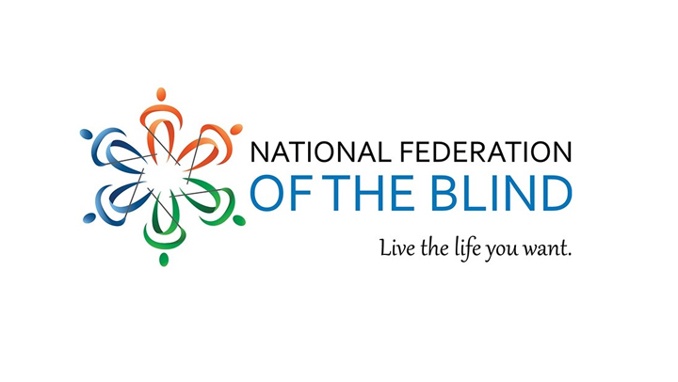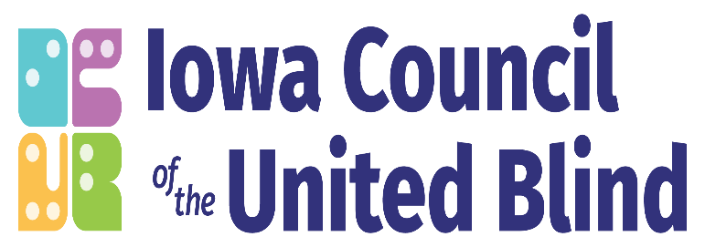April 11, 2025

**Office of the Attorney General of Iowa  
Hoover State Office Building  
1305 E. Walnut Street  
Des Moines IA 50319**

Dear Attorney General Bird,

We are writing to you on behalf of blind Iowans to request that you withdraw Iowa from the case Texas v. Kennedy. This lawsuit is an attack on important protections for blind Iowans since Section 504 prohibits discrimination in so many programs that we access on a daily basis including in educational and medical settings.

The National Federation of the Blind of Iowa (NFBI) and the Iowa Council of the United Blind (ICUB) have long been dedicated to improving the lives of blind individuals in our state. Our organizations have a rich history of advocacy and support, working to ensure equal opportunities and the protection of the rights of our members and all blind Iowans. Our members, who are spread across the state, are employed in a wide range of professions, attend every kind of school, and live in communities of all sizes. Anti-discrimination protections like those of Section 504 allow our members to contribute to our state alongside our fellow Iowans.

Your office has stated that the lawsuit is only related to the inclusion of gender dysphoria as a disability, and that it has no impact on other people with disabilities. However, count 3 in the Claims For Relief section of the lawsuit specifically requests that the court declare section 504 unconstitutional.

We strongly urge you to continue protecting the rights of blind Iowans rather than attacking a statute that has protected us for more than fifty years. The statute has contributed both culturally and economically by assisting thousands of disabled Iowans by allowing them to participate in society and the work force while reducing their dependence on governmental support. The statute has provided a major financial boon to the entire Iowa and United States economy.

If there is a concern with one aspect of the law, work on that. Do not throw out the baby with the bath water.

Thank you very much for your consideration.

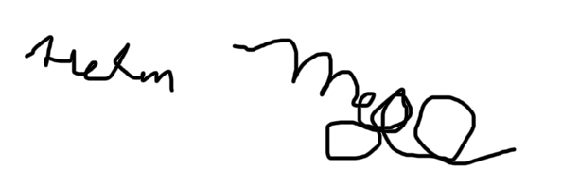

Helen Mejia

President National Federation of the Blind of Iowa (NFBI)  
[hmejia@nfbi.org](mailto:hmejia@nfbi.org)  
(570) 983-7867



Lori Trujillo Roush

President Iowa Council of the United Blind (ICUB)

[president@icublind.org](mailto:president@icublind.org)

515-402-3508