**National Federation of the Blind of Iowa**

**Old Capitol Chapter**

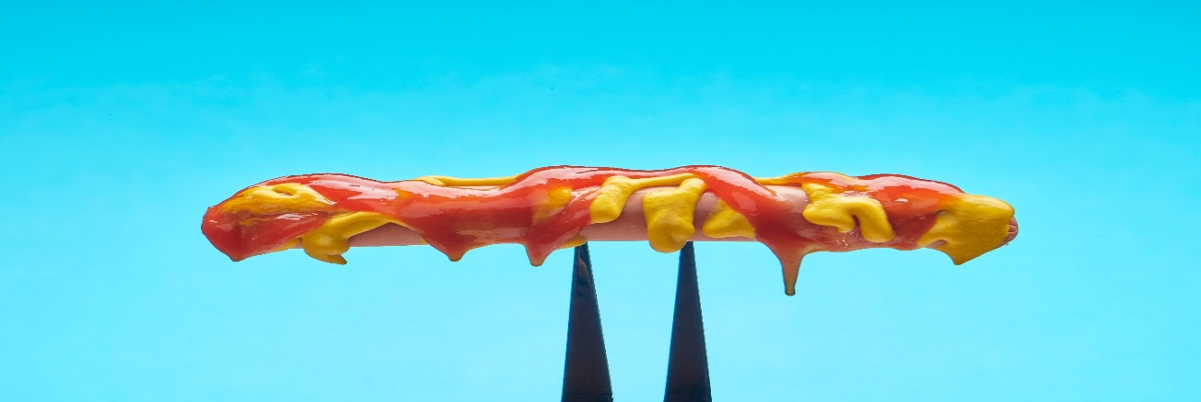

**The NFBI/Old Cap Chap invites you to our annual Priscilla McKinley cookout on Saturday, September 20, 2025,**

**Iowa City Park, Pavilions 7 & 8**

**200 Park Road, Iowa City, IA 52246**

**Lunch will be served at 12:00 noon with activities to follow**

**Members of the NFBI want to meet other blind individuals and their families. There will be plenty of food to share and fun to be enjoyed by all.**

**Please RSVP to** [**OldCapChap@NFBI.org**](mailto:OldCapChap@NFBI.org) **or call Inny Duncan at 319-930-8440 by Friday, September 5, 2025.**

