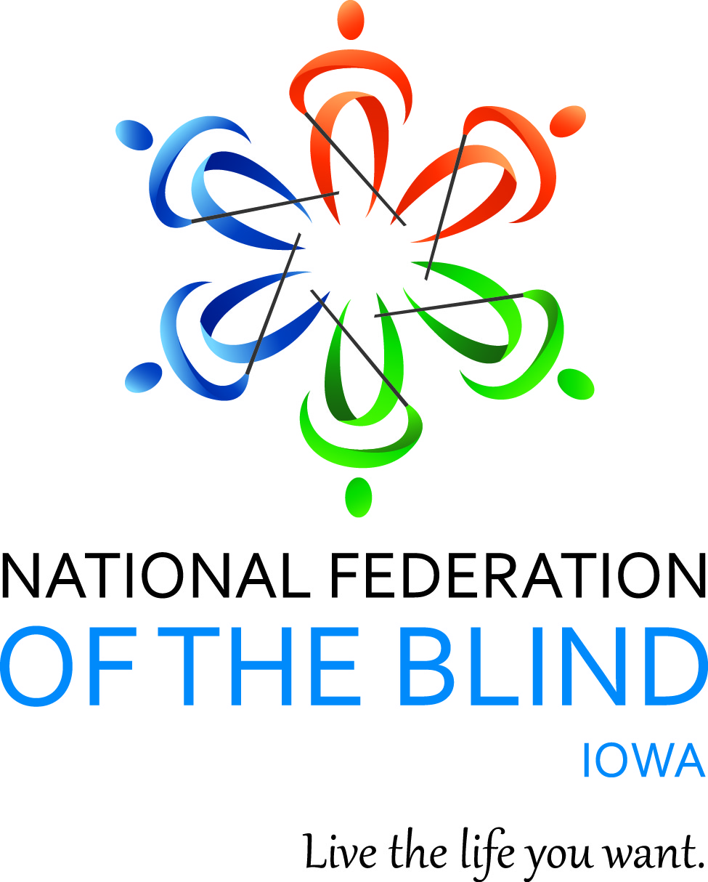

NATIONAL FEDERATION OF THE BLIND OF IOWA

99th Annual STATE CONVENTION

October 17–October 19, 2025

Holiday Inn and Suites Des Moines Northwest
4800 Merle Hay Road
Urbandale, IA 50322

Helen Mejia, President
E-Mail: hmejia@nfbi.org
Cell: (570)983-7867
Website: www.nfbi.org

If you have questions or need assistance during the convention, contact Elizabeth Rouse at (Cell: 563-210-1854)

Committee Chairs
Becky Young: Dorr Prize
Becky Young: Youth Activities
Bob Ray: Legislative
Bob Ray, Nominating
Karen Clayton, Audit
Scott Van Gorp, Resolutions
__ Convention Planning
__ Fundraising
__ Membership

2024-2025 OFFICERS AND BOARD
Helen Mejia, President, Des Moines, hmejia@nfbi.org
Cindy Ray, First Vice-President, Urbandale, cray@nfbi.org
Scott Van Gorp, Second Vice President, West Des Moines, svangorp@nfbi.org
Richard Webb, Secretary, Burlington, NF5B@mmsn.org
David Hammel, Treasurer, Urbandale, dhammelia@aol.com
Vacant, Board Member,
Becky Young, Board Member, Urbandale, byoung@nfbi.org
Elizabeth Rouse, Board Member, Durant, elizabethrouse.nfb@gmail.com
Shawn Mayo, Board Member, Des Moines, shawnmmayo@gmail.com

Use the hashtag: #NFBIA2025
Like us on Facebook: National Federation of the Blind of Iowa
Follow us on X: @NFB_Iowa
Sign up for the Tall-Corn mailing list to get our latest information at nfbnet.org

AGENDA

Friday, October 17, 2025
9:30 A.M. –11:00 A.M. Seniors Group Seminar, Bob Ray, NFBI Seniors Group coordinator. Salon C
11:00 A.M.–5:00 P.M. In-person registration and online registration packet pickup, Pre-function foyer outside of Salons B and C
11:00 A.M.–5:00 P.M. Exhibits, Pre-function Foyer outside of Salons B and C
12:30 P.M.–2:30 P.M. At Large Chapter meeting, Cindy Ray, President. Salon C
1:00 P.M.–2:00 P.M. Overview of the Ray-Ban Meta and its newest features, Wayne Turner, Rehabilitation Technology Specialist Iowa Department for the Blind. Bennigan’s Meeting Room
2:30 P.M.–3:30 P.M. Overview of iOS 26, including the new Braille Access, Wayne Turner, Rehabilitation Technology Specialist Iowa Department for the Blind. Bennigan’s Meeting Room
4:00 P.M.–4:30 P.M. Resolutions Committee Meeting, open to all, Scott Van Gorp, Chair. Salon C

Friday General Session – Salon C
5:00 P.M. Call to Order: Helen Mejia, President National Federation of the Blind of Iowa.
Invocation:
Pledge of Allegiance
National Federation of the Blind Pledge
5:15 P.M. Meet the 2025 NFBI Scholarship Winners, Emily Wharton, NFBI Scholarship Committee Chair.
5:30 P.M. National Report, Everette Bacon, Second Vice-President National Federation of the Blind.

6:30 P.M. Iowa Educational Services for the Blind and Visually impaired Update, Susan Brennan, Regional Director IESBVI.
7:00 P.M. Iowa Department for the Blind Update, Sarah Willeford Deputy Director, Karly Prinds Orientation Center Program Administrator, and Kim Walford Independent Living Program Administrator.
8:00 P.M. Adjourn.

8:00-11:00 P.M. Hospitality. Join us for a great time for networking and to mix and mingle in person. Hot and cold appetizers provided, bring your own beverages. Trivia will begin at 8:30. Salon C

Saturday, October 18, 2025

7:30 A.M–9:00 A.M. Exhibits, Pre-function Foyer outside of Salons B and C
8:00–9:00 A.M. Final Registration/packet pickup, Pre-function foyer outside of Salons B and C

Saturday Morning GENERAL SESSION – Salon C
9:00 A.M. Call to Order.
9:05 A.M. Presidential Report – Helen Mejia, President NFBI.
9:30 A.M. Establishing My Own Practice, Darrel Kirby, President Old Capitol Chapter NFBI.
9:50 A.M. Persisting through the process to become an adoptive parent, Terri Wilcox, Des Moines chapter NFBI.
10:05 A.M. Becoming a Business Enterprises Program Vendor, Luis Gutierrez, Des Moines Chapter NFBI.
10:20 A.M. Membership Maintains the Movement, Elizabeth Rouse, Membership Committee.
10:50 A.M. Problem-solving our way through the world of ham radio, Bob Ray, Des Moines Chapter NFBI and Richard Webb, Secretary NFBI.
11:10 A.M. Volunteering with NFBI’s BELL Programs, Barbara Hammel, Des Moines Chapter NFBI.
11:25 A.M. Youth are our future, Becky Young, Chair Youth Programs Committee NFBI.
11:40 A.M. Embracing Leadership Potential through the KJLSP. Elizabeth Rouse, Board Member NFBI.
12:00 p.m. Adjourn

12:30-1:45 P.M. Lunch.
Invocation: Sara Coleman, Des Moines Chapter NFBI
Keynote Address: Back to the Future, Dick Davis, Circle Pines MN.

Saturday Afternoon GENERAL SESSION – Salon C
2:00 P.M. Call to Order.
2:05 P.M. What Do Blind People Do for Fun? panel, moderator Shawn Mayo, Des Moines chapter NFBI. Panelists Luis Gutierrez, Des Moines Chapter NFBI, Darrel Kirby, Old Capitol Chapter NFBI, Karly Prinds, Des Moines Chapter NFBI, and Emily Wharton, Des Moines Chapter NFBI.
2:40 P.M. What is Washington Seminar, Enrique Mejia, Des Moines Chapter NFBI and Elizabeth Rouse, Board Member NFBI.
3:00 P.M. NFBI Legislative Priorities, Bob Ray, Chair Legislative Committee NFBI.
3:30 P.M. Insights from my career in Finance, Rich Crawford, Sioux Falls SD.
3:50 P.M. Why Money Matters? Fundraising to support our action, Everette Bacon, National Representative and Elizabeth Rouse, Fundraising Committee NFBI.
4:20 P.M. Creating Your Own Opportunities, Geneva Jacobsen, Avoca IA.
4:40 P.M. Planning our 100th convention, Helen Mejia, President NFBI.
5:00 p.m. Adjourn

5:15 Student meet-up, raised seating area in hotel lobby, Enrique Mejia, coordinator.

7:00 p.m. Annual Banquet – Salon C
Master of Ceremonies: Enrique Mejia, Des Moines Chapter NFBI
Invocation: Cindy Ray, First Vice-President, NFBI
Banquet Address: Everette Bacon, – National Representative and Second Vice-President, National Federation of the Blind
PAC Plan, Elizabeth Rouse PAC Coordinator NFBI
Awards

Sunday, October 19, 2025

Affiliate Board Meeting and Business Meeting– Salon C
9:00 A.M. Board meeting
call to order and determination of quorum
Approval of secretary and treasurer’s reports
New/old business
Adjourn
9:15 A.M. Business Meeting
Remembering the ones we’ve lost over this last year, Cindy Ray, First Vice-President NFBI
2024 Meeting Minutes, Richard Webb, Secretary, NFBI
Treasurer’s Report, David Hammel, Treasurer, NFBI
Audit Committee Report, Karen Clayton, Audit Committee Chair
Resolutions Committee Report, Scott Van Gorp, Resolutions Committee Chair
10:00 A.M. Report from the Friends of the Library, Cindy Ray, President
10:10 A.M. Chapter and group Reports
At Large Chapter: Cindy Ray, President
Des Moines Chapter, Becky Young President
Old Capitol Chapter, Darrel Kerby, President
Siouxland Chapter, Karen Clayton, Treasurer
Southeast Iowa Chapter, Richard Webb, President
Seniors Group: Bob Ray, Coordinator
NFB Newsline Report, Scott Van Gorp, NFBI Newsline Coordinator
11:00 A.M. Elections, Bob Ray, Nominating Committee Chair NFBI
Election of 2 board members for two-year terms and 1 board member for a one-year term
Election of Delegate and Alternate delegate to the 2026 National Convention in Austin Texas
Old Business
New Business
11:30 A.M. Final Remarks
Everette Bacon, National Representative,
Helen Mejia, President, National Federation of the Blind of Iowa
12:00 P.M. Adjourn

Convention Notes:

Please take the time to visit our sponsors and exhibitors and thank them for supporting the work of the National Federation of the Blind of Iowa. Thank you to the following sponsors and exhibitors for being a part of our 99th convention!

Silver Sponsor:
Vanda Pharmaceuticals

Bronze Sponsor:
AIRA Inc.

White Cane Sponsors and Exhibitors
Ask Resource Center
Nanopac

For those who need it, there is a dog relief area at the hotel. As you exit the west entrance, turn north and go about 50 paces until you are along the fence. Bags and a waste receptacle are available.

There will be door prizes drawn throughout general sessions, the banquet, and the business meeting. Please bring your door prizes to convention if they haven’t been sent ahead of time. We will have a baked goods auction interspersed throughout sessions as well. Also, please don’t forget to buy popcorn and support the affiliate at the same time!

Inclusivity, Diversity, and Code of Conduct
Thank you for cultivating an atmosphere of mutual respect where attendees can learn, network, and share with each other. The National Federation of the Blind of Iowa is committed to diversity, equity, and the free expression of ideas as outlined in our Code of Conduct. We recognize a shared responsibility to create and uphold that atmosphere.
Prohibited behaviors, such as harassment, retaliation, and sexual misconduct, will not be tolerated and may result in removal from the convention and/or other consequences. To report an incident at the convention, please contact President Helen Mejia at 570-983-7867.
The full Code of Conduct and resources are at nfb.org/codeofconduct.

Dream Makers Circle
You can help build a future of opportunity for the blind by becoming a member of our Dream Makers Circle (DMC). It is easier than you think. You can visit your bank and convert an account to a P.O.D. (payable on death) bank account, which is payable after your passing to the National Federation of the Blind or one of our affiliates. Your legacy gift to the National Federation of the Blind or the National Federation of the Blind of {insert state} can be made in the form of a will or living trust, an income generating gift, or by naming us as the beneficiary of a retirement plan, IRA, pension, or a life insurance policy. You can designate a specific amount, a percentage, or list the NFB as one of several beneficiaries. For additional information, please contact Patti Chang at 410-659-9314, extension 2422 or at pchang@nfb.org.

Vehicle Donations
The National Federation of the Blind uses car donations to improve the education of blind children, distribute free white canes, help veterans, and so much more. We have partnered with Vehicles for Charity to process donated vehicles. Please call toll-free 855-659-9314, and a representative can make arrangements, or you can donate online by visiting https://nfb.org/vehicledonations.

Preauthorized Contributions
Can you help the National Federation of the Blind on a regular basis? Please consider joining our preauthorized contribution (PAC) plan. Starting at $5 monthly, you can help us turn dreams into reality and raise expectations. Call 877-632-2722, visit: https://nfb.org/pac to fill out the online form, or email pac@nfb.org for additional information.

MISSION OF THE NATIONAL FEDERATION OF THE BLIND OF IOWA
The National Federation of the Blind of Iowa advances the lives of its members and all blind people in the United States. We know that blindness is not the characteristic that defines you or your future. Every day we raise the expectations of blind people, because low expectations create obstacles between blind people and our dreams. Our collective power, determination, and diversity achieve the aspirations of all blind people.

THE NATIONAL FEDERATION OF THE BLIND PLEDGE
I pledge to participate actively in the efforts of The National Federation of the Blind to achieve equality, opportunity, and security for the blind; to support the policies and programs of the federation; and to abide by its constitution.

