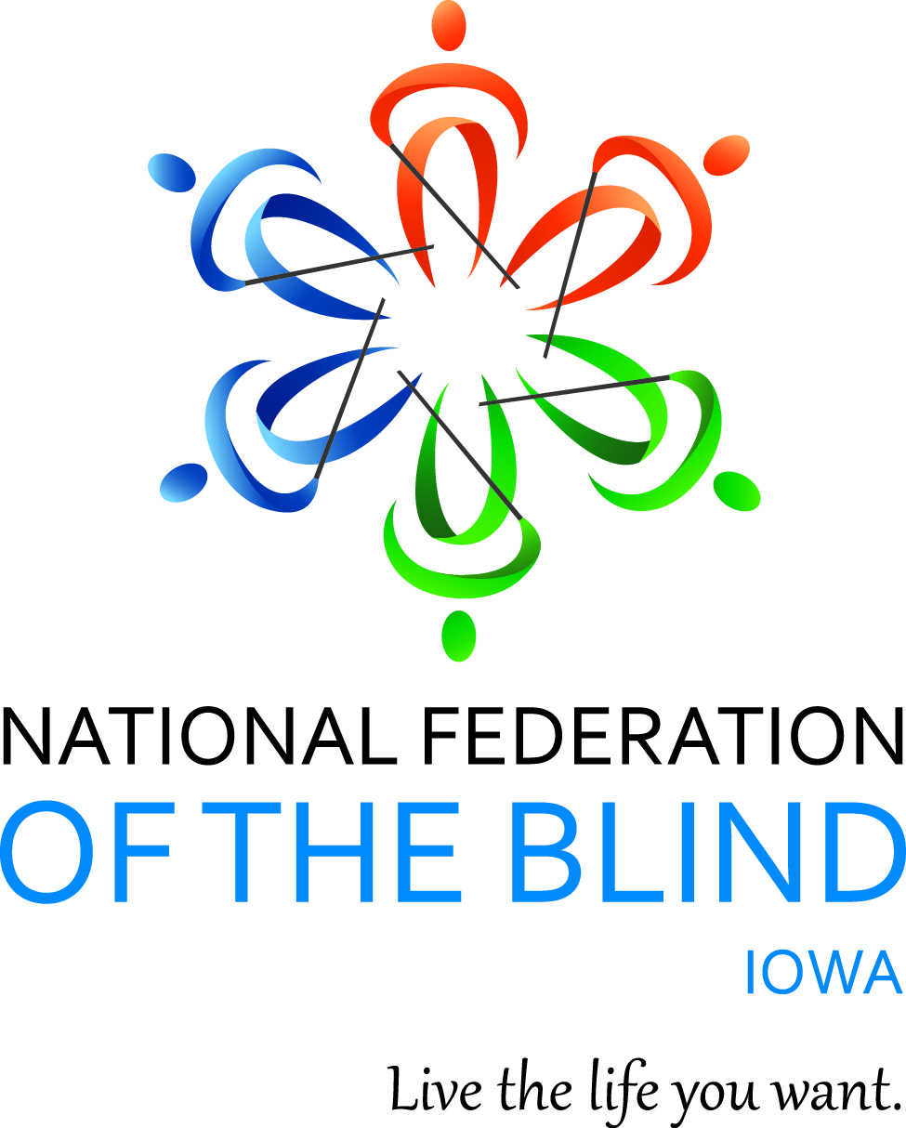

NATIONAL FEDERATION OF THE BLIND OF IOWA

100th ANNUAL STATE CONVENTION

The Next 100 – Connected by Purpose, Driven by Progress

October 9–October 11, 2026

Holiday Inn & Kinnick Conference Center

1220 1st Avenue

Coralville, IA 52241

Helen Mejia, President
E-Mail: hmejia@nfbi.org
Cell: (570) 983-7867
Website: www.nfbi.org

If you have questions or need assistance during the convention, contact Elizabeth Rouse at (563) 210-1854.

Sponsors & Exhibitors

Thank you to all the sponsors who contributed toward the costs of this year’s convention making it more affordable for blind Iowans to attend.

Silver Sponsor
Iowa Lions Foundation

Bronze Sponsor
Nicolet Bank

White Cane Sponsors
Democracy Live
En-Vision America
Greater Iowa Credit Union
Iable
JW.ORG
Leader Dogs for the Blind
NanoPac, Inc.
Vanda Pharmaceuticals/Non-24

2025-2026 BOARD OF DIRECTORS

Helen Mejia, President, Des Moines
Cindy Ray, First Vice President, Urbandale
Scott Van Gorp, Second Vice President, West Des Moines
Richard Webb, Secretary, Burlington
David Hammel, Treasurer, Urbandale
Becky Young, Board Member, Urbandale
Elizabeth Rouse, Board Member, Durant
Karen Clayton, Board Member, Sioux City
Shawn Mayo, Board Member, Des Moines

Committee Chairs

Karen Clayton: Audit
Elizabeth Rouse: Convention Planning
Becky Young & Donna Prime: Door Prize
____: Fundraising
Roger Erpelding: Legislative
Scott Van Gorp: Membership
Shawn Mayo: Nominating
Elizabeth Rouse: Resolutions
Emily Wharton: Scholarship
____: Youth Activities

Use the hashtag: #NFBIA2026
Like us on Facebook: National Federation of the Blind of Iowa
Follow us on X: @NFB_Iowa
Sign up for the Tall-Corn mailing list to get our latest information at nfbnet.org

AGENDA

Friday, October 9, 2026

10:00 A.M.–3:15 P.M. & 4:00 P.M.–4:45 P.M. In-Person Registration & Online Registration Packet Pickup – Hall of Fame
10:00 A.M.–4:45 P.M. Exhibit Hall – Hall of Fame
10:30 A.M. –12:00 P.M. Seniors Seminar – Cindy Ray, Coordinator, NFBI Blind Seniors Group, Hospitality Suite 208
1:00 P.M. –3:00 P.M. Parents of Blind Children Seminar – Molly Hefflefinger & Monica Rouse, Hospitality Suite 234
1:30 P.M.–3:30 P.M. At Large Chapter Meeting – Cindy Ray, President, Hospitality Suite 208
3:30 P.M.–4:00 P.M. Resolutions Committee Meeting (open to all) – Elizabeth Rouse, Chair, Resolutions Committee, Hospitality Suite 234

Friday General Session – Kinnick C/D

5:00 P.M. Call to Order – Helen Mejia, President, NFBI
Pledge of Allegiance
National Federation of the Blind Pledge
Housekeeping Items – Elizabeth Rouse, Chair, Convention Planning Committee
Welcoming Remarks from Our National Representative – Jim Marks, Board Member, NFB & President, NFBMT
5:20 P.M. Membership Matters Most (panel) – Scott Van Gorp, Chair, Membership Committee
5:50 P.M. Meet the 2026 NFBI Scholarship Winner – Emily Wharton, Chair, Scholarship Committee
6:00 P.M. Telling Our Story: NFBI Kernel Book Project – Barbara Hammel, Urbandale
6:15 P.M. Break & Transition to Kinnick Center
6:30 P.M. Invocation – Terri Wilcox, Des Moines
6:35 P.M. Presidential Report – Helen Mejia, President, NFBI
7:00 P.M. What Would You Like NFBI to Do? (discussion) – Enrique Mejia, Des Moines
7:20 P.M. Accessible Tabletop Gaming – Emily Wharton, Des Moines & Scott Stevens, Cedar Rapids
8:00 P.M. Adjourn
8:30 P.M. – 11:00 P.M. Hospitality – Kinnick Center
Join us for a fun-filled night of connection as we meet with old and new friends from across the state. Cash bar available, brought to you by the Old Capitol Chapter.

Saturday, October 10, 2026

7:30 A.M.–8:45 A.M. Final Opportunity for In-Person Registration & Online Registration Packet Pickup – Hall of Fame
7:30 A.M–8:45 A.M. Exhibit Hall – Hall of Fame

8:00 A.M. Breakfast – Kinnick Center

Saturday Morning General Session – Kinnick C/D

9:00 A.M. Call to Order – Helen Mejia, President, NFBI
9:05 A.M. The National Convention Experience – Bitrus Gwamna, Inaugural Winner, Nyla Wisecup Convention Scholarship
9:20 A.M. Why My Friend Got Better Tech Than I Did – Enrique Mejia, Des Moines
9:45 A.M. Expanding My Comfort Zone – Karly Prinds, Des Moines
10:10 A.M. National Report – Jim Marks, Board Member, NFB & President, NFBMT
11:00 A.M. Updates from the Iowa Department for the Blind (IDB) & Iowa Library for the Blind and Print Disabled – Sarah Willeford, Interim Director, IDB & Director, Iowa Library for the Blind & Print Disabled
12:00 P.M. Adjourn
12:00 P.M.–1:45 P.M. Final Opportunity for Exhibit Hall – Hall of Fame
12:30 P.M.–1:45 P.M. Lunch – Kinnick Center
Keynote Presentation: Blind Entrepreneurship: Innovation in the Iowa Business Enterprises Program – Matt Nemmers, Executive Officer, IDB Business Enterprises Program

Saturday Afternoon General Session – Kinnick C/D
2:00 P.M. Call to Order – Helen Mejia, President, NFBI
2:05 P.M. What is the IDB Education & Training Team? – April Stots, IDB Education & Training Director
2:35 P.M. Meet the New Orientation Center Director – Brianna Murray, Director, IDB Orientation Center
3:05 P.M. Legislative Report – Roger Erpelding, Chair, Legislative Committee & Cindy Ray, Urbandale
3:35 P.M. The 2026 Washington Seminar – Jonathan Ice, Cedar Rapids
3:50 P.M. Traveling to New Places for Work – Felicia Burns, Des Moines
4:05 P.M. Becoming a Writer – Emily Wharton, Des Moines
4:30 P.M. Living the Life I Want: My Journey in Acquiring Nonvisual Skills – Elizabeth Rouse, Board Member, NFBI
5:00 P.M. Adjourn
5:15 P.M. Student Meet-Up – Kinnick C/D

7:00 P.M. Annual Banquet – Kinnick Center
Master of Ceremonies – Enrique Mejia, Des Moines
Invocation – Cindy Ray, First Vice President, NFBI
Banquet Address – Jim Marks, Board Member, NFB & President, NFBMT
Preauthorized Contribution (PAC) Plan – Elizabeth Rouse, Coordinator, NFBI PAC Program
Awards & Drawings

Sunday, October 11, 2026

Affiliate Board Meeting & Business Session – Kinnick C/D
9:00 A.M. Board Meeting
Call to Order & Determination of Quorum
Secretary’s Report
Treasurer’s Report
Old/New Business
Adjourn
9:15 A.M. Business Session
Remembering the Ones We’ve Lost – Cindy Ray, First Vice President, NFBI
2025 Meeting Minutes – Richard Webb, Secretary, NFBI
Treasurer’s Report – David Hammel, Treasurer, NFBI
Audit Committee Report – Karen Clayton, Chair, Audit Committee
Resolutions Committee Report – Elizabeth Rouse, Chair, Resolutions Committee
Friends of the Library Report – Cindy Ray, President
Chapter & Group Reports
At Large Chapter – Cindy Ray, President
Des Moines Chapter – Becky Young, President
Old Capitol Chapter – Darrel Kirby, President
Siouxland Chapter – Karen Clayton, Treasurer
Southeast Iowa Chapter – Richard Webb, President
Blind Parents Group – Terri Wilcox, Coordinator
Blind Seniors Group – Cindy Ray, Coordinator
Blind Students Group – Enrique Mejia, Coordinator
NFB Newsline Report – Scott Van Gorp, Coordinator
Nominating Committee Report – Shawn Mayo, Chair, Nominating Committee
Election of Officers & Board Members
Election of Delegate & Alternate Delegate to the 2027 National Convention
Old Business
New Business
Final Remarks
Jim Marks, Board Member, NFB & President, NFBMT
Helen Mejia, President, NFBI
12:00 P.M. Adjourn

Convention Notes:

Be sure to visit our sponsors and exhibitors and thank them for supporting the National Federation of the Blind of Iowa! Stop by registration first to grab your exhibitor sheet, then visit them all for a chance to win a cash prize!
Need a dog relief area? When facing the elevators, use the exit door to your right. Head straight outside a short distance, and you’ll find the relief area. Please remember to clean up after your dog and help keep the area clean for everyone!
Exciting door prizes will be drawn throughout general sessions, the banquet, and the business session! If you haven’t sent your door prize ahead of time, please bring it to convention and give it to one of our Door Prize Committee Chairs, Becky Young or Donna Prime.
Got a sweet tooth? You’re in for a treat! Our Baked Goods Auction will be sprinkled throughout the sessions, so be sure to bring your appetite—and your bidding game! If you’re planning to bring a baked good, please let Elizabeth Rouse know. It’s sure to be a deliciously good time!

Sponsor Ad:

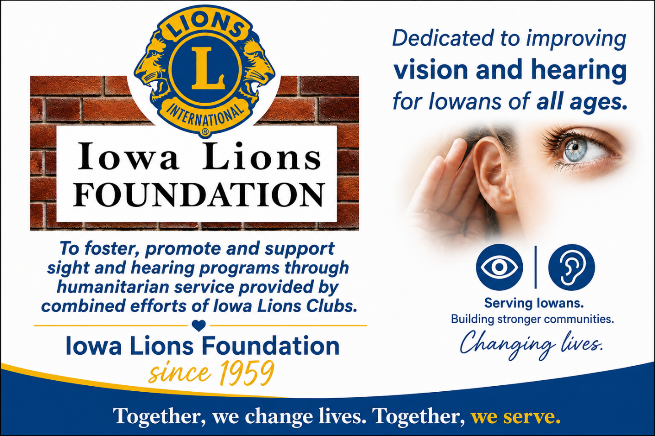

Inclusivity, Diversity, & Code of Conduct
Thank you for cultivating an atmosphere of mutual respect where attendees can learn, network, and share with each other. The National Federation of the Blind of Iowa is committed to diversity, equity, and the free expression of ideas as outlined in our Code of Conduct. We recognize a shared responsibility to create and uphold that atmosphere.
Prohibited behaviors, such as harassment, retaliation, and sexual misconduct, will not be tolerated and may result in removal from the convention and/or other consequences. To report an incident at the convention, please contact President Helen Mejia at (570) 983-7867.
The full Code of Conduct and resources are at nfb.org/codeofconduct.

Dream Makers Circle
You can help build a future of opportunity for the blind by becoming a member of our Dream Makers Circle (DMC.) It is easier than you think. You can visit your bank and convert an account to a payable on death (P.O.D.) bank account, which is payable after your passing to the National Federation of the Blind or one of our affiliates. Your legacy gift to the National Federation of the Blind or the National Federation of the Blind of Iowa can be made in the form of a will or living trust, an income generating gift, or by naming us as the beneficiary of a retirement plan, IRA, pension, or a life insurance policy. You can designate a specific amount, a percentage, or list the NFB as one of several beneficiaries. For additional information, please contact Patti Chang at (410) 659-9314, extension 2422 or at pchang@nfb.org.

Vehicle Donations
The National Federation of the Blind uses car donations to improve the education of blind children, distribute free white canes, help veterans, and so much more. We have partnered with Vehicles for Charity to process donated vehicles. Please call toll-free (855) 659-9314, and a representative can make arrangements, or you can donate online by visiting https://nfb.org/vehicledonations.

Preauthorized Contributions
Can you help the National Federation of the Blind on a regular basis? Please consider joining our preauthorized contribution (PAC) plan. Starting at $5 monthly, you can help us turn dreams into reality and raise expectations. Call (877) 632-2722, visit: https://nfb.org/pac to fill out the online form, or email pac@nfb.org for additional information.

Mission of the National Federation of the Blind of Iowa
The National Federation of the Blind of Iowa advances the lives of its members and all blind people in the United States. We know that blindness is not the characteristic that defines you or your future. Every day we raise the expectations of blind people, because low expectations create obstacles between blind people and our dreams. Our collective power, determination, and diversity achieve the aspirations of all blind people.

The National Federation of the Blind Pledge
I pledge to participate actively in the efforts of The National Federation of the Blind to achieve equality, opportunity, and security for the blind; to support the policies and programs of the federation; and to abide by its constitution.

