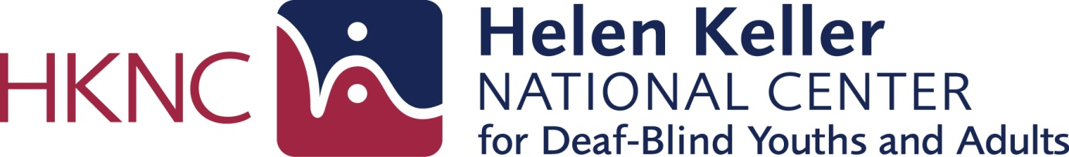

POSITION ANNOUNCEMENT

The mission of the Helen Keller National Center for Deaf-Blind Youths and Adults is to enable each person who is deaf-blind to live and work in his or her community of choice. The Helen Keller National Center is the ONLY center in the United States that provides vocational training exclusively to youth and adults who are deaf-blind. Employment at HKNC is a "one-of-a-kind" experience and at HKNC, we seek employees who have a strong work ethic, strive for excellence, enjoy a challenge, and are highly motivated and creative.

We currently have an exciting career opportunity available to join the Technology Department as a Full Time Senior Instructor in our Sands Point, NY location.

The Senior Instructor evaluates consumer’s ability to use adaptive technology and computer skills. Adaptive technology includes hardware and software such as: refreshable braille displays, braille notetakers, screen magnification, related software applications and telecommunications equipment. The Senior Instructor is responsible to plan lessons and provide skills training in content areas of Adaptive Technology curriculum based on the findings of the evaluation and as determined by consumer’s personal needs and preferences, employing appropriate techniques, materials and communication preferences.

Master’s degree in Deaf Education. Special Education, Education of the Blind/Visually impaired, Rehabilitation of the Blind/Visually impaired, computer science or related field required. Sign Language skills preferred – must become proficient within 2 years of employment.

Hours & Compensation:

- FT work schedule Monday – Friday (35 hours/week).
- Competitive salary
- Paid vacation, personal and sick time.
- 100% company paid benefits (no employee contribution) including tuition reimbursement.

Availability: Immediately

UNION There is a collective bargaining agreement in effect between the Helen Keller National Center and Local 1199 Hospital and Health Care Employees Union. Employment in this position is conditional upon joining and maintaining membership in the union.

To apply please send your resume and cover letter, including salary requirements, to:

Via Email: hkncrecruitment@hknc.org

Via Fax: (516) 767-2302

Via Mail: Helen Keller National Center
141 Middle Neck Road
Sands Point, NY 11050
Attn: Human Resources Department
Job Code: Sr. Instructor, ADAPTIVE TECH

Interviews are by appointment only. Only those candidates qualified for current open positions will be contacted for an interview.

The Helen Keller National Center is an Equal Opportunity Employer (EOE). Persons with disabilities needing assistance in the application process should contact (516) 944-8637 (Voice/TTY) or Fax (516) 767-2302.

