Save the DatE!
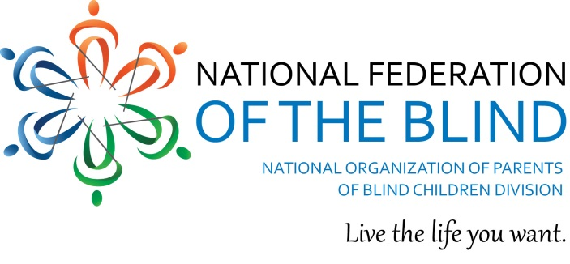
The Texas Association of Blind Students
In conjunction with
The Texas Parents of Blind Children
Would like to invite you to the 2015 NFB Texas Youth Conference
DRIVE: Dream the Real Independent Vision for Excellence!
Sponsored by: NFB Newsline for Texas ®
When: Friday April 10 –Saturday April 11, 2015
Where: Holiday Inn Midtown, 6000 Middle Fiskville RD Austin TX 78752
(512) 451-5757
Room rates are $89.00 per night plus 15% tax. Mention NFBT Youth Conference when making your reservations to get the group rate. Make your reservations now!
Who: Parents of blind children, blind students, and related professionals will come together this exciting weekend to network, learn, and have lots of fun!
The conference registration fee is $50 and will be payable at registration on-site by check, cash, or credit card. This conference fee includes:
- Admission to the TABS and/or TPOBC network that is advocating for those who are blind to live the life they want
- Entry to the conference door prize drawing
- All conference meals including the NFBT Youth Conference formal banquet
- Admission to our exhibit hall where you will be able to have hands-on access to the latest assistive technology and other related products of interest
Registration is now available at: https://www.nfbtx.org
Exhibitors/Sponsors are Welcome!
Exhibitors/sponsors will have the opportunity to display their products throughout the weekend to a diverse group of potential customers/clients. If you are interested in participating as an exhibitor/sponsor, please contact our office, (512) 323-5444, for more information.
FINANCIAL ASSISTANCE
Limited financial assistance may be available to qualifying individuals, for more information, please contact Amy Brown, abrown@nfbtx.org, (512) 323-5444, or Gabe Cazares, gcazares@nfbtx.org, (281) 965-9583.
Parents, students, and related professionals you won’t want to miss this weekend of fun, information, and networking! If you have any questions about the seminar please contact Gabe Cazares, gcazares@nfbtx.org, or Kim Cunningham, kim@tpobc.org

