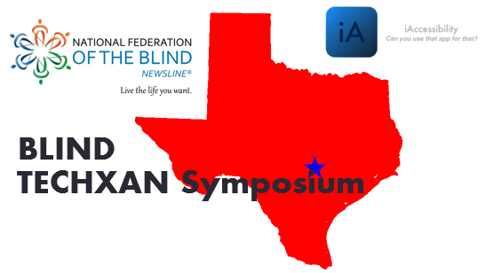

iAccessibility and NFB-Newsline
Saturday, August 22, 2015
Location: TSBVI Cafeteria
(1100 W. 45th St, Austin, Texas)
Noon - 4:00 pm

Come Join Us To Explore NewsLine and the Technology Possibilities……

iAccessibility Featuring
- VoiceOver Training
- App Accessibility
- App Development

iAccessibility Contact: mikedoise@icloud.com

NFB Featuring
- KNFBReader
- NFB-Newsline
- NFB Connect

NFB Contact: jlineback@nfbtx.org

Don't miss the opportunity to LEARN and NETWORK.
Many Giveaways and Refreshments will be served.

