Save the DatE!
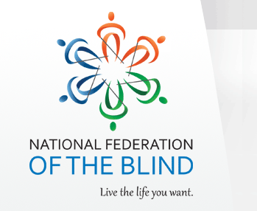

The Texas Association of Blind Students
In conjunction with
The Texas Parents of Blind Children
Would like to invite you to the annual NFB Texas Youth Conference!
When: Friday April 08 –Sunday April 10, 2016
Where: Best Western Dallas, 8051 Lyndon B Johnson Fwy Dallas, TX 75251
(972) 680-3000
Room rates are $90.00 per night plus 15% tax. There are also 2 bedroom suites available for $120.00 per night. Mention NFBT Youth Conference when making your reservations to get the group rate. Make your reservations now!
Who: Parents of blind children, blind students, and related professionals will come together during this exciting weekend to network, learn, and have lots of fun!
The conference registration fee is $50 and can be paid online or on-site by check, cash, or credit card. This conference fee includes:
- Admission to the TABS and/or TPOBC network that is advocating for those who are blind to live the life they want
- Entry to the conference door prize drawing
- All conference meals including the NFBT Youth Conference formal luncheon
- Admission to our exhibit hall where you will be able to have hands-on access to the latest assistive technology and other related products of interest
Registration is now available at: http://www.nfbtx.org
Exhibitors/Sponsors are Welcome!
Exhibitors/sponsors will have the opportunity to display their products throughout the weekend to a diverse group of potential customers/clients. If you are interested in participating as an exhibitor/sponsor, please fill out the form at http://goo.gl/forms/nOxOfM8gMW
FINANCIAL ASSISTANCE
Limited financial assistance may be available to qualifying individuals, for more information, please contact Norma Crosby, ncrosby@nfbtx.org, (281) 968-7733, or Bre Brown, bbrown@nfbtx.org (304) 203-3832.
Parents, students, and related professionals you won’t want to miss this weekend of fun, information, and networking! If you have any questions about the seminar please contact Bre Brown, bbrown@nfbtx.org, or Kim Cunningham, kim@tpobc.org

