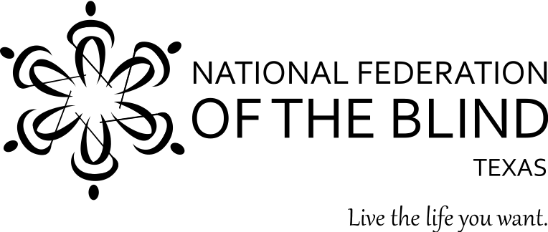

YOU’RE INVITED!!!

WHAT: National Federation of the Blind Meet-and-Greet
WHEN: May 8, 2018 from 3-5 PM
WHERE: Gateway Community Health Center
La Union Conference Hall, third floor
1515 Pappas St.
Laredo, TX 78041

Are you a blind or low vision Laredo area resident interested in learning more about the National Federation of the Blind? Members of the NFB of Texas will be available to answer your questions at the Gateway Community Health Center. Stop by to network, meet new friends, and to learn more.
The NFB, the oldest and largest nationwide organization of blind Americans, defends the rights of blind people of all ages and provides information and support to families with blind children, older Americans who are losing vision, and more. We believe in the hopes and dreams of blind people and work together to transform them into reality. Visit www.nfbtx.org for information about our programs and initiatives.
Please RSVP by May 3, 2018.

To RSVP, or for more information, contact:
Norma Crosby, National Federation of the Blind of Texas President (English)
ncrosby@nfbtx.org
(281)-968-7733

Roberto Delgado (Spanish)
Roberto_delgado1952@yahoo.com
(956) 568-1606

