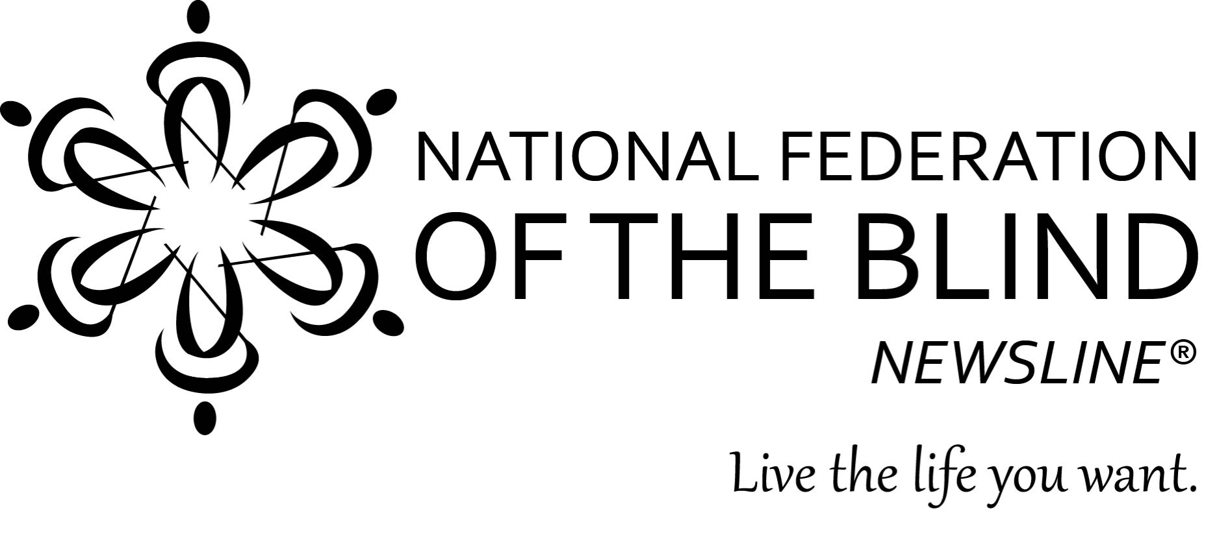
YOU’RE INVITED!!!

WHAT: NFB-NEWSLINE® OPEN HOUSE
WHEN: May 18, 2018 from 1-3 PM
WHERE: National Federation of the Blind of Texas
1600 E Highway 6, Suite 215
Alvin, TX 77511

NOTE: Enter the First National Bank building and take the elevators on the right to the second floor.

Join members of the National Federation of the Blind of Texas as we introduce blind and print disabled South Houston area residents to our audio newspaper service. You don’t need to be a technology whiz to enjoy access to over 400 publications, including: the Houston Chronicle, Corpus Christi Caller Times, San Antonio Express-News , and a dozen more Texas newspapers and magazines. Come learn how you can subscribe to and enjoy this free service. We’ll sign you up on-site, and everyone who subscribes during this event will have a chance to win a $100 cash prize.

Please RSVP by May 14, 2018.

To RSVP, or for more information about the event contact:
Liz Wisecarver, NFB-NEWSLINE® Texas Coordinator
lwisecarver@nfbtx.org
(346) 704-0145

