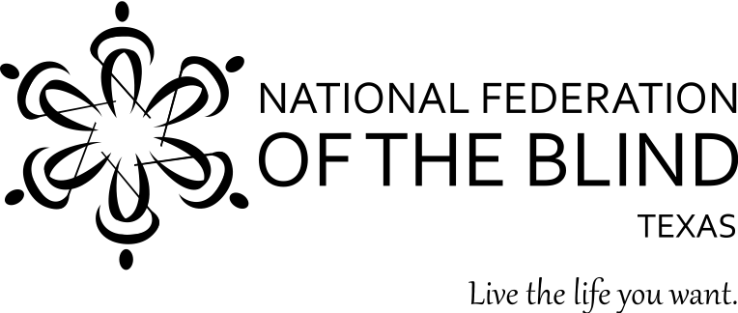

YOU’RE INVITED!!!

WHAT: National Federation of the Blind Meet-and-Greet
WHEN: May 18, 2018 from 3-5 PM
WHERE: National Federation of the Blind of Texas
1600 E Highway 6, Suite 215
Alvin, TX 77511

NOTE: Enter the First National Bank building and take the elevators on the right to the second floor.

Are you a blind or low vision South Houston area resident interested in learning more about the National Federation of the Blind? Members of the NFB of Texas will be available to answer your questions at the National Federation of the Blind of Texas office. Stop by to network, meet new friends, and to learn more.
The NFB, the oldest and largest nationwide organization of blind Americans, defends the rights of blind people of all ages and provides information and support to families with blind children, older Americans who are losing vision, and more. We believe in the hopes and dreams of blind people and work together to transform them into reality. Visit www.nfbtx.org for information about our programs and initiatives.

Please RSVP by May 14, 2018.

To RSVP, or for more information, contact:
Norma Crosby, National Federation of the Blind of Texas President
ncrosby@nfbtx.org
(281)-968-7733

