Virginia Rehabilitation Center for the Blind and Vision Impaired

Annual Friends and Family Day

DEMYSTIFYING INDEPENDENCE

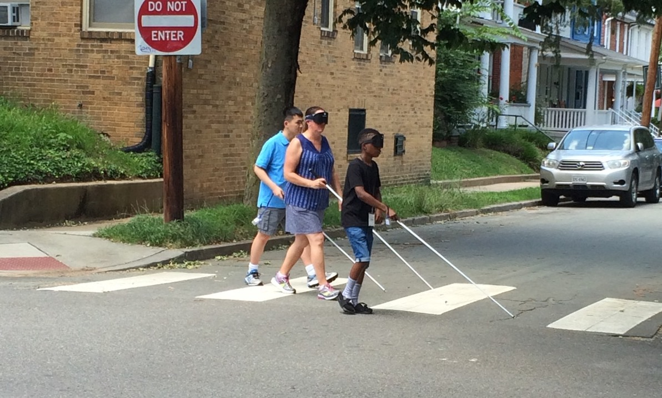
Stepping toward independence!
(Picture description - two blind students and instructor using canes to cross a street)
(Picture caption – Stepping toward independence!)

Open to anyone who is blind or vision impaired, or anyone who wants to learn how to help a family member or friend who is blind or experiencing vision loss.

When: Saturday, October 21, 2017
9:00 AM -- 4:00 PM

Where: Virginia Rehabilitation Center for the Blind and Vision Impaired
401 Azalea Avenue, Richmond, VA 23227

Have you ever wondered:
- what techniques a blind person uses to cross streets independently and safely?
- how to grocery shop as a blind person?
- how to manage medications as a person who is blind?
- how a blind family member would participate in a game night?
- what jobs blind people are doing?
- what developments in entertainment technology are accessible to family members who are blind?
- what chores parents should expect their blind children to complete at home?
- what peer support groups are out there, and how families can benefit from becoming active in one?
- what resources are available to someone who is blind or vision impaired?

Whether you have been blind or vision impaired for many years or have only recently been diagnosed as legally blind, whether you have a family member who is blind or vision impaired, whether you have participated in the VRCBVI training program or not, the 2017 VRCBVI Friends and Family Day has something for you! Come and meet successful blind people who are engaged in their communities and work. It will be an exciting time to focus on what you can do rather than what you can’t see.

This activity is free to participants. Lunch will be available.

Visit our website at vrcbvi.org, and a finalized agenda will be posted by October 1, 2017.

RSVP by Tuesday, October 17, 2017, by calling (804) 371-3151 to let us know that you plan to attend and how many people will be in your party.

This year's event is going to be the most exciting and informative one yet!

Come prepared to have fun, meet new friends, catch up with friends you haven’t seen in a while, learn a lot, and get involved in activities you love to do!

