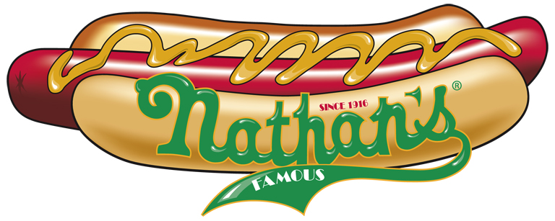

Blind Merchant’s Marketing Kit Request Form

Location: ___________________________________________________

Address: _______________________________________________________________

City: ___________________________State: ______ Zip Code: ________________

Contact: __________________________________________

Phone: ________________________

Email: ______________________________________________

Food Service Distributor: ___________________________________________

Food Service Distributor Contact: ____________________________________

Food Service Distributor Contact Phone: _____________________________

Food Service Distributor Contact Email: ________________________________

Current Hot Dog Product and Size: ____________________________________

Current Hot Dog Usage (estimated cases per week): ____________________

In connection with Buyer’s use of the Marketing Materials provided free of charge, the Buyer agrees that Buyer shall use only those specific materials designated and authorized by Nathan’s. Buyer shall use the Marketing Materials only in conjunction with the offer and sale of Nathan’s products.

Please Fax this form to 205-822-9653 and we will order your marketing materials that will be shipped UPS.

