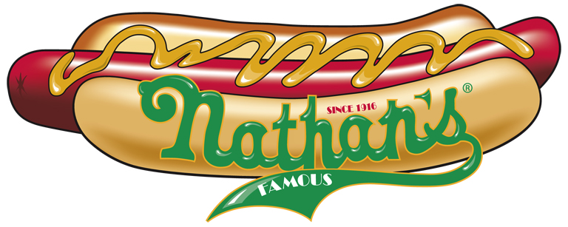
NEW PRODUCTS – NEW PRICES- NEW MARKETING MATERIALS

Last September many of you were introduced to Nathan’s Famous Hot Dogs. Today, Nathan’s is proud to offer all blind vendors a program created especially for Randolph Sheppard. Through this program, you are now able to offer your customers Nathan’s Premium Beef Hot Dogs as well as promote the product through the use of high quality, professional marketing materials. Nathan’s is known worldwide for its quality and taste. Serving Nathan’s will help you build your business through customer satisfaction and return business.

The program established for the Randolph Sheppard is as follows:

- Nathan’s Famous Beef Hot Dog Products will be delivered to your distributor at $2.35 per lb. (Specialty Dogs will cost $2.45 per lb.)
- You will receive two (2) free cases of Nathan’s Hot Dogs as a Start-up Incentive for each location you are operating. (You will only receive these free cases after you place your first order of at least 2 cases.)
- We will supply you with High Impact Marketing materials furnished at no charge.

In this package, you will find the following:

- A list of all the Nathan’s Products. (Please note, all items are not immediately available at your distributor.) You can contact us at the below emails or phones for specific products you may need to bring into your distributor.
- Order form for your Marketing Kit
- Marketing kit information
- Nathan’s Trademark Agreement

To get the program started, simply fill out the attached Marketing Kit Request form as well as the attached Trademark Agreement and fax it to 205 822 9653. Once received, we will send you a marketing kit, as well as an operational training guide. Upon receipt of the marketing kit, you can order Nathan’s Hot dogs through your distributor and begin selling the worlds greatest hot dogs.

As an incentive for you to begin using Nathan’s in your facility, Nathan’s will credit your account with 2 cases of hot dogs after your initial order for at least 2 cases of hot dogs is received. It is our way of thanking you for your business as well as giving you the opportunity to sample our product to your customers.

We are here to help you successfully introduce Nathan’s Famous to your customers. If you have any questions whatsoever, you can contact us at the following:

Jeff Kaufman Tom Reid
205 266 7083 206 734 5596
jvkaufman@bellsouth.net tomreidmp@gmail.com

Please send us your Marketing Request form right away and we will get you started.

