

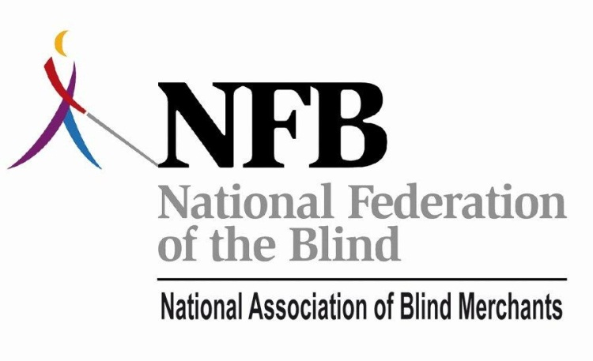

The Curriculum, Trade Show, and Networking at BLAST+ 2011 Is Shaping Up To Be Extraordinary, Wide-Ranging, Compelling, Instructive, Dynamic and Fun!!! Please Register for the Conference NOW!!! Please Make Your Hotel Reservations NOW!!!

Greetings Colleagues and Friends,

As many of you know, Business Leadership and Superior Training has become the principal annual conference for Blind Vendors and State Licensing Agency management and staff over the past decade. Each year we have expanded curriculum, added networking opportunities, team building exercises and top notch tours and entertainment. In 2011, by popular demand, we are moving this dynamic Business Leadership and Superior Training, BLAST+ conference to the fall. Join us for education, motivation and the largest Trade Show for blind entrepreneurs and those with whom they work.

This year BLAST+ (re-branded to include new programming) adjusts its focus to deal with the reality of a changing Randolph-Sheppard and a changing business climate for the blind and those professionals with whom we work. Wednesday and much of Thursday we will offer additional instruction and motivational presentations for those working to build business opportunities in addition to, or independent of Randolph-Sheppard. We are finalizing plans for eBay training and other opportunities to investigate internet based businesses.

Former New York Governor David Patterson will share his experience. As the first blind Governor in the nation, he has much to say about the bureaucracy, business, and blindness. We will hear from Dave Ramsey as well as Chris LoCurto from Dave’s team of wealth building experts. Many will recognize Dave Ramsey’s name from his bestselling book *The Total Money Makeover*. He is heard by millions on hundreds of radio stations. We will also hear from Eric Alexander. Mr. Alexander accompanied Eric Weihenmayer to the top of Mount Everest. (Mr. Weihenmayer was the first blind person to summit Everest.) Eric Alexander has inspired thousands with his stories of extreme outdoor, “daring do.” He is in high demand by Fortune 1000 companies. Eric teaches and truly does inspire leadership through teamwork…plus MUCH, MUCH more.

Plan To Attend: **Training at the conference will begin at 11 a.m. on Wednesday morning September 21st and conclude at 11 a.m. on Saturday, September 24th. We are in the process of finalizing the agenda and complete details will be available by August 15th.** Rooms can be booked now. Simply call the Nashville Airport Marriott (615-889-9300), tell them that you are booking for the National Association of Blind Merchants, BLAST+ conference. Rooms are available at the low rate of $114.00 per night plus applicable taxes. These rates are effective from Monday, September 19th through Saturday, September 24th, 2011. **Hotel rooms are selling quickly. If rooms are sold out at the Airport Marriott we have reserved a room block at the Courtyard Marriott which is less than a mile away. We will be providing transportation to and from the overflow hotel during the conference.** Music city is beautiful in the fall and as always, space is at a premium. BLAST+ registration inclusive of all activities and training materials will cost $200.00 with a $50.00 discount for early registrations made prior to August 15th, 2011. Registration fee may exclude some tours and events held outside of the hotel conference center.

**Visit** [**www.blindmerchants.org**](http://www.blindmerchants.org) **To Register for BLAST+ Online.**

To share your ideas or for more information please feel free to contact me at (1-866)543-6808 or via email at [kevanworley@blindmerchants.org](mailto:kevanworley@blindmerchants.org).

We look forward to seeing you!



Kevan Worley

Executive Director

National Association of Blind Merchants