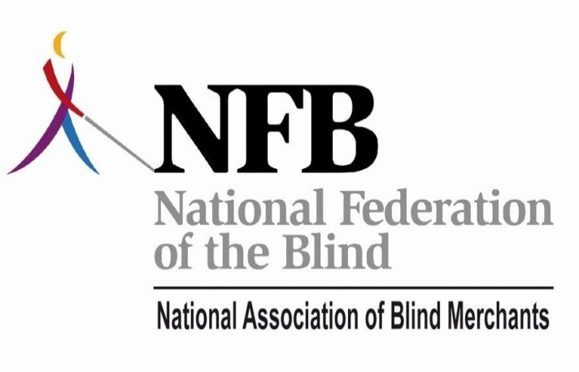

The National Association of
Blind Merchants
(A Division of the National Federation of the Blind)
&
Tennessee Business Enterprises
Presents
National Training Conference for Merchant Vendors, Program Staff, Corporate Partners, and All Blind and Vision Impaired People Interested in Entrepreneurial Ventures
September 21-24, 2011
Nashville Airport Marriott - Nashville, Tennessee
Welcome to BLAST+ 2011

The Business Leadership and Superior Training (BLAST) conference was first launched in March of 2002 in Las Vegas, Nevada. The goal of BLAST has been to take training for blind vendors and State Agency personnel to a whole new level. This is accomplished by offering highest quality consumer driven training, motivation, and networking opportunities.

Thank you for joining us as we continue to raise standards and expectations to a whole new level!

NOTE: Upon registration at the BLAST+ conference you should have been given a BLAST+ name badge. This badge must be worn at all conference activities. The name badge serves as your prepaid ticket to the trade show and the luncheon and all seminars, receptions, and breakfasts.

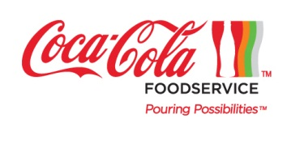

Thank you to our generous sponsors who provided support for this year’s event. The U.S. economy still poses challenges for our industry and your businesses, so your financial support is even more appreciated.
Diamond Title Sponsor
BLAST+ Conference Co-Sponsors
Tennessee Business Enterprises
NFB Jernigan Institute

Titanium Investors
Blackstone Consulting Inc.
Pepsi

Platinum Partners
Otis Spunkmeyer
Brown Goldstein & Levy
Nayyarsons Food Corp.

Gold Leadership Contributors
U-Select-It Vistar PGF
Sodexo

Silver Superior Training Sponsors
BrakeBush Brothers University of New Orleans- ExcEl
Nestle Business Leadership Network
Johnson Food Service 365 Retail Markets
Quiznos John Jones Inc.
.

Host Sponsors
The Vending Center, Inc. World ATM
LaBarre Law Offices
Thank You
The National Association of Blind Merchants Extends Heartfelt
Gratitude to the Coca-Cola Company
Coca-Cola has shown generous support to the NABM, which in turn benefits our entire industry. The NABM is a not-for-profit association and all funding sources are reinvested into education and promotion of the industry. Please say ‘Thank You’ to the Coca-Cola Company for their commitment to Randolph-Sheppard, to our association, and to you.

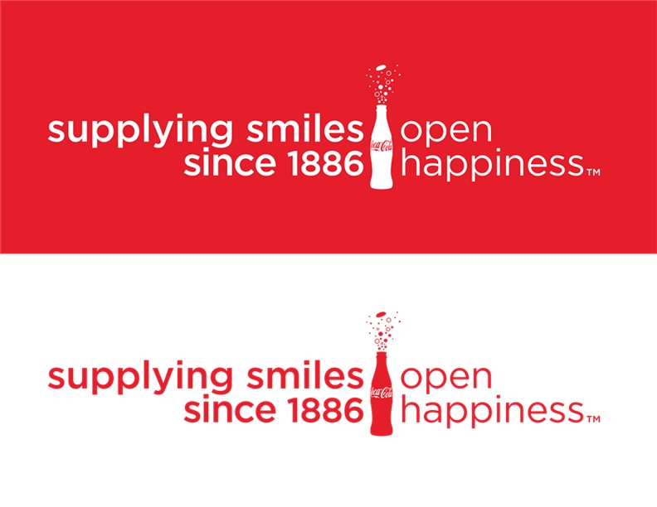

BLAST+ Conference Co-Sponsor:
Tennessee Business Enterprises Program
The National Association of Blind Merchants would like to take this opportunity to offer a very special thank you to our Tennessee hosts.
Tennessee Business Enterprises is a unique public/private partnership that enables independent business people to work in concert with the State of Tennessee to provide vending and other food services to customers across the Volunteer State. These business people just happen to be legally blind. The mission of TBE is to provide entrepreneurial opportunities for legally blind citizens in the state of Tennessee who have been trained and licensed to manage food service and vending facilities. TBE is nationally recognized for its leadership and spirit of innovation. TBE- A program that works!

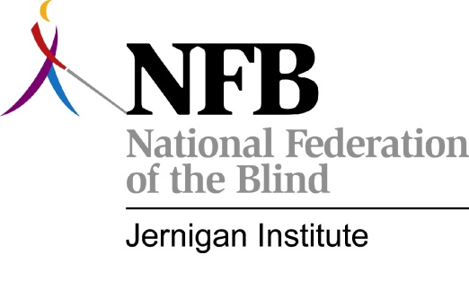

BLAST+ Conference Co-Sponsor
NFB Jernigan Institute
The National Federation of the Blind Jernigan Institute leads the quest to understand the real problems of blindness and to develop innovative education to help the world’s blind achieve independence. A central concern of the Institute is increasing employment opportunities for the blind. This collaboration with National Association of Blind Merchants and other partners will improve the prospects for many blind people who want to be self-employed.

Tuesday, September 20th

4:00 p.m. – 6:00 p.m. Registration
Capitol Foyer
If you have not pre-registered, please register! If you have pre-registered, please stop at the registration desk to pick up your name badge and other BLAST+ materials. Remember that your name badge must be worn during all BLAST+ conference activities. You may also purchase tickets to the Wednesday noon Entrepreneurs Luncheon for $30.00 at this time. Tickets for the 7:00 p.m. September 23 show at the Grand Ole Opry are available for purchase at the registration desk as well. Tickets to the Grand Ole Opry cost $55.00 a person and include round trip transportation.
(Your name badge serves as your prepaid ticket which shows that you have registered.)

Wednesday, September 21st

8:00 a.m. – 8:00 p.m. Registration
Capitol Foyer
If you have not pre-registered, please register ! If you have pre-registered, please stop at the registration desk to pick up your name badge and other BLAST+ materials. Remember that your name badge must be worn during all BLAST+ conference activities. You may also purchase tickets to the Wednesday noon Entrepreneurs Luncheon for $30.00 at this time. Tickets for the 7:00 p.m. September 23 show at the Grand Ole Opry are available for purchase at the registration desk as well. Tickets to the Grand Ole Opry cost $55.00 a person and include round trip transportation.
(Your name badge serves as your prepaid ticket which shows that you have registered.)

Wednesday, September 21st Continued
10:00 a.m. - 12:00 p.m. Meet with a S.C.O.R.E Volunteer
Hospitality Suite
Description: The Sevice Core Of Retired Executives, SCORE, is a not-for-profit organization dedicated to the education and counseling of entrepreneurs who are growing, solving challenges to their business or forming new businesses. Meet with a SCORE volunteer for one-on-one counseling today!

10:15 a.m. - 11:45 a.m. Breakout Sessions

10:15 a.m. Franchising as a Career Option…Is It Right For You?
Jackson
Presenter: Dan Aronoff
President, FranNet of Middle and West Tennessee
Description: Who doesn’t love the idea of being their own boss, controlling their own destiny? Become better educated and enlightened about the world of franchising. Topics covered will include: Benefits of a franchised system – Who is right for franchising? -- How to find the right franchise for you – What are the concept options?

10:15 a.m. Asset Management for Growth
Knoxville
Presenter: Dr. William (Bill) Galle
ExcEL, University of New Orleans
Description: This session will focus on using your financial statements to grow your business through sound asset management. Have you ever wondered what debt-to-income and debt-to-equity means to your business? Even if these are not new concepts for you, come find out how using sound asset management can help you grow your business.

Wednesday, September 21st Continued

10:15 a.m. Let’s Get Started
Salon C
Presenter: Dr. Kenneth Lacho
ExcEL, University of New Orleans
Description: This session will begin with a video presentation about four very different start-up companies – how it came to be that they started their companies and the challenges they encountered. If you are thinking about starting a new company, or have recently started a new company, the video, presentation and discussion to follow will go over obstacles that the vast majority of start-ups face.

10:15 a.m. Building Your eBay Business
Memphis
Presenter: Jonas Klink
Sr. Product Manager, Search Front-End & Accessibility, eBay Inc.
Presenter: Rick Willison
Blind Entrepenuer
Description: Why be dependent on others who will not take advantage of the skills you have to offer, when you can create your own jobs right now? Want to expand your existing business onto a platform that already has 95 million active buyers and sellers? Come learn about how easy it is to get started selling on eBay, and get any questions you may have about the process answered.

10:15 a.m. Getting To Know Your Business Plan
Chattanooga
Presenters: Jennifer Arceneaux & Gay Young
ExcEL, University of New Orleans
Description: Think you are too busy to write a business plan? Don’t really understand what it is, or what it should say? Help is here! In this session we will be going over the business plan and what each section of the plan means to you – the business owner – and whoever may be reading it. Special emphasis will be placed on how to understand the local and national economic trends on your business planning. Your business plan is the road map to success for your business. Do you know what the 7 P’s for Success are? Come find out!
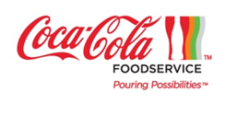

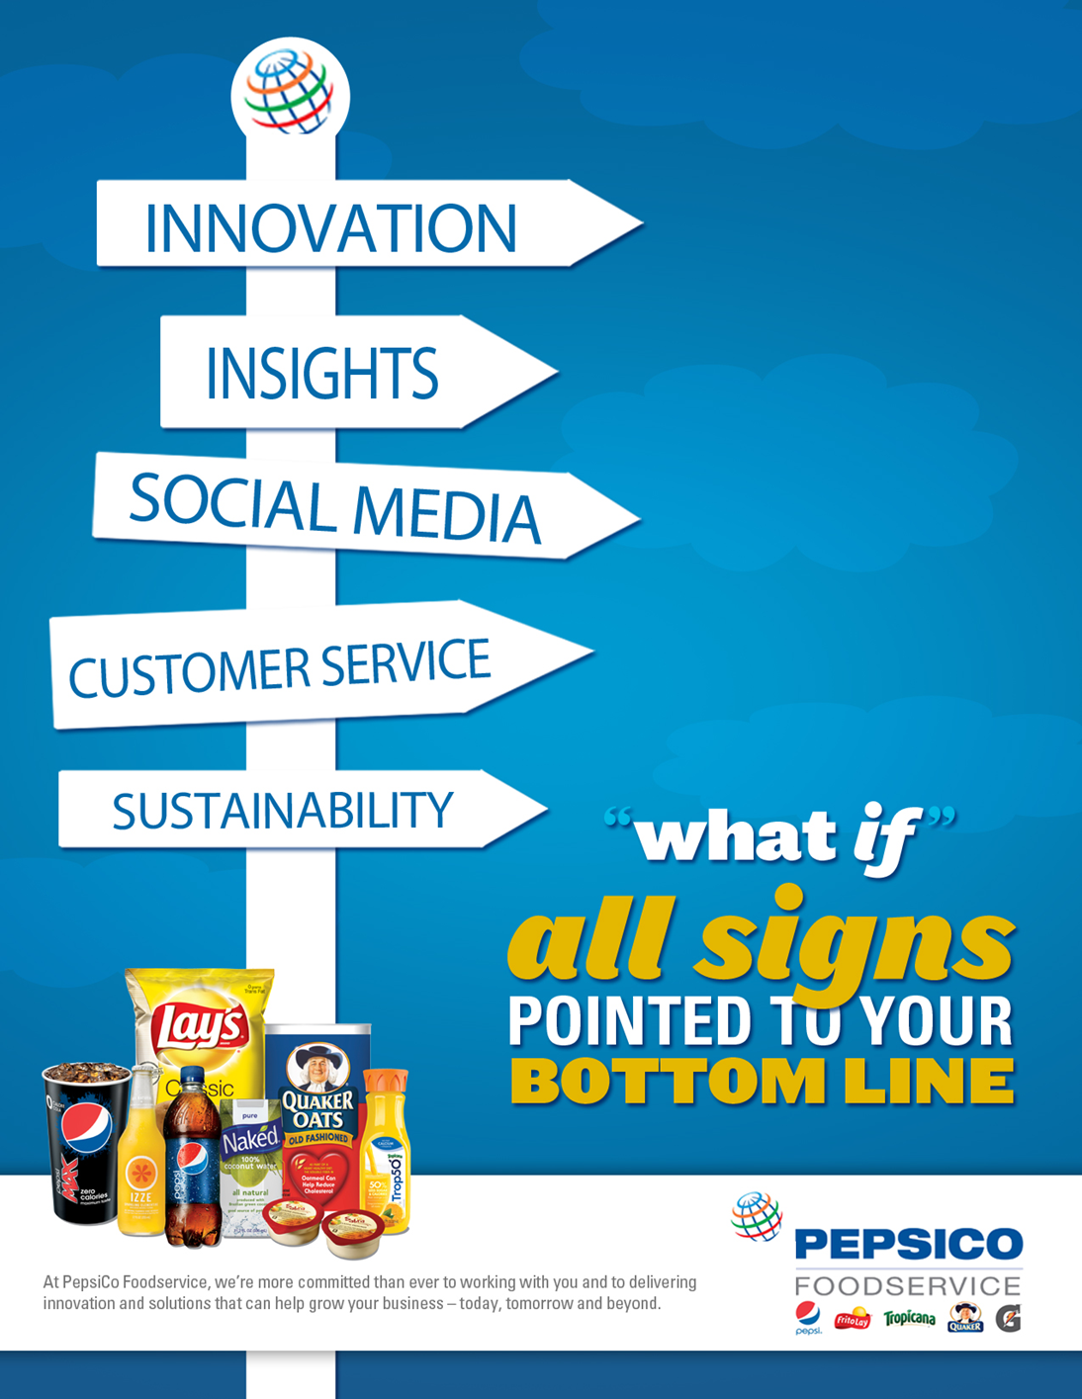

Wednesday, September 21st Continued
12:00 p.m. Entrepreneurs Luncheon
Salons D & E
Master of Ceremonies: Nicky Gacos
President, National Association of Blind Merchants
Making Your Entrepreneurial Dreams Come True
Featured Speaker: Blind Business Woman Carla McQuillan
Executive Director, Main Street Montessori Schools, Springfield, Oregon

(Cost of luncheon is NOT included in the basic BLAST+ registration rate)
All BLAST+ attendees are cordially invited to participate in a special entrepreneur’s luncheon. The cost is $30.00. Tickets may be reserved in advance or purchased when checking in at the registration desk.

1:30 p.m. Building the Solution Network
Capitol 2
Facilitator: Kim Williams
First Vice President, National Association of Blind Merchants
Description: An open forum for Blind Vendors Interested in sharing positive ideas for future improvement of Randolph-Sheppard.

1:30 p.m. - 3:00 p.m. Meet with a S.C.O.R.E Volunteer
Hospitality Suite
Description: The Service Core Of Retired Executives, SCORE, is a not-for-profit organization dedicated to the education and counseling of entrepreneurs who are growing, solving challenges to their business or forming new businesses. Meet with a SCORE volunteer for one-on-one counseling today!

Wednesday, September 21st Continued
1:30 p.m. State Licensing Agency Roundtable
Capitol 2
Facilitator: Terry Smith
Director, Tennessee Services for the Blind; Chairman, Committee on Randolph-Sheppard, National Council of State Agencies for the Blind
Description: This exclusive roundtable provides the opportunity for administrators and staff to share information and network with one another. These sessions are ONLY for State Agency managers and staff members. This roundtable will give you an important opportunity to share information and ideas with your colleagues.

1:45 p.m. - 2:15 p.m. 365 Retail Marketing
Chattanooga
Presenter: Joe Hessling
National Sales Representative
Description: 365 Retail Markets has evolved the retail space beyond a glass-front vending machine into a technology-assisted, small footprint store – called a SmartShop. The SmartShop can run completely unmanned utilizing 365 Retail Markets self-checkout technology and a video surveillance system. 365 Retail Markets supplies all of the hardware, software, and service that are needed to launch and sustain a SmartShop. Come learn more!!!

For decades, self-service has been a way to lower costs and increase productivity in retail. 365 Retail Markets is the global leader in item-level RFID retail solutions. A 365 Retail Market unattended SmartShop™ will help you transform your business to become more efficient and profitable.

2:30 p.m. - 3:00 p.m. 365 Retail Marketing
Chattanooga
Presenter: Joe Hessling
National Sales Representative

Wednesday, September 21st Continued
AYYARSONS FOOD CORP
We are proud to have been an integral part of BLAST from the beginning. From the first BLAST conference held in Las Vegas until now, we have been here. We will continue to be here for the NABM, the BLAST conferences, our current partners, and future partners.
Today the operative word in all government contracts is "COMPETITIVE". We have always been COMPETITIVE and therefore we have been successful. Nayyarsons is now successfully working in 49 locations covering 28 states. We would welcome the opportunity to work with you. Let us know how we can help you be successful!
1:45 p.m. - 3:15 p.m. Breakout Sessions

1:45 p.m. Financial Assistance
Knoxville
Presenter: Nashville SBA Representative
Description: This session is geared for acquiring startup and expansion capital for companies. If you are thinking about starting a company, or are in the process of starting one, come hear from an expert about requirements to be approved for SBA guaranteed loans, and other programs that can be helpful to your business.

1:45 p.m. What Can I Do With My Apple Products?
Salon A
Presenter: Ken Zangla
Director, Training, Resource and Assistive-technology Center (TRAC) at the University of New Orleans
Description: Come learn about ten new apps that you can use in your business for the I-Touch, I-Pad, and I-Phone users. Come see the new fun apps that can make your life easier.

Wednesday, September 21st Continued

1:45 p.m. Your Road Map to Success – The Business Plan
Salon B
Presenter: Dr. Kenneth Lacho
ExcEL, University of New Orleans
Description: Dr. Lacho will lead a presentation on the elements of a complete business plan. This will include the major sections the plan should cover and the details that should be included in each section. Some of the areas included in the discussion are local and national economic measures, marketing, promotions, and operational issues.

1:45 p.m. Linked In
Salon C
Presenter: Tom Babinszki
Program Manager, Center for Entrepreneurship, The Hadley School for the Blind
Description: LinkedIn helps people to stay in touch with business partners, develop new business contacts, and participate in online discussions. This presentation will show you how to get the most out of this site.
1:45 p.m. Blast off with Blio
Salon F
Presenter: James Gashel
Vice President of Business, K-NFB Reading Technology, Inc.
Description: This education session teaches how to make books usable and accessible for business, personal growth, and fun.

1:45 p.m. Building Your eBay Business
Memphis
Presenter: Jonas Klink & Rick Willison
Sr. Product Manager, Search Front-End & Accessibility, eBay Inc.
Description: Why be dependent on others who will not take advantage of the skills you have to offer, when you can create your own jobs right now? Want to expand your existing business onto a platform that already has 95 million active buyers and sellers? Come learn about how easy it is to get started selling on eBay, and get any questions you may have about the process answered.

Wednesday, September 21st Continued

1:45 p.m. What You Need to Know About US Business Leadership Network Certification
Salon G
Presenter: Patricia Richards
Director, USBLN® Disability Supplier Diversity Program
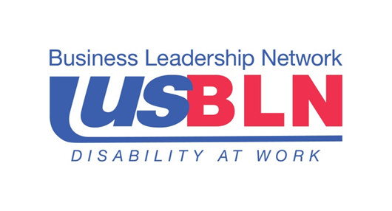
Description: Attend an open forum discussion on a ground-breaking program that is leveraging corporate supplier diversity programs through the USBLN® Disability Supplier Diversity Program (DSDP). Come learn about the DSDP and explore how your business may benefit from becoming certified.

The US Business Leadership Network (USBLN®) embraces the full inclusion of people with disabilities in the labor force and marketplace, assists in career preparation for and employment of people with disabilities, improves customer experiences for people with disabilities, and promotes the certification and growth of disability-owned business. Visit www.usbln.org to learn more
Otis Spunkmeyer is proud to partner with the National Association of Blind Merchants to bring our respected brand name and quality products into your facilities and to support the training and marketing efforts of the blind merchants in Randolph Sheppard. For more information call 1-888-ASK-OTIS.

Wednesday, September 21st Continued

3:30 p.m. Upward Mobility Training Session I
Salons D & E
Building Your eBay Business
Presenter: Jonas Klink
Sr. Product Manager, Search Front-End & Accessibility, eBay Inc.
3:45 p.m. What You Need to Know About USBLN Certification
Presenter: Jill Houghton
Acting Executive Director, Business Leadership Network
3:55 p.m. Meet The Blind Entrepreneurs: Hear the personal stories from successful blind entrepreneurs building profitable businesses in the 21st century
Lisa Holt Haskins - CEO Of ANGEL SERVICES
William Burley - BURLEY-WILSON & ASSOCIATES, L.L.C.
Maurice Shackelford - OWNER AND FOUNDER OF PEACHTREE TRAVEL
Brandy Wojcik - DISCOVERY TOYS EDUCATIONAL TEAM LEADER
Mark Jones - CEO Of VICKSBURG BROADCASTING
Al Bickell - OWNER Of BILLY JOE’S LOUNGE
Jeanette McCallister - CEO Of A HEART STAFFING
Carla McQuillan - FOUNDER OF MAIN STREET MONTESSORI SCHOOLS
Qin Lian - OWNER OF DRAGON TRADERS FURNITURE STORE
Tonia Gatton - SUCCESSFUL EBAY SELLER
5:15 p.m. Be An Entrepreneur: Take the Risk
Featured Speaker: Dan DeSalvo
Executive Vice President, Great American Seminars
Description: Sharpen your communication skills, build more effective workplace relationships, and handle those inevitable personality clashes, job-related conflicts, and other difficult situations with ease. Light the spark, start a BLAST!

Wednesday, September 21st Continued

7:00 p.m. - 10:00 p.m. Welcoming Reception and Barbecue
Cumberland Ballroom
Celebrating 125 years of & 75 years of Randolph-Sheppard
This is the perfect networking event. Share ideas for success with colleagues and make lifelong friends.
Reception Highlight: Local Blind Singer/Songwriter JP Williams
"JP Williams is not only a soulful singer, but his songs have a realness that reeks with someone who isn’t just ‘making stuff up’...he's lived his songs and that's why his songs will live for a long time to come..."

Sodexo, Inc. is a world leader in Quality of Daily Life Solutions in the U.S., Canada, and Mexico, serving 10 million consumers in 6,000 locations every day. Our dedication to excellent service, corporate citizenship, and fighting hunger all come from one goal - to make every day a better day!

Thursday, September 22nd

7:15 a.m. Annual Leadership Breakfast
Cumberland Ballroom
Master of Ceremonies: Nicky Gacos
President, National Association of Blind Merchants
Greetings From: The Honorable Beth Harwell
Speaker of the House of Representatives, State of Tennessee
Leadership Breakfast Highlight: The Honorable Governor David A. Patterson, New York
First Ever Blind Governor; Member, National Federation of the Blind

(Leadership Breakfast Covered By Your Registration Fee)

Thursday, September 22nd Continued

8:40 a.m. Upward Mobility Training Session II
Cumberland Ballroom
Business Education at Your Own Speed
Presenter: Tom Babinszki
Program Manager, Center for Entrepreneurship - The Hadley School for the Blind
8:50 a.m. US Business Leadership Network
Presenter: Jill Houghton
Acting Executive Director, US Business Leadership Network
9:05 a.m. Special Appearance by Dave Ramsey
CEO of The Lampo Group, Inc. (Financial Guru)
9:10 a.m. Lead Without Limits
Presenter: Chris LoCurto
Vice President of Live Events, Lampo Group, Inc.
10:00 a.m. Blind Entrepreneurial Alliance and Beyond: A Perspective from Washington DC
Presenter: Catriona McDonald
President, Linchpin Strategies, LLC
10:15 a.m. Randolph-Sheppard at Seventy-Five
Presenter: Lynnae Ruttledge
Commissioner of the Rehabilitation Services Administration, United States Department of Education Washington DC – Via Satellite
10:40 a.m. Break
10:55 a.m. Blast Off With Blio
Presenter: James Gashel
Vice President of Business, K-NFB Reading Technology, Inc.
11:10 a.m. The State of Randolph-Sheppard: A Panel Discussion
Moderator: Scott C LaBarre
Esquire, LaBarre Law Offices P.C.
Panel Members:
Daniel Frye Management and Program Specialist, Randolph-Sheppard Programs, U.S. Department of Education
Catriona McDonald President, Linchpin Strategies, LLC
Michael Hooks Program Manager, Business Enterprise Program of Texas
Nicky Gacos President, National Association of Blind Merchants
Joe Blackstone CEO Blackstone Consulting, Inc.
Terry Smith Director, Tennessee Services for the Blind; Chairman, Subcommittee on Randolph-Sheppard NCSAB
Andy Freeman Esquire, Brown, Goldstein & Levy, LLP
Thursday, September 22nd Continued

11:50 a.m. No Limits to What We Can Achieve
Presenter: Eric Alexander
Mountain Climber Extraordinaire
Description: Eric Alexander, a world-class skier, climber, and mountaineer is achieving his goals while playing an instrumental role in helping others to achieve their own. Recently he defied the odds and scaled Mt. Everest with his blind friend, Erik Weihenmayer. Eric reminds us of our humanity and demonstrates the courage it takes to succeed.

Blackstone Consulting, Inc.

BCI began in 1991 in Full Food, Mess Attendant and Janitorial Services with the Department of Defense. We are proud to have provided quality service for the past 20 years. In 1999, we began our lifelong relationship with the various state BEP’s in support of the Randolph-Sheppard Act. Since then we have assisted and empowered Blind Vendors and state agencies to achieve the goals set out by the government.

Our dedicated team of ‘Can Do’ people has led BCI to unprecedented gains in the market where we have consistently enjoyed double digit growth over the last five years.

The foundation of our success starts in our corporate headquarters in Los Angeles, CA where we have our Human Resource (HR), Financial, Payroll, Business Development and Operations team. In addition, we are augmented in the field by our operating team in support of our day-to-day efforts and the needs of the specific project locations.

Our relationship with and support of the Randolph-Sheppard Act has allowed us to create business opportunities with the States and individual vendors of Alaska, Arizona, California, Colorado, Georgia, Iowa, Hawaii, New Jersey, New York, Washington D.C. and Wisconsin.

Bringing the BCI team of professionals to bear in support of Blind Vendors across the country and the Business Enterprise Programs have time and again demonstrated to the US Government the value of developing entrepreneurs from the blind and visually impaired community. Our knowledge and experience on Federal and State food service contracts has provided the necessary guidance and direction required in tendering and winning business for the states involved.

BCI- MORE SOLE SOURCE RSA CONTRACTS, 100% RENEWAL RATE ON RSA CONTRACTS, WON 16 OF 17 OR 94% OF NEW CONTRACTS, LARGEST NUMBER OF PARTNERS AND STATES WITHIN RSA.

BCI - BOLD, CONSISTENT, INTEGRITY

Thursday, September 22nd Continued

12:30 p.m. - 6:00 p.m. BLAST+ Trade Show
Nashville Ballroom & Foyer
Taste and touch the latest and greatest exhibits of business products, food, and technology; sponsored by the National Association of Blind Merchants. This product and services showcase will also feature experts who can answer your specific questions about accessible technology, legal issues, partnering for military and other government contracts, social security, vending, marketing, financial planning, and more. Go to the show! Many food service, vending, and access technology exhibitors will have extraordinary specials available only for this tradeshow. Please support those companies that support the blind merchants of Randolph-Sheppard.
(Trade Show Admittance Covered By Your Registration Fee)

We are trial lawyers who handle cases of every stripe, both civil and criminal. We also have an active practice in many other areas of the law, including family law and health care. Above all else, we are a client-centered law firm. We strongly identify with our clients and their problems, and we have the skill, the experience, and the tenacity to solve those problems.
Our lawyers have been selected as among the Best Lawyers in America. Brown, Goldstein and Levy---- true Randolph-Sheppard champions.
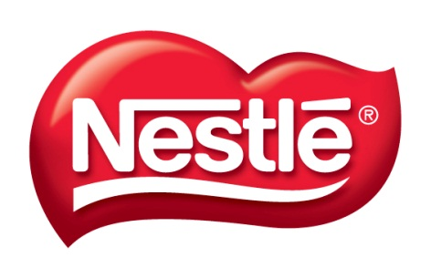
To learn more visit: www.browngold.com

Nestlé is the world's leading Nutrition, Health and Wellness Company. Our mission of "Good Food, Good Life" is to provide consumers with the best tasting, most nutritious choices in a wide range of food and beverage categories and eating occasions, from morning to night.

Thursday, September 22nd Continued
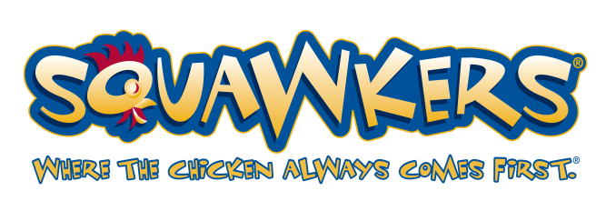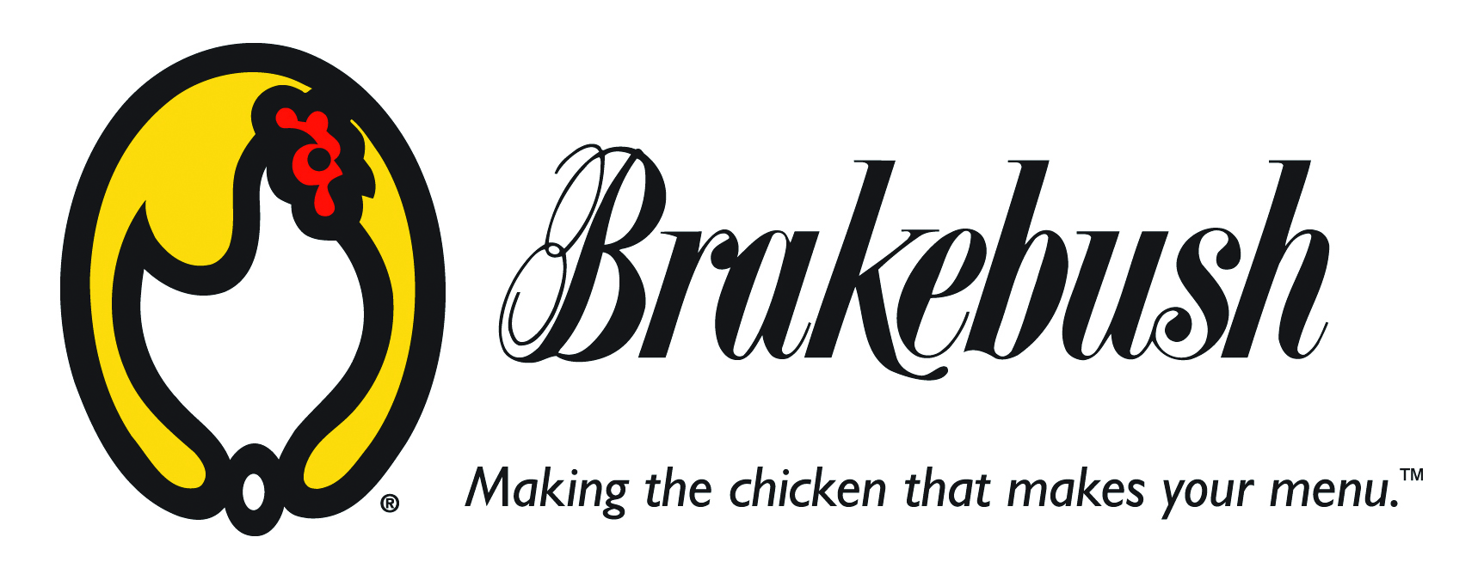
Brakebush & Squawkers – The Team of Success for Your Foodservice Operation!
Brakebush Bros., Inc. has been focusing on one thing since 1925… chicken! We feature a full line of innovative, easy to prepare, delicious chicken, allowing variety for any menu.
Squawkers® gives you everything you need to succeed - a branded foodservice program to add credibility to your foodservice operation and encourage repeat customers. – Great tasting Brakebush chicken - Complete support, including apparel, signage, menu boards, packaging and point of sale, as well as a national sales team to help ensure your success. All with low startup costs and NO FRANCHISE FEES!
We at Brakebush are very excited about our new partnership with the National Assoc. of Blind Merchants and those that take part of the Randolph-Sheppard Act.
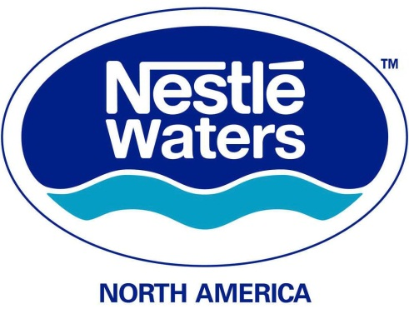
Nestlé Waters focuses on delivering the most suitable healthy hydration solutions for everyone. Being the world's leading bottled water company is based on a solid economic model: strong brands, global presence, innovation capacity, environmental stewardship and passionate people. Learn more at www.nestle-waters.com

Thursday, September 22nd Continued

3:00 p.m. State Licensing Agency Roundtable
Capitol 2
Facilitator: Terry Smith
Director, Tennessee Services for the Blind; Chairman, Subcommittee on Randolph-Sheppard NCSAB

4:30 p.m. Building Connections Reception
Nashville Ballroom and Foyer
Special Entertainment Provided By: The Smoky Mountain Band
(Reception Covered By Your Registration Fee)

6:00 p.m. Buses Load: Enjoy the Sights and Sounds of Music City
Come enjoy downtown Nashville! Buses will be running from The Airport Marriott Hotel, The Springhill Suites, and the Courtyard Marriott to downtown. You will be dropped off on the main strip on Broadway and 2nd. The last bus returning to the hotels from Broadway and 2nd will depart at 11:30 p.m. Check with the registration table for all of the details.

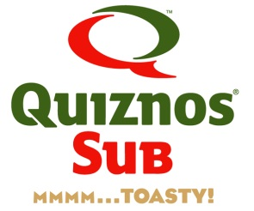
The little sub shop that began over 30 years ago in Denver, CO still has the same bold ideas that we had in the beginning. We boldly believe that your food should taste great and that we should use only the highest quality ingredients to create your perfect lunch. Dedicated to making Mmmmm…One Sub · Soup · Salad at a time. www.quiznos.com

Friday, September 23rd

7:00 a.m. Women’s Leadership Breakfast
Capitol 1
Guest Speaker: Commissioner Raquel Hatter
Tennessee Department of Human Services
Only 23% of Randolph-Sheppard managers are women, we can do better! Ladies, come be inspired and motivated by Commissioner Hatter’s message of determination, self-sacrifice and fulfillment.
(Ladies, ‘Leadership Breakfast’ Covered By Your Registration Fee)

8:15 a.m. Continental Breakfast
Ballroom Foyer
(Continental Breakfast Covered By Your Registration Fee)

8:45 a.m. Upward Mobility Session III
Cumberland
Creating Bold Partnerships to Leverage a Future of Opportunity
Presenter: Heidi Chico
President, The Wittern Group
Member, Board of Directors, National Automatic Merchandising Association
Description: Perspective from a CEO, educator, manufacturer, and advocate for best practices.
9:05 a.m. Confessions of a Young Advocate
Presenter: Sean Whalen
Linchpin Strategies, LLC; President, National Association of Blind Students
Description: Sean Whalen recounts his journey from the University of Wisconsin to Washington DC and talks about his experiences interning for Linchpin Strategies in Congress and representing the interests of Randolph-Sheppard entrepreneurs on Capitol Hill.

Friday, September 23rd Continued

9:20 a.m. Lessons Learned in Hawaii
Presenter: Susan R. Kern
Deputy Attorney General, Hawaii
9:35 a.m. The Leading Edge of Randolph-Sheppard: Recognizing New Initiatives
Panel Members
Tennessee Business Enterprise Commissary Program: Kevin Berk, Tennessee
Landscaping Along the Highways: Anthony Franco, Colorado
Self-Serve Counters Increase Profit, Reduce Labor: Jim McManus, Maine
What’s Old Is Now New, the Private Sector Factory Cafeteria:
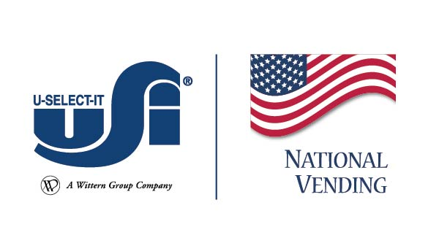
Deborah Myrick, Alabama
O’Learry’s Gift Emporium: Don Morris, Maryland

National Vending Your choice for Premier Vending and Foodservice Management Services
Our customer centric approach delivers customized solutions to meet your needs anywhere in North America with a single point of contact. We offer professional, consistent, local service with commission consolidation, invoice aggregation and 24/7 web enabled account tracking.
Find us online at www.nationalvending.com or call us toll free at 866-VENDING.

U-Select-It The Leading Vending Machine Manufacturer
USI vending machines are built for maximum customer satisfaction, low maintenance and affordability with machines paying for themselves on every vend. Whether you are just starting a vending machine business, or growing an existing one, let our 80 years of expertise work for you. We cover all aspects of the vending machines industry including financing, service, energy efficiency, and healthy-environmentally friendly vending options. To learn more visit www.uselectit.com or call 800-247-8709.

Friday, September 23rd Continued

10:05 a.m. 365 Retail Marketing
Presenter: Joe Hessling
National Sales Representative
10:10 a.m. It is Scarier than You Think: Why Workman’s Comp? What you and your employees need to know
Presenter: Mark Newman
Blackstone Consulting Inc., SIU (Special Investigative Unit) Manager
10:40 a.m. Break
11:00 a.m. Nourishing America One Snack At A Time: Building a stronger nation through health and sustainability
Presenter: Dr. Joel Kimmons
Nutrition Scientist, Centers for Disease Control and Prevention
Presenter: Denise Funkhouser
U.S. General Services Administration
11:30 a.m. Evolve or Die: Seven Steps to Rethink the Way You Do Business
Presenter: Robin Crow
Author, Speaker, & Entrepenuer

LaBarre Law Offices P.C. is wholly owned and operated by Scott C. LaBarre. Mr. LaBarre specializes in Randolph-Sheppard law, employment law, disability rights, Social Security matters, business law, and other general civil litigation. Scott LaBarre greatly enjoys working with blind merchants because he believes firmly in achieving the letter and spirit of the Randolph-Sheppard Act and its overarching goal of promoting the maximum vocational potential of blind operators. Contact LaBarre at slabarre@labarrelaw.com

Friday, September 23rd Continued

12:30 p.m. Luncheon
Nashville Ballroom
Master of Ceremonies: Kevan Worley
CEO, Worley Enterprises
Life, Liberty and the Pursuit of Happiness: An Effort of Unity
Keynote Speaker: Jessie Hartle
Director of Governmental Affairs, National Federation of the Blind

Johnson Food Services, LLC
Johnson Food Services, LLC (“JFS”) is a limited liability company that was formed in 2002 with Donald Johnson, and American Service Contractors, LP (“ASC”) as its members. Mr. Johnson serves as President and Jim Ed Rice of ASC serves as Operations Officer. Johnson Food Services, LLC, an equal employment opportunity employer, provides jobs for more than 1,500 workers in Columbia and surrounding environs.

2:15 p.m. Upward Mobility Training Session IV
Cumberland
Team Building through Song
Facilitator: Kid Billy
Description: Reflect on your shared experiences, discover your combined potential, find out how creative you are, and work toward a common goal. Led by Grammy award winning hit songwriter facilitators, Team Building through Song will bring your group together in a fun team building activity that is empowering, memorable and productive.

Friday, September 23rd Continued

6:00 p.m. Buses Load: Grand Ole Opry
Tickets to the 7:00 Grand Ole Opry show are on sale for $55 which includes your transportation.
Tickets are available at registration. We will be providing transportation to the show and back. The bus will be leaving at 6:00 p.m. from the Marriott Airport Hotel. Come hear the best of country music, they don’t call it ‘music city’ for nuttin’!

Saturday, September 24th

Upward Mobility Training Session V
Cumberland
8:45 a.m. Future of National Training for the Blind in Business: An Open Forum
Facilitators: Nicky Gacos
President, National Association of Blind Merchants
Terry Smith
Director, Tennessee Services for the Blind; Chairman, Committee on Randolph-Sheppard NCSAB
Dan Frye
Management and Program Specialist, Randolph-Sheppard Programs, U.S. Department of Education
9:10 a.m. Vision Beyond Vision: An Insight into Success
Presenter: Rick Willison
eBay Seller/Blind Entrepreneur

Saturday, September 24th Continued

9:35 a.m. What the Agencies Said: A Report
Presenter: Raven Pulliam, Illinois
Presenter: Terry Smith, Tennessee
9:45 a.m. What the Vendors Said: A Report
Presenter: Kim Williams
First Vice President, National Association of Blind Merchants
10:00 a.m. Break
10:15 a.m. Your Best Today
Presenter: Hallerin Hilton Hill
CEO and Founder, Wisdom House
10:59 a.m. Adjourn

SPECIAL THANKS TO OUR TENNESSEE HOST SPONSOR:
The Vending Center, Inc.
The Goal of The Vending Center Inc. is to provide our customers with quality vending equipment and parts in a timely, professional and affordable manner. We strive to provide training and technical information to our customers, enabling them to give superior service to the true customers, The End User. To learn more please visit: www.thevendingcenter.com

