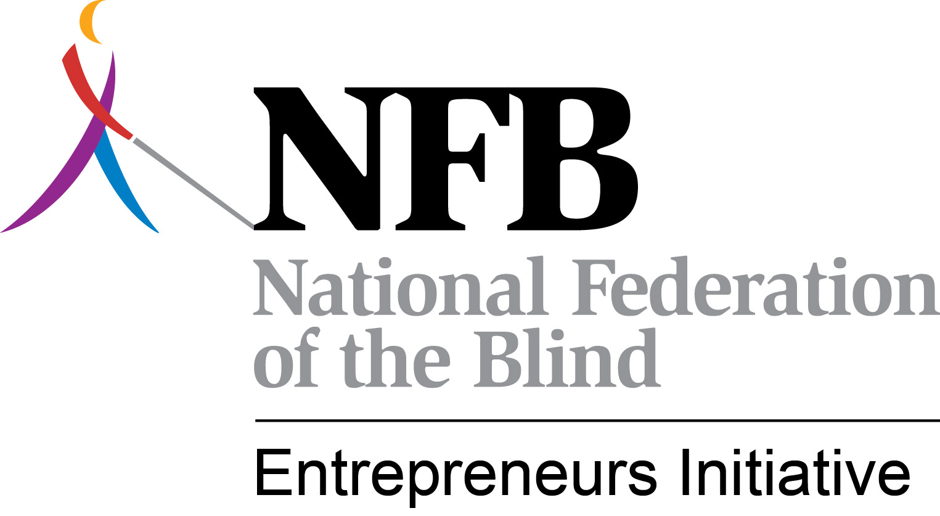

The NFBEI Monthly Blitz

March, 2013

March was not a slow month but at least there were no bombshells. We were able to focus on finalizing plans for BLAST and working on the agenda for the NFBEI / NCSAB staff training as well as address ongoing issues. Here are the highlights of some of the activities of the NFBEI for the month of March.

**Finally Some Good Dam News –** The Virginia SLA got some good news this week about the Dam Neck Naval facility. You may recall that this Navy Seals training facility had initiated the process of putting this full food service on the Procurement List with the intent of Goodwill running it. The Virginia SLA objected as did the NFBEI and NCSAB. Ultimately the decision was made to withdraw the notice to place it on the Procurement List and the contract will now be competitively bid. This was a major victory for Randolph-Sheppard. Although there is no guarantee that the Virginia SLA will win the bid, at least the Navy has been forced to abide by the law.

**On the Other Hand –** Well we have to balance the good with the bad – the victories with the losses. We won at Dam Neck but we lost at Fort McConnell in Kansas. NCSAB took the lead in challenging the placement of the food service, which we believe was mischaracterized as dining attendant services, on the Procurement List. AbilityOne disagreed. Efforts were hampered on this effort because the SLA showed little interest in engaging in the fight.

**GSA Finally Gets it Right –** After years of misapplying the law, GSA’s attorneys have finally agreed with the NFBEI’s position that the Randolph-Sheppard priority applies to properties with less than 15,000 square feet and 100 Federal employees if there is going to be vending. Terry met with GSA in February and this was one of the topics of discussion. Following that meeting, GSA officials met with their attorneys who concurred with our position. The bottom line is that GSA does not have to provide space if there are fewer than 15,000 square feet and/or 100 employees but if the decision is made to have vending then the priority kicks in. This is being communicated to GSA’s regional concession specialists so we should see more opportunities in these smaller locations. We have now prevailed on this issue with the U.S. Postal Service and GSA. We’re still working on the VA but we expect to prevail there too.

**The VA – One Step Forward and Two Steps Back** - We continue to press the VA on its noncompliance with the Randolph-Sheppard Act. Clearly, we have different interpretations of the law. The problems are multifaceted. First, the VA has a Randolph-Sheppard liaison. On the surface that sounds like a good thing. However, she isn’t even located organizationally in the same division of the VA that handles hospital administration or the Canteen Service. In other words, she is a powerless bureaucrat who can do little to influence change. She simply passes issues on. To whom, we don’t know but they seem to disappear into a deep dark hole. We were told months ago that new policies were being written on how the VA will interact with Randolph-Sheppard. Where are those policies? We insisted that RSA’s consultation be sought so that assurances can be made that the new policies are Randolph-Sheppard compliant. RSA hasn’t seen them. And then to make matters worse, the Oregon SLA prevails in arbitration against the VA and the VA essentially says we don’t agree with the decision of the panel and we will not comply. And in the midst of all of this, the VA goes to Congress and asks for more money to hire more staff for its Canteen Service. We have let the politicians know that the VA could actually reduce staff if they’d let Randolph-Sheppard vendors have at least a slice of the pie. We continue to work this issue and believe we will have more positive news to report soon.

**Reinventing Randolph-Sheppard** – On March 15th, Dr. Maurer, President of the National Federation of the Blind, called together some of NFB’s Randolph-Sheppard leaders to brainstorm on how to revitalize Randolph-Sheppard and create more opportunities for blind entrepreneurs and how to take advantage of the opportunities that are already out there. As a result, we are close to sharing a proposed piece of legislation that will, if enacted, resolve the conflicts between Ability One and Randolph-Sheppard. I had mentioned previously that we were working on such legislation. As the result of our meeting, we fine-tuned the potential bill and will soon begin the process of building consensus for its passage. Other strategies were also developed that will be further refined later. Stay tuned.

**Sequestration Comes and Goes** - We realize the full impact of sequestration is yet to be felt, but when the deadline came and went some noted the similarity with the Y-2K scare a little over a decade ago. Clearly, painful cuts lie ahead but the good news is that it appears that at least most state Business Enterprise Programs will see little or no impact. BEPs use Federal VR dollars in most states but the reduction in dollars has had virtually no impact that we have been able to determine. No state has reported that they are unable to do basic functions such as repair equipment, etc. We hope that continues to be the case. We can still expect fewer customers in some Federal buildings once anticipated furloughs occur and some of our troop dining facilities could still be hit hard. But all of that remains to be seen.

**News from NCSAB** – Although technically April’s news, we will report that Michael Jones has resigned as the Director of the Oklahoma program. Michael also chaired NCSAB’s Randolph-Sheppard Committee. Ray Hopkins of Virginia will take over the NCSAB duties and we see that as a positive. Although we hate to see Michael leave, our main concern is the impact this could have at Fort Sill. That facility has been draped with controversy for the last couple of years and the solicitation for the food service will soon be out. We can only hope this development doesn’t impact the state’s efforts in regards to submitting a bid.

**We Want to be Part of Your Annual Meetings –**  Nicky Gacos was in Hawaii early in the month at their annual meeting. Kevan Worley made a trip to Alabama and met with merchants there. We have several other meetings on the books for later this year. We will be in Maine in April conducting training and in Ohio in May. If your state is interested in having us participate in your annual meeting, let us know. We want to be involved and be in as many states as possible this year.

**Going to Have a BLAST** – Much effort was devoted in March to putting the finishing touches on the BLAST training. Kevan Worley and Nicky Gacos have worked tirelessly on making sure this is the best BLAST ever. BLAST will be held May 20-23 in Indianapolis. For more information or to register, you can go to [www.blindmerchants.org](http://www.blindmerchants.org). As of this writing, there are still two scholarships and a few partial scholarships available. Criteria for receiving stipends will be based on need and/or a willingness to provide leadership in our effort to build careers, protect and preserve the Randolph-Sheppard program. I’ve been working on putting together the agenda for the staff training being co-sponsored by the NFBEI and NCSAB. We are excited about the number of states who have already signed up to be at BLAST and participate in the staff training. As of now, 27 states have staff registered to attend and it is expected we will have 30-35 before it’s over.

**Sustaining the NFBEI** –In January, we announced that we were making NFBEI membership / subscription service available to state licensing agencies. We are pleased that 8 states have come on board or have committed to do so. Our goal was to have 10-15 states and with several states still looking at it we hope to reach that goal. Our primary source of funding remains donations from blind entrepreneurs, teaming partners, committees of blind vendors, state NABM chapters, and other stakeholders. We have been pleased with the level of contributions we have received so far. If you believe in what we are doing, you can give generously to our effort. Some have contributed $10,000 and others have given $100. The amount doesn’t matter. What matters is you are part of this important initiative and you are helping us protect the program for future generations of blind people. You can send a check made out to NABM and note in the memo portion of the check that it is for the NFBEI. Checks can be mailed to:

National Association of Blind Merchants

1837 S Nevada Ave.

PMB 243

Colorado Springs, CO 80905

Terry Smith

NFB Entrepreneurs Initiative

[tsmith@nfb.org](mailto:tsmith@nfb.org)

(423) 468-4969