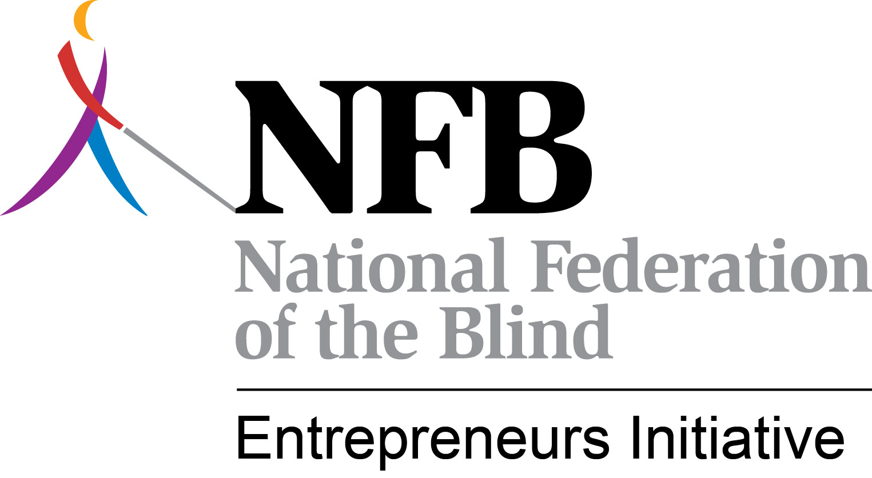
The NFBEI Monthly Blitz
April - May, 2013

This has been a very busy spring. We were not able to send out a Blitz last month. Therefore, this May-June edition is a bit longer than normal. Thanks for your understanding. With all of the preparation that went into BLAST and the staff training, time just got away. Before we get into the meat of this month’s Blitz, let me say that we often hear from blind entrepreneurs across the country that they never see the Blitz and are unaware of the activities of the NFBEI and some of the critical issues facing the Randolph-Sheppard Program. Please share this with as many people as you can. It is critical that you help us keep people informed about the challenges we face and what is being done to meet those challenges. We are asking BEP Directors and Committee Chairs to share this with all vendors.
Super Blast Was Super Indeed – The 2013 edition of BLAST in Indianapolis was super indeed. Almost 500 blind vendors, BEP staff, and other stakeholders attended this year’s meeting. The agenda was full of outstanding presenters speaking on leadership and relevant topics of interest to Randolph-Sheppard entrepreneurs. One of the highlights was the largest exhibit hall ever at a Randolph-Sheppard event. There were 57 exhibitors. Another highlight was the first ever BEP staff training that preceded BLAST. The training was co-sponsored by the National Council of State Agencies for the Blind and attracted approximately 80 participants representing 33 states. The feedback was extremely positive. Folks are already looking forward to BLAST 2014. The conference has gotten so large that NABM is now on an 18-month rotation so the next one will be in the fall of next year. No contracts have been signed but BLAST 2014 may have a definite Lone Star flavor to it. Stay tuned for a formal announcement. Early in the BLAST conference, NFB President Dr. Marc Maurer addressed attendees saying, “Let’s go out and do something outrageous.” That audacious spirit of imagination and commitment to our cause may be the most accurate characterization of Indy Super BLAST 2013.
Healthy Vending Takes Center Stage – There is no escaping the healthy vending issue. It is here to stay and the Randolph-Sheppard community cannot simply say no. Yes, we can fight unreasonable edicts or legislative attempts that threaten the livelihoods of blind entrepreneurs. However, we must also understand that our vendors must be willing to be part of the solution. If we are not, the policy edicts, executive orders, and legislative threats will be crammed down our collective throats. Kevan Worley, NABM Executive Director, and Nicky Gacos, NABM President, recognize this. That’s why the healthy vending initiative appeared on the BLAST agenda no less than 4 times, if you include the staff training and pre-conference focus group. But talking about it at a meeting and then doing nothing is not an effective strategy. At Mr. Gacos’ direction, Mr. Worley has created a national task force to try to bring together different points of view in a way that results in a balanced approach that focuses more on education and less on mandates. The task force includes blind entrepreneurs, BEP administrators, Federal Government officials, public policy experts, nutritionists, health advocates, and others. A small amount of funding has been secured to help with the work of this task force. Miracles are not to be expected. There is no silver bullet that solves the problem. However, the different groups are talking and the hope is that a model approach can eventually be developed. We continue to add healthy concessions resources to the website at www.blindmerchants.org. You will be hearing much more about this in the future.
A Victory of Sorts at the Naval Damn Neck Facility –In March, we reported about the battle being fought at the Damn Neck Naval Facility in Virginia. This is the base where the Navy Seals are trained. A new full-food service is being initiated to feed the Seals and the Navy negotiated with an AbilityOne agency without first offering it to the SLA. The Committee for Purchase published in the Federal Register its intent to place the Dam Neck full-food service on the Procurement List. The NFBEI joined NCSAB in expressing objections to the Committee for Purchase. More importantly, the Virginia SLA objected and ultimately the Committee made the decision not to place the full-food service on the Procurement List thanks to everyone’s advocacy. The Navy will now competitively bid the full-food service. That doesn’t mean the SLA will get the contract. There is still an issue as to whether or not the SLA can meet the security requirements of the Navy. That issue is still being explored. Look for an update in a future issue of the Blitz.
Multi-State Bundling: It’s Back – In May, the Army issued an RFP seeking proposals for a contractor to manage and operate the food services at 8 Army hospitals in 8 different states. The Rehabilitation Services Administration has taken the position in the past that the military can bundle contracts like this provided the Randolph-Sheppard priority is still recognized. RSA has indicated it is up to the states to work together to come up with creative approaches to respond to such opportunities. We faced this with the Marines two years ago. We tried to put together multi-state coalitions in order to respond to the Marines’ RFP. We partially succeeded in that California and Arizona joined together to submit a bid. The bid was not within the competitive range but it was at least the first attempt to have states work together in such a manner. This time, we are taking a different approach. The NFBEI is facilitating an effort to have one SLA bid on all 8 state hospitals. It would mean that the SLA will be operating in other states, which is a new approach. At least one potential teaming partner has stepped forward and discussions with at least one other are still ongoing. We are encouraged that there may be a real opportunity here to preserve these opportunities for blind entrepreneurs. As for one SLA managing facilities in another state, it is the position of the NFBEI that we want to preserve those opportunities for blind entrepreneurs and this approach may be the only way to do it. When the next issue of the Blitz comes out, we will know if the state is successful in submitting a bid. Stay tuned.
Is AbilityOne Up to More Games in Alaska? – Well, the battle over full-food vs. DFA and the application of the No Poaching provisions of the law to current Randolph-Sheppard contracts continues. The latest issue is unfolding at Fort Richardson in Alaska at this very moment. It is complicated. The Army is claiming that the contract is no longer full-food service and wants to convert the contract to DFA and award it to an AbilityOne agency. We do not agree that it is DFA because it has contingency cooks for a large portion of the year. We also believe it is a blatant violation of the no poaching provisions of the law. It is too early to say how this will turn out. We will have more to report in the coming months. The NFBEI is urging the SLA to challenge the decision of the Army.
The Tale of Two States: To Pay or Not to Pay Utilities – While blind entrepreneurs in Maine fight a determined governor who wants to charge blind entrepreneurs on state property for utility costs, entrepreneurs in Nevada celebrate a major victory with the passage of SB 54 which clarifies that BEP participants cannot be charged for utility costs on state property. Congratulations to the Nevada SLA and to the blind entrepreneurs who helped get the bill passed. As we send out this issue of the Blitz, the matter in Maine remains unresolved. The Governor wanted all blind entrepreneurs on state property to pay utilities but later revised his legislative request to limit the payment of utilities to one facility – the one that serves the capitol. So, the good news is most blind entrepreneurs have been spared but the fight continues to protect the one entrepreneur in the capitol. The NFBEI has attempted to assist in this effort. Terry Smith was in Maine in April where he conducted training on collective action, developing legislative relationships, and effective strategies for lobbying to protect the rights of blind entrepreneurs. A letter was even drafted as part of the training that was signed by all of the BEP entrepreneurs and sent to the appropriate legislative committee dealing with the bill. That committee eventually voted 7-2 against the bill but the matter is still under consideration by the Appropriations Committee and could still pass. The fight continues.
Can Randolph Sheppard Entrepreneurs Be Required to Pay Utilities on Federal Properties? – We are seeing more and more situations where Federal entities are trying to charge the blind entrepreneur for utility costs. The latest is in Georgia where we have offered technical assistance on the matter to the SLA. Can a Federal entity charge for utilities? RSA has taken the position that the Randolph-Sheppard Act is silent on utilities; therefore, the Federal entity can charge for utilities. The NFBEI doesn’t necessarily agree with this interpretation. First, the fact that the law is silent actually works to our favor. The law is very specific in what a Randolph-Sheppard vendor can be required to pay, which is a set aside fee. We would maintain that if Congress intended to require Randolph-Sheppard entrepreneurs to pay additional costs, it would have so stated. It didn’t. If we accept the argument that since the law is silent then it is allowable, then Federal entities can charge rent, commissions, fees for processing paperwork, etc. Secondly, we believe the charging of utilities is in effect a limitation on the earnings of the blind entrepreneur, and as such must be justified to the Secretary of the U.S. Department of Education that the limitation is necessary, since not to charge for utilities would have an adverse effect on the interests of the United States. Thirdly, some entities are trying to unilaterally amend an existing permit in order to start charging for utilities. Permits are issued for an indefinite period of time and cannot be amended unilaterally. Not everyone in the Randolph-Sheppard community may agree with this interpretation but we bring it up here to alert states to the problem and not to feel they have no option except to agree to the payment of the utilities.
Taking a Closer Look at the Coast Guard and NASA Exchanges – We’ve been working with at least two states which are having problems with the Coast Guard and NASA Exchanges. At issue is either the refusal to recognize the R-S priority or unfair competition from the exchanges. NABM President Nicky Gacos has authorized the NFBEI to utilize the services of NABM’s attorney, Susan Gashel, to conduct some legal research on how Randolph-Sheppard intersects with these exchanges. This research will be the basis upon which technical assistance will be provided to the states. If your state is experiencing similar problems with either the Coast Guard or NASA, please communicate these to Terry Smith.
NFBEI Unveils Potential New Legislation at BLAST – Details of the long awaited legislation to promote blind entrepreneurship were revealed for the first time at BLAST. This proposed legislation would require the President’s Committee to assign at least 10% of all new contracts to companies owned by persons with disabilities rather than to large non-profit agencies. We specify in the bill that if the contract is for food service, the contract must be awarded to a company owned by a person who is blind. This is our attempt at preventing situations like what occurred at Fort Drum from happening again. At Fort Drum, the SLA passed on a military dining contract and it went to an AbilityOne agency instead. It was lost forever to Randolph-Sheppard. Under our bill, a blind person would still get first shot at that contract. The bill also allows the military contracting officer to place full-food service contracts on the Procurement List PROVIDED the R-S priority is recognized, meaning the SLA would still get it. Why is this legislation so critical? 1. It creates new entrepreneurial opportunities for people with disabilities; 2. It solves the problem of SLAs failing to go after viable opportunities; 3. It resolves the full-food service versus DFA dispute; 4. It negates the famed Joint Policy Statement and the need to promulgate new regulations as desired by DoD and AbilityOne; 5. It affords Randolph-Sheppard the opportunity to take advantage of AbiltyOne’s fair market pricing model rather than competitive bids; 6. It would resolve problems like those mentioned earlier at the Dam Neck Naval Facility where by the SLA cannot get an organizational security clearance; and 7. It reduces potential litigation. The beauty of this approach is that it doesn’t touch the Randolph-Sheppard Act. It remains intact. Clearly, such a bill will require the support of AbilityOne and we plan to meet with them to seek their support as well as the support of other organizations. Many groups learning of this effort are indicating their support. We believe we can get 100 or more organizations of and for people with disabilities to support such a landmark bill. This is not a short term project. Passage will likely take a couple of years. You will be hearing a lot more.
NFBEI Presents at NCSAB – Terry Smith participated in the spring conference of the National Council of State Agencies for the Blind in Bethesda in April. He spoke on the many challenges faced by Randolph-Sheppard. One of those challenges we face is a Rehabilitation Services Administration that has failed to push for compliance to the law by other Federal entities. He was referencing RSA as an institution and not any individuals at RSA, for whom the NFBEI has great respect. The RSA Commissioner Nominee Janet LeBreck was in attendance for Terry’s presentation. Later, Terry talked with Ms. LeBreck who expressed her appreciation for his remarks. She said, “We have to protect the Randolph-Sheppard Program. It is a good program and once it is gone it is gone forever and so are the opportunities for blind people.” These were encouraging words indeed. It is very important to have a Commissioner who understands Randolph-Sheppard and the promise it holds. We look forward to working with Ms. LeBreck whose Senate confirmation is expected any day.
NFBEI Participates in Ohio Upward Mobility Training – Terry Smith and Kevan Worley were happy to participate in Ohio’s Annual Upward Mobility Training in May. We did the first half day of training. The training focused on national issues faced by the program today, active participation, and branding. We were well received and the training went extremely well. This is the type of training the NFBEI wants to do. If you have training coming up in your state, contact Terry Smith and let’s see if the NFBEI can contribute. This calendar year, the NFBEI will be in at least a dozen states providing training. Let’s hope your state is one of them.
NABM President Named to Key NAMA Committee – Congratulations to NABM President Nicky Gacos who was recently named to the powerful Government Affairs Committee of the National Automated Merchandising Association. There has been concerted effort by NABM to get more involved with NAMA which represents all vending companies in the country. Nicky will be a voice for all blind entrepreneurs. If you have issues that need to be brought to the attention of NAMA, contact Nicky at nickycolorado@netscape.net.
DoD Contracting Training Coming Up – The Rehabilitation Services Administration will be sponsoring a two day training on military dining on August 26-27 in Baltimore, Maryland. Some stipends will be available. For information, contact Dan Frye with RSA at Daniel.Frye@ed.gov.
Sustaining the NFBEI – Thanks to the generosity of blind entrepreneurs and teaming partners as well as support from many SLAs, the NFBEI has in large part achieved its fund raising objectives for the current year. We are happy to say that nine states have paid their NFBEI subscription dues, 4 others have committed to do so, and 2 others are still considering it. If all of these purchase the subscription service, we will achieve our goal of having 15 states participate. We know that several states have renewed interest after having attended BLAST and experienced firsthand the work being done. If we have anyone reading this who would like to contribute to the cause, we would welcome your donation. You can send a check made out to NABM and note in the memo portion of the check that it is for the NFBEI. Checks can be mailed to:
National Association of Blind Merchants
1837 S Nevada Ave.
PMB 243
Colorado Springs, CO 80905
In recent weeks, the Randolph-Sheppard program, NABM and NFBEI have been featured on National Public Radio Morning Edition, Vending Times, and VendingMarketWatch. Now, we are 18 months into the NFBEI effort and with your engagement and support, the important work we do will continue.

Terry Smith
NFB Entrepreneurs Initiative
tsmith@nfb.org
(423) 468-4969

