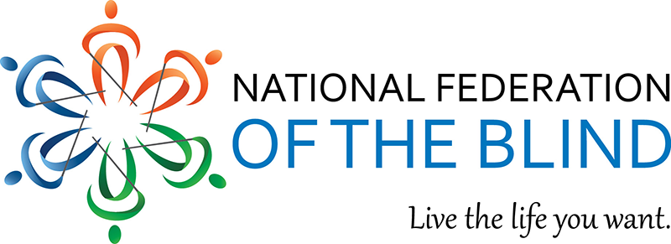

National Convention: Registration – Mini Communications Toolkit
Affiliates and divisions: we need your help to publicize national convention and increase registration before June 15. Please use this toolkit for social media, websites, and mailing lists.
This toolkit includes content templates to assist, but please feel free to tweak as needed. It’s also great to add a story element. Copy and paste the content to the corresponding platform. For Twitter, each bullet point represents one post to share at a time.
For timing, we recommend sharing social media posts starting immediately at least once a week, updating web content as soon as possible, and sending out the email at least twice between May 27 and June 15. If you have questions, please reach out to CommunicationsTeam@nfb.org.

Twitter Posts – Choose One at a Time
- It’s the largest gathering of blind people! Attend national convention, Tuesday, July 14 through Saturday, July 18, 2020. This year is new and will be virtual. Register today. #NFB20 nfb.org/convention
- #NFB20 will feature most of the elements our members know and love, with some new twists. There will be multiple ways to participate in and interact with all convention events. Register now! nfb.org/convention
- Attend #NFB20! Members are requested and non-members are welcomed to participate. Register to get access to exclusive offers, convention announcements, door prizes, and other exciting content. nfb.org/convention
- Deadline approaching! Register for @NFB_voice National Convention, July 14-July 18, 2020. Register by June 15. nfb.org/convention
- The #NFB20 @NFB_Voice National Convention is coming to you! Register today and help us connect blind people from anywhere and create opportunities everywhere.

Facebook Post
Attend the largest gathering of blind people July 14 through July 18. The 2020 NFB National Convention will feature most of the elements we all know and love, with some new twists. There will be multiple ways to participate in and interact with all convention events. We benefit from the strength and knowledge gained from the many blind people we meet at convention. Your ideas and your voice are needed. Comment if this will be your first convention or share your favorite part of convention. Register by June 15. nfb.org/convention

Affiliate Website
Note: when possible, please have a blurb on the affiliate homepage or under events.
The National Federation of the Blind National Convention is the largest gathering of blind people in the world. Plan to attend July 14 through July 18, 2020. The 2020 National Convention will be held virtually for the first time, and you can participate by phone or web. Through this unique event, we will connect blind Americans from anywhere to build opportunities everywhere. We look forward to spreading the 2020 view on blindness to the entire nation and beyond. Learn more register today at no cost: nfb.org/convention

Email Content

Subject Line:
Attend the National Federation of the Blind National Convention

Email Text:
The largest gathering of blind people will be held July 14 through July 18. This will include most of the elements we all know and love, with some new twists. The 2020 National Convention will be held virtually for the first time, and you can participate by phone or web. There will be multiple ways to participate in and interact with all convention events. Members are requested and non-members are invited to register at no cost in order to get access to exclusive offers, convention announcements, door prizes, and other exciting content.
Who should attend?
- blind people
- people losing vision
- seniors and students
- parents of blind children
- educators and employers
- rehabilitation professionals

Schedule Overview
- Tuesday, July 14: Seminars
- Wednesday, July 15: Board Meeting and Resolutions Day
- Thursday, July 16: Division Day, Opening Ceremonies
- Friday, July 17: Presidential Report, General Sessions, Affiliate Caucus
- Saturday, July 18: Business Meeting, Resolutions, Banquet

Advocacy. Education. Connections. Deadline to register is June 15. Learn more at nfb.org/convention.

