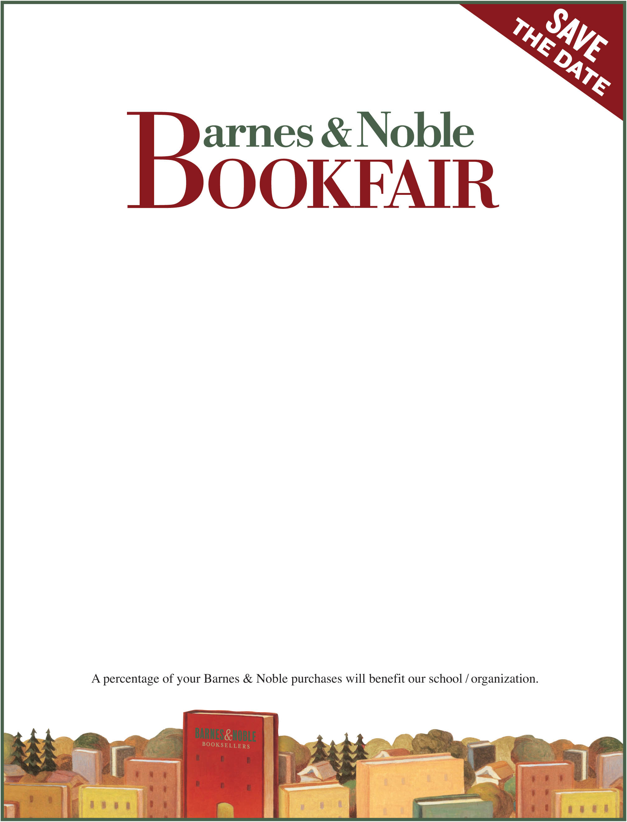

April 11th
Barnes & Noble
Woodland Plaza
8620 E 71st St.
Tulsa, OK
918-250-5034

Tulsa Chapter, National Federation
Of the Blind of Oklahoma
Bookfair ID 522417

Saturday, April 11th,
10-11am Meet Jim Stovall, author of the Ultimate Gift & many others & have your book signed,
10am-2pm Have your name printed in Braille, see the first Braille coin, and
Help us celebrate Louis Braille’s birthday!

call Joan Holopoff @ 918-250-5034 for more information

